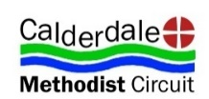
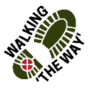Walking “THE WAY” BEECHWOOD PARK Points info.
The Beechwood Park Walk (North Halifax) can be downloaded from Youtube Channel https://www.youtube.com/channel/UCKW56R0wIJJKQghPkFm-9jw
This walk is designed to help you with your wellbeing and reflect upon your life and lifestyle. Each walk can be stopped at anytime on your device or on your printed sheet. There will be a ‘Spiritual’ aspect at the end of each stopping point for those who wish to think more deeply. Feel free to stop the video before, if you do not wish to continue. There will be a notification both on the video and the sheet that says “SPIRITUAL” if you wish to journey deeper. Take as much time as you like at each point and move on in your own time. This walk has been produced by the Methodist Church in Calderdale. We hope you enjoy it and that it helps to contribute something positive to your life. Please remember to wear sensible clothing suitable for the conditions. This is easy walking and should not take too long. Use the QR Code on your phone for the Video if you prefer.
MAP
11: END
5: Gym
Equipment
HEATHY LANE
10: Litter Bin
8: POND
7: Stream
3: Bowling Green
2: Play Ground
1: Car Park
9: Bird
Box
6: Skate Ramps + BMX Track
4: Football Pitch

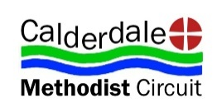
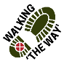 Walking “THE WAY” BEECHWOOD PARK Point 1.
Start: Point 1- Car Park
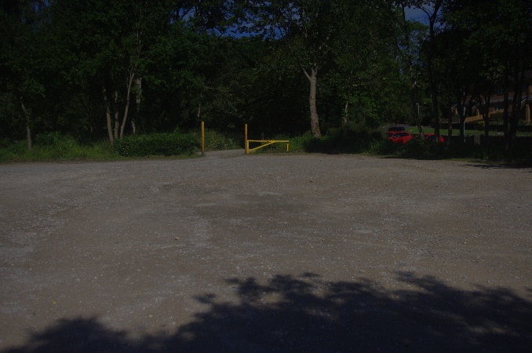
- How did you get here? It is important to think about the journey we have travelled to get where we are now. Was your journey easy? What things did you have to do to get here? Did you walk, cycle, drive, get a lift or other transport?
- Think about the kind of energy it has taken to get to this point.
- As you look around what modes of transport do you see?
- You have undertaken a journey to get here and the journey will continue as you follow the trail.
- SPIRITUAL- In the Bible the Wise Men were guided on their journey by a star to go and see the baby Jesus. How has God guided you?
- Think about your life and how you got to be where you are today. Perhaps you might like to think how God has helped and guided you on this journey.
QR CODE

Walking “THE WAY” BEECHWOOD PARK Point 2
Walk to Point 2 – Playground
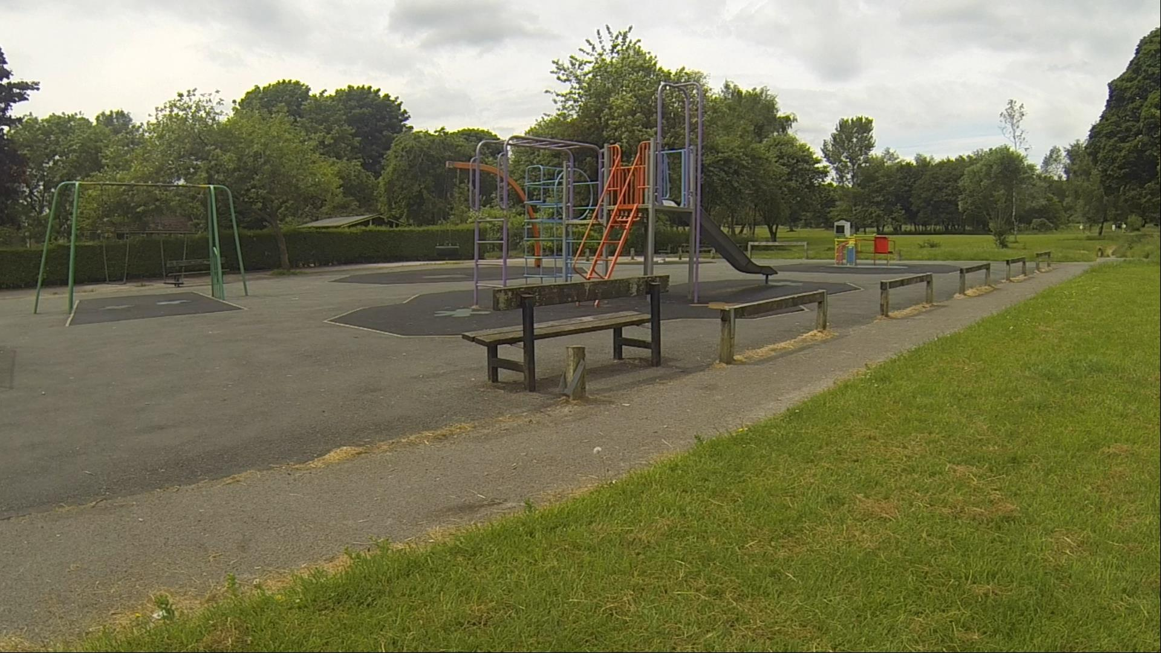
- Be still for a moment, take a look around.
- As you look at the play equipment it brings joy and happiness to those who are able to use it.
- When you were younger what was your favourite part of the play equipment you enjoyed the most?
- Think about the things in your life that bring you joy.
- How can you make sure you continue to do those things?
SPIRITUAL – In the Bible Jesus says, ”I have come that you might have life in all its fulness.” Think about the things in your life that are life giving to you?
QR Code

Walking “THE WAY” BEECHWOOD PARK Point 3
Point 3 – Bowling Green
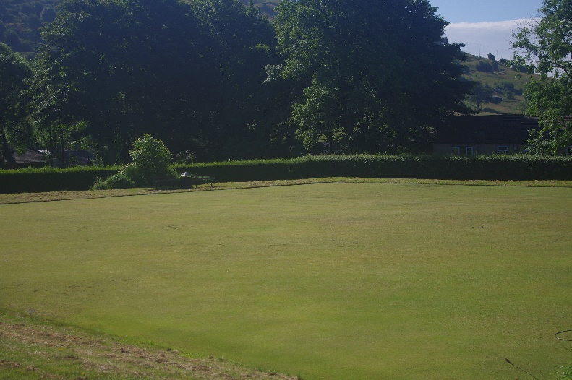

- Be still for a moment, take a look around.
- If the bowling green is not in use imagine the people who play bowls.
- Think about what playing bowls or any sport gives to you.
- Is there a sport that you might like to have a go at?
- How can you do this?
- What benefit have you had in the past from doing a sport or leisure activity you enjoy?
- Playing sport or doing leisure activities helps us to relax, keep fit, helps our mental health and helps us to belong.
- Recreation is good for our well being, or perhaps re-creation.
SPIRITUAL- How can you be re-created on a daily basis?
QR Code

Walking “THE WAY” BEECHWOOD PARK Point 4
Walk to Point 4 - Goal posts on Field
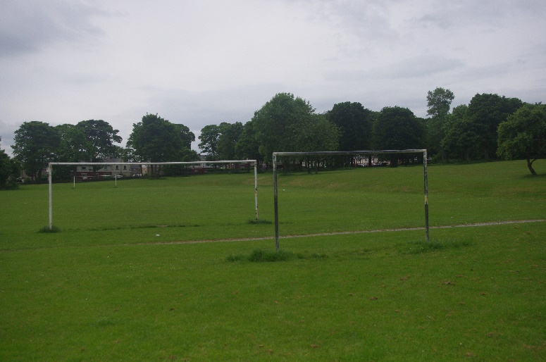

- Be still for a moment, take a look around.
- As you look at the goal posts think about what the aim of playing sport with goals to score in is.
- What dreams or goals do you have in your life that help give you motivation?
- How can you best achieve those goals?
- Do you need help with reaching those?
- Who can help you?

- SPIRITUAL – Think about God and Jesus and the Holy Spirit who are able to help you. Perhaps you might like to ask God for help with things to help you achieve your goals.
QR Code

Walking The WAY Beechwood Park Point 5
Point 5 - Exercise equipment
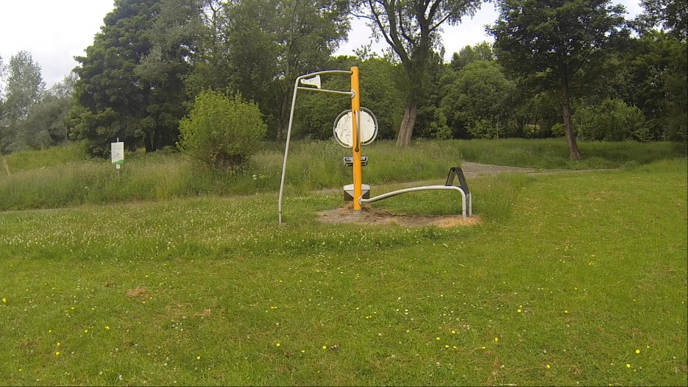

- Be still for a moment, take a look around.
- Think about this fitness equipment and what it represents.
- Think about What might stop you from using it?
- This equipment has been placed here to provide free fitness facilities for those who are not able or willing to pay gym costs
- What benefit do you think you will get from using it or doing other exercise with low costs?
- Think about how your wellbeing can be improved through exercise and being able to access it.
- SPIRITUAL – Sometimes there are barriers in being able to take part in things that benefit you. Perhaps you might like to think about God’s love for you and acceptance of you is unconditional and paid for through Jesus.
QR Code

Walking The WAY Beechwood Park Point 6

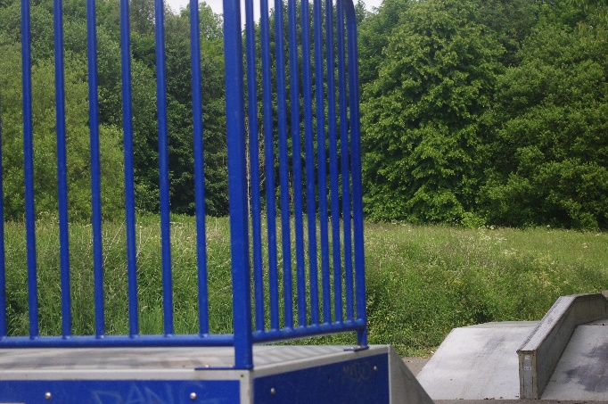
- Be still for a moment, take a look around.
- Think about the things that excite you or give you a bit of an adrenaline rush.
- Do these things bring fear or a nervousness that brings excitement?
- Think about the things that you are fearful of.
- Think about things that help you overcome those fears and anxieties.
- Do you have a ‘happy place’ or something you do that helps to refocus upon when you are fearful?
- Think about those experiences and those places where you return to some sense of normality and peace.
- SPIRITUAL – Perhaps you might like to ask God to bring a 0real deep peace into your life and situation. ‘Lord God, please let me know and have your peace.’
QR Code

Walking “THE WAY” BEECHWOOD PARK Point 7.
Walk up towards the Pond stop and look at the stream either on the left or further up on the right.
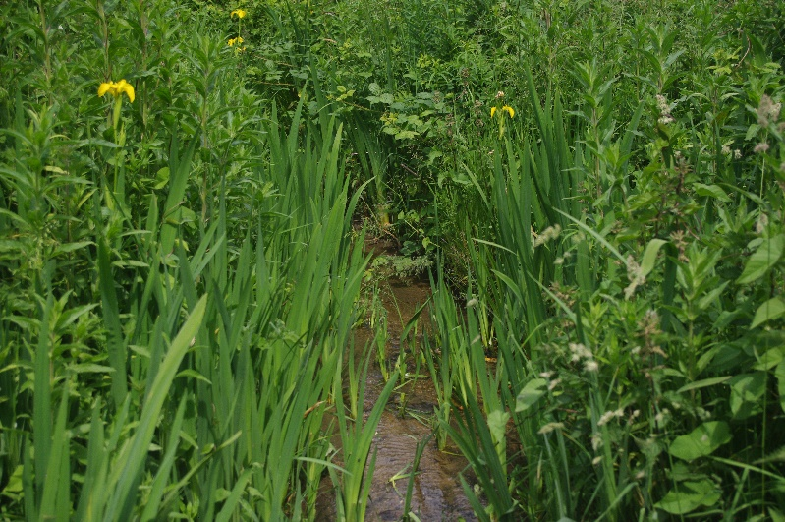
- Be still for a moment, look and listen to the running water
- As you hear the water running think about where it has come from.
- Think about where the water goes to.
- The water is on a journey taking things along with it. It also refreshes, it cleanses and it gives life.
- Think about the things in your life that this water represents. What gives you life?
- SPIRITUAL: Jesus once said, “I have come that you may have life and have it to the full.”
- Perhaps you might like to think of things in your life and if they refresh, replenish and give you life. Do you need more of Jesus to give you life?
QR CODE

Walking “THE WAY” BEECHWOOD PARK Point 8.
Walk to Point 8: POND
- Be still, look at the pond what you can see?
- What do you notice about this pond? Is it stagnant or flowing?
- Think about all the things that exist because this pond is here.
- Think about the micro-organisms that exist in here and how small they are and yet how important they are to the circle of life. They have an important part to contribute.
- Think about your own life and how important you are and what you contribute to the lives of others.
- SPIRITUAL - Perhaps you might like to think about how important you are not only to your family, friends and society but also to God.

QR Code

Walking “THE WAY” BEECHWOOD PARK Point 9.
Walk back down to the skate park and turn left along the path.
- Look around to find a bird nesting box.
- As you look around notice that you are looking upwards.
- By looking upwards what do you notice about what you can see?
- While you are looking for the bird boxes what else do you notice?
- Think about how often you walk around either looking down or not looking above eye level.
- Do you think you are missing something by just looking down or at eye level?
- SPIRITUAL – When we look around more intentionally, we see more things and become aware of so much more. Perhaps you might like to look and see if you can see something of God in creation, other people or in the world around you.
QR Code

Walking “THE WAY” BEECHWOOD PARK Point 10.
Litter Bin.

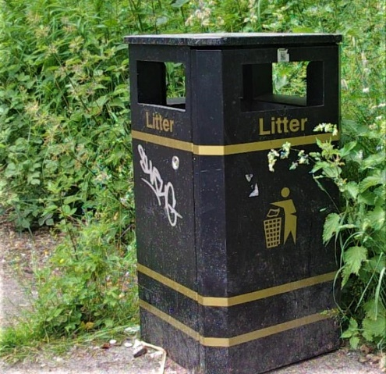
- Be still for a moment, take a look around.
- Think for a brief moment about the negativity that exists in your life. As you look at the rubbish bin imagine those negative thoughts and images being placed into the bin. Now your mind, body and Spirit are free to journey onwards.
- Now take a look around and take in the beauty, fullness of life and peace that exists in this place.
- Perhaps you might like to think about the environment and the small thing you can do to make a difference.
- Perhaps you might like to volunteer where you can help the sustainability and nurturing of life.
- SPIRITUAL – With God there is always forgiveness, love and the chance of a new start. Perhaps today you might ask God to walk more closely with you and have a new start.
QR Code

Walking “THE WAY” BEECHWOOD PARK Point 11.
END:
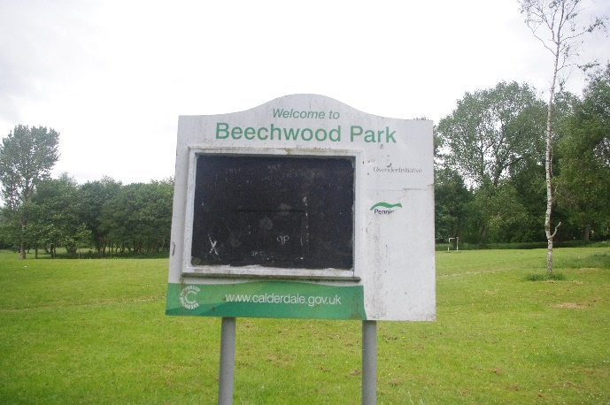
END

- Think about this short journey you have been on
- What did you like best?
- What positive thing are you going to try and achieve?
- Journey onwards home.
- SPIRITUAL – As you journey onwards from this place perhaps you might like to thank God for showing you things today. Perhaps you might like to ask God to continue this journey with you.
- Be blessed as you continue your journey through life.
© Calderdale Methodist Circuit 2021 Reflections by Rev Paul C Welch
QR Code

