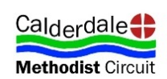
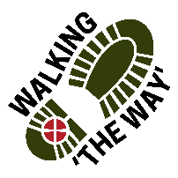 Walking The WAY 1 of 5

Canal Walk 3
START: Sowerby Bridge Market Car Park – Mytholmroyd
TASK: Pick up a stick for the journey 3.9 miles 1 hr 20min Approx
Lord as we take these steps on this journey, enable us to see you in the things we see, hear you in the things we hear and experience something of your presence and love as we journey on.
Walk 3 POINT 1: before TUNNEL
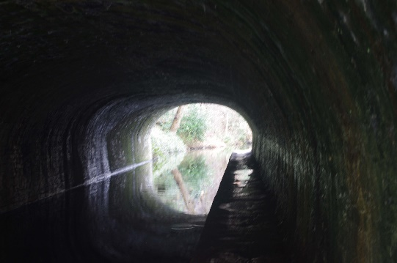
- As you enter the tunnel and walk through, think about what you see, feel and hear.
- OTHER SIDE of Tunnel Be still for a few moments.
- What did you feel like on entering the Tunnel?
- What were your thoughts while in the middle of the tunnel?
- As you exited the tunnel did your feelings change?
- Did your feelings change once out in the light?
- Think of times in your life when you felt the same way as when you walked through the tunnel.
- Appreciate and be thankful for experiences you have in life, good and bad, scary and joyous.
- Perhaps you might like to say Thank you to God for walking with you through those times.
- As you journey on think about what you have just experienced.
- MOVE ON!
Walk 3 POINT 2: Tunnel – Luddenden Foot 2 of 5
LUDDENDEN FOOT- Ball Sculpture
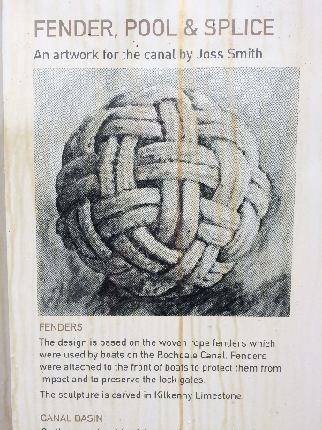
- Be still for a few moments.
- What things do you see?
- As you look at the sculpture, what does it make you think about?
- Think about what pieces of art/ sculpture have made an effect on you?
- How do you express your creativity?
- Think about the gifts that you have.
- Appreciate and be thankful for the gifts you have.
- Perhaps you might like to say Thank you to God for giving you the gifts you have.
As you journey on think about what you have just experienced.
MOVE ON!

Walk 3 POINT 3: INDUSTRIAL AREA 3 of 5
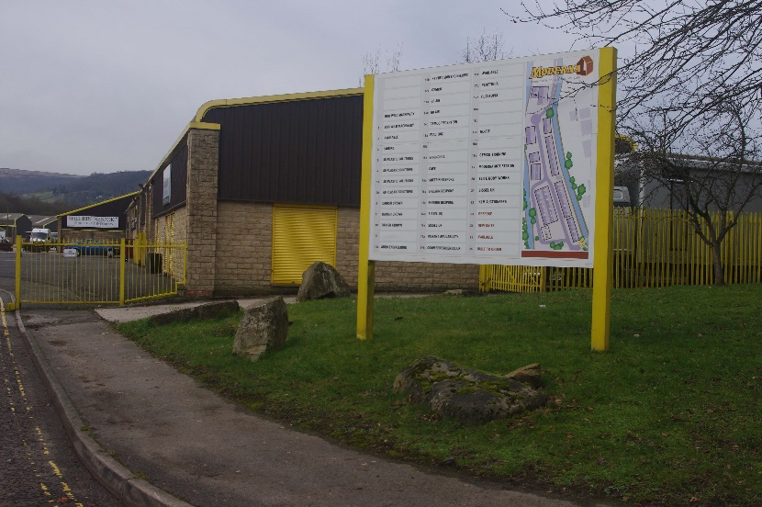

- Be still for a few moments.
- Take a look around and look at the businesses.
- What do you see being produced?
- Think about those people who run those businesses and provide work for their employees.
- Think about those employees and their families and how they are able to live because of their employment.
- Think about your job or former job and what it gave you.
- Appreciate and be thankful for that experience.
- Perhaps you might like to say Thank you to God for helping you and your family to have the things you needed and still need.
As you journey on think about what you have just experienced
MOVE ON!
Come off the Canal in Mytholmroyd and go to St Michaels Church

4 of 5
Walk 3 POINT 4 Mytholmroyd – St Michaels Church
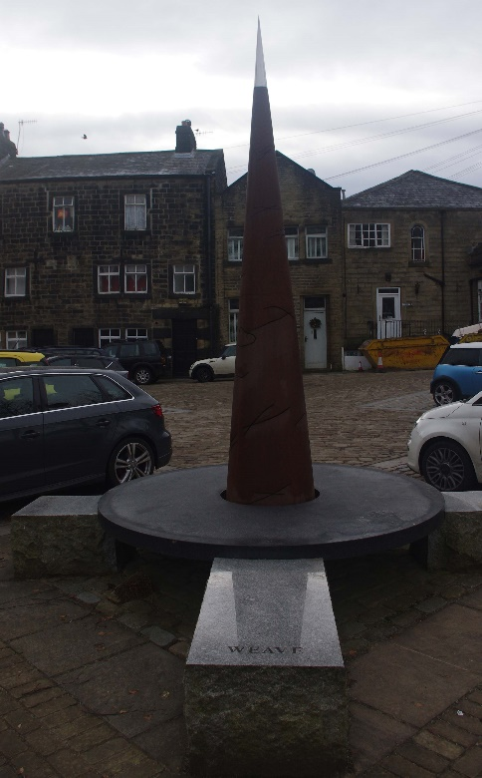
- Be still for a few moments
- Take a look around, what draws your attention?
- Take a look at the monument and the words around the side.
- What do those words say to you?
- What words best describe the emotions those words evoke within you?
- How do you use your words are they encouraging or destructive to others?
- Take hold of your stick you picked up along the way. Think of those times someone may have upset you by their words.
- Transfer that time in your mind onto the stick as you hold it.
- It is now time to let those things go. Take your stick and stand on the bridge and let it go and watch it go down the river out of sight.

5 of 5
End of the journey Liturgy:
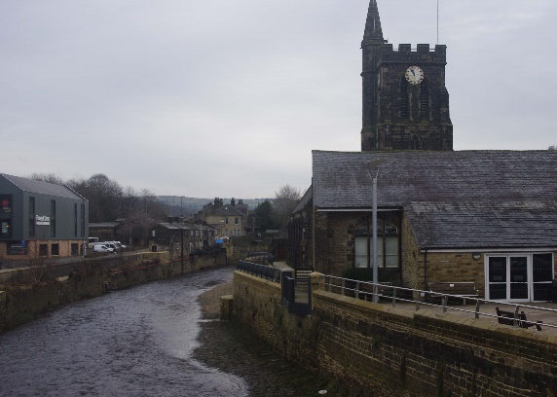
As we have let go of our stick into the river, we have also let go of the things that hold us back and carry with us that weigh us down.
Lord we thank you for all we have seen, heard and experienced along this journey and seen something of you and your creation. We thank you for those who have journeyed so far with us and have blessed us along the way. Amen
Be blessed as you journey home.
COFFEE? – Take Out can be bought from Jo’s Kitchen across road from St Michaels on bridge.

