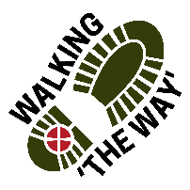 Walking The WAY 1 of 6

CANAL WALK 5
Hebden Bridge (Hebden Royd Methodist Church) – Shaw Wood Road, Todmorden OL14 6DB
TASK: Have your KEYS with you. Along the journey look for things that you might need a key for.
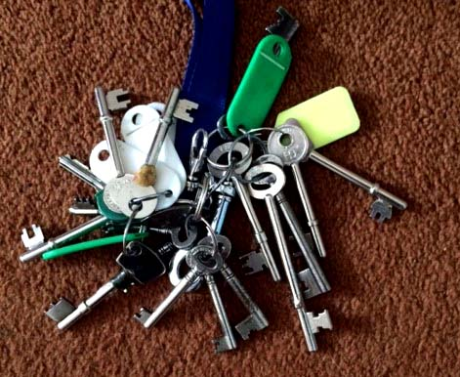
Lord as we take these steps on this journey, enable us to see you in the things we see, hear you in the things we hear and experience something of your presence and love as we journey on.
Walk for 10 minutes Approx.

POINT 1: Stubbing Wharf 2 of 6
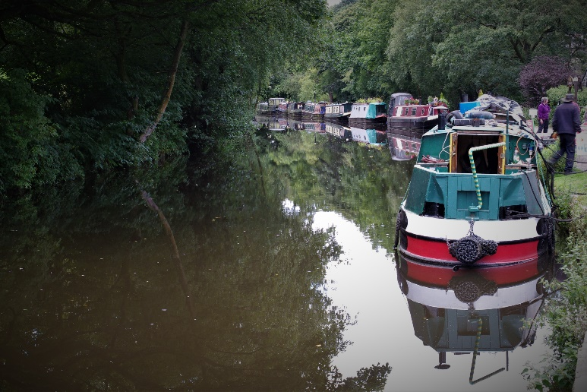
- Be still a few moments
- What do you see?
- The Stubbing Wharf Pub also does narrow boat trips, have you been on a narrow boat? If yes, what do you remember about it. If no, what do you imagine it to be like?
- The narrowboat offers a different form of travel, think about the calmness and peace this brings as you travel along at a slower pace.
- Do you think you notice more when travelling at a slower pace?
- Appreciate and be thankful for the experiences that help you have a slower pace of life.
- Perhaps you might like to say Thank you to God for giving you opportunities to slow down.
MOVE ON! Walk for Approx 10 minutes

3 of 6
POINT 2: TURNING AREA below Rawden Mill Lock No. 12
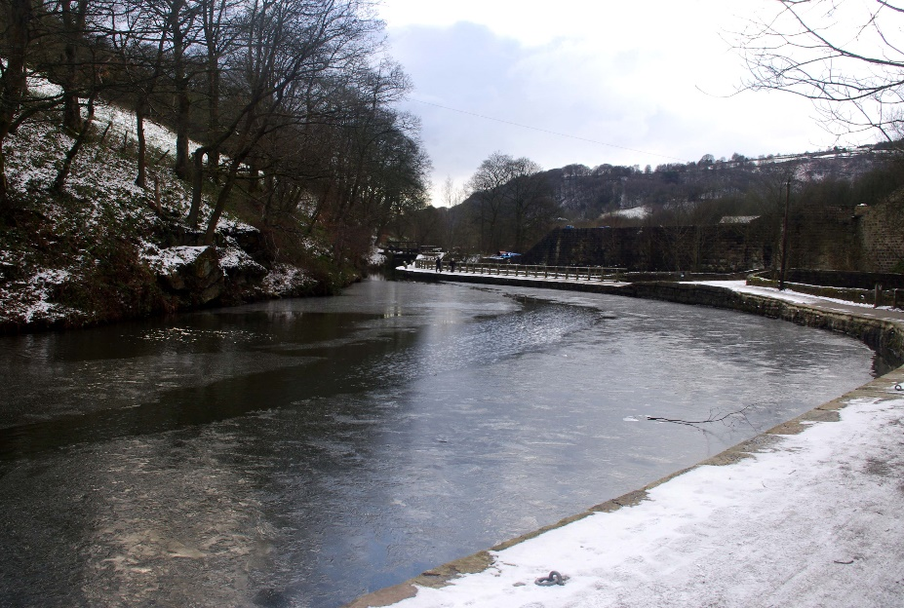
- Be still a few moments
- Take a look around. What do you see?
- This is a wide area along the canal that enables the boats to turn around or wait to go through the lock. Think about times you have been waiting. Do you find it easy to wait?
- Do you find it easy to wait and contemplate or do you feel you want to rush on?
- When things don’t seem to be moving forward, how does this make you feel?
- At these times do you think you should embrace the waiting time and accept it as a gift?
- Appreciate and be thankful for the experiences that help you have a slower pace of life.
- Perhaps you might like to say Thank you to God for giving you opportunities to slow down.
MOVE ON. Walk approx. 5 minutes to Boat Community

POINT 3: BOAT COMMUNITY 4 of 6
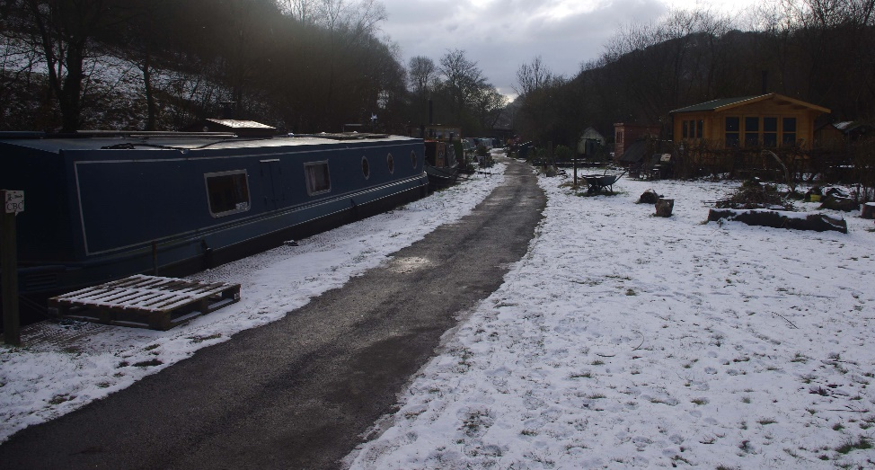
- Be still a few moments
- What do you see?
- Think about this community here and the different lifestyle choice these people have made.
- What communities are you part of?
- Think why you are part of those communities?
- Think what lifestyle choices you can make to give you a sense of peace and fulfilment.
- Appreciate and be thankful for the communities that you are part of that bring you peace and contentment.
- Perhaps you might like to say Thank you to God for giving you opportunities to be part of such a community.
MOVE ON to Forest School

POINT 4: Tinderwood Trust Forest School 5 of 6
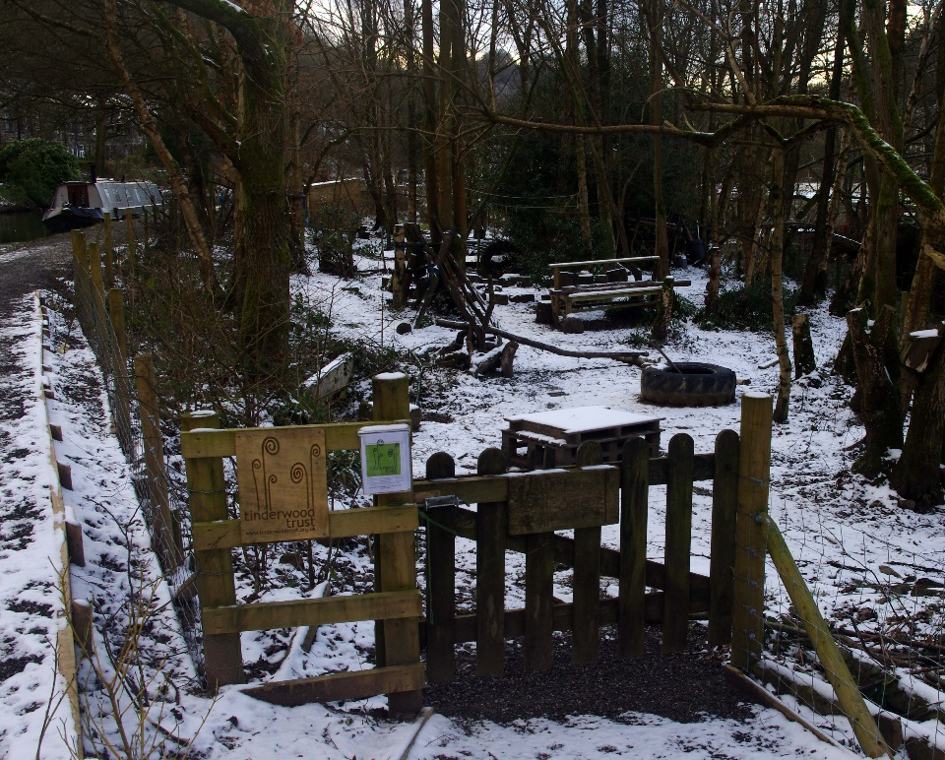
- Be still a few moments
- Take a look around. What do you see?
- Think about what takes place in this special space.
- Think where do you learn, develop and grow best?
- Think about what things enable you to learn, grow and develop?
- Appreciate and be thankful for the experiences that help you develop and grow.
- Perhaps you might like to say Thank you to God for giving you opportunities to learn in a way that suits you best.
MOVE ON. Walk to Lock at Shaw Wood Road. Lock 15

Shaw Wood Road Todmorden OL14 6DB 6 of 6

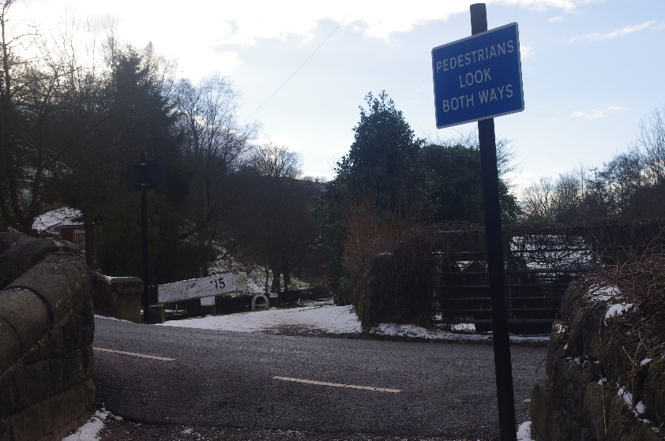
End Liturgy
- What things did you notice that you needed a key for?
- What do our keys allow us to do?
- What keys do you have that enable you to open and explore new journeys and experiences?
- Could you be a key for someone that helps them open up their spirituality, knowledge or experiences?
Lord we thank you for all we have seen, heard and experienced along this journey and seen something of you and your creation. We thank you for those who have journeyed so far with us and have blessed us along the way. Amen
Coffee: Turn right onto Shaw Wood Road and then left on Main road towards Todmorden. There may be a van in a layby 300 yds where you might be able to get a drink from.
Safely Travel home and be blessed.

