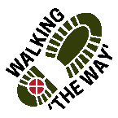 Walking the WAY Scammonden February 2022
Park at Wood Edge Car Park off Low Platt Lane.
Starting from Wood Edge car park walk towards the motorway (reservoir down below on left) onto a surfaced path. When the path forks follow the left one until you reach a fairly steep path heading downhill.
Follow this path as it zigzags downhill almost to the waters edge. Where it levels out (at Point 2 on map.) Turn left onto a permissive path running parallel to the shoreline with the reservoir on your right. When you get close to the Sailing Club you will see a sculpture which says ‘The Tree Planter’.
REFLECTION POINT 1– The TREE PLANTER
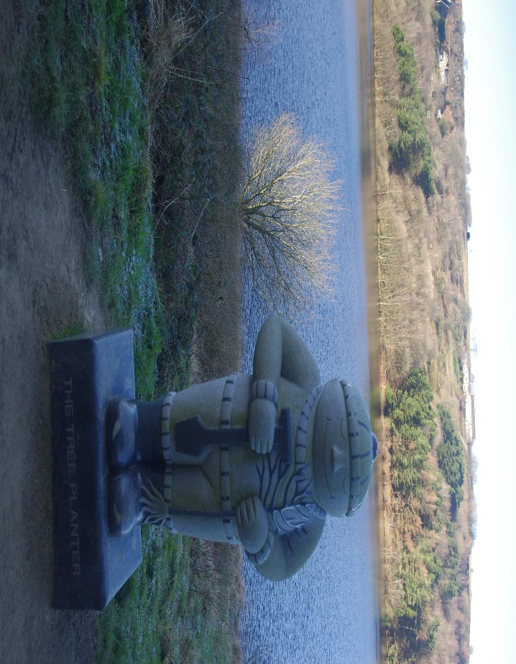
- As you look at the sculpture what does it make you think of?
- Now think about trees and what they do for the environment?
- As we think about them taking in Carbon dioxide they release oxygen into the atmosphere how does this make you feel?
- What are the things that you give out that makes a difference to others?
- Be thankful for the things that give you life.
SPIRITUAL- Like the tree taking in the bad things and giving out something good and beneficial, when Jesus died on the cross he took all of the wrong things in our lives and gave us forgiveness, new life and life in all of its fullness. How does this make you feel?
Journey on.
Follow the path to the sailing club. The path bears left up a steep short incline. At the Top go through the gate and go right.
As you catch your breath take a look over the fence at the well down below.

REFLECTION POINT 2- WELL
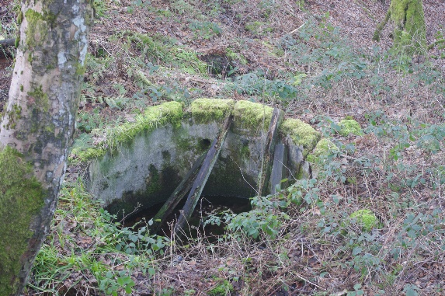
At the last reflection point we thought about the things that give us life. Wells are important to communities where there is not much water and so are life giving to those people in those communities.
- Think about wells. What do they provide?
- Wells need to be constantly fed and replenished from a source like a natural spring. Think about where you are fed and replenished to help you live?
- Be thankful for those places or people.
SPIRITUAL- Do we think at times that our lives are dry and we thirst for many things like peace and contentment. Jesus once came across a woman who was drawing water at a well. She asked him for ‘Life giving water’. Are you aware that Jesus offers us that too. Perhaps you might like consider asking for that if you feel your life needs refreshing.
Journey On.
Now follow the path down with the fence on your right and down to the sailing club Access Road.
At the bottom turn left on the Access Road and then take the first right. This will take you down towards the water side.
Near the bottom of the slope, turn left on the path with the reservoir now on your right. Follow the path until you see a ‘fish’ sculpture.
REFLECTION POINT 3 – FISH Sculpture
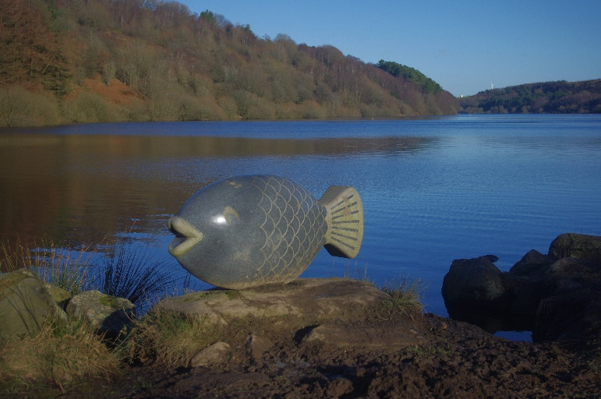
- Have you ever heard the saying, ‘I feel like a fish out of water’?
- Have you ever felt like that?
- Sometimes we feel like we don’t fit in or like we don’t belong or that we stand out from the crowd. Can you think of any instances where you have felt like that or you have noticed others feeling like that?
- What happened? Did anyone make you feel welcome or at ease or did you do that for someone else?
- If you have ever seen fish jump, or salmon work their way up a stream or seen dolphins or whales leap into the air how does that make you feel?
- Sometimes we need to be a fish out of water to make a difference or to enable something amazing to happen. How does that make you feel?
- Think about those times when you have felt good about something you did even though it seemed hard to think about doing initially.

SPIRITUAL- FISH
Jesus spent some of his time around lakes, fishermen and fish and some pretty amazing things happened.
On one occasion he told his fishermen friends where to drop their nets to catch a haul of fish which they did. Have you ever felt guided by God (Jesus or the Holy Spirit)? Think about what happened when you followed the guidance given.
Journey On.
Continue on the path with the reservoir on your right to the head of the reservoir. Passing through two gates close to each other (Don’t go over the bridge in between the gates this is for cattle only). Shortly after going through the 2nd gate the path forks. Go right onto the bridge.
Cross the bridge and gather on other side if other people are around make sure you can see the bridge and water flowing under.
REFLECTION POINT 4 – BRIDGE
- You have just crossed a bridge, think about what do bridges do?
- Did you have to think much before crossing the bridge?
- Have you ever crossed a bridge that was really high or looked a bit uncertain? How did you feel?
- Sometimes there has to be the first step taken in order to get to the other side. Have you ever taken a risky step to do something that enabled you to move on?
- Look back at the bridge and the steps you took to cross it. You had to take one step at a time. Think about your life and steps you have taken to get you to this point where you are now.
- Be thankful for those steps but also those who may have helped you or held your hand as you took those steps.

SPIRITUAL- BRIDGE
Imagine we are one side of a great chasm and God is on the other. There is no way we can cross the chasm by ourselves and so God sent Jesus to be the bridge to help us get to God. Like crossing the bridge, we have to be willing to take the first step in trust and faith. Have you taken that step? Think about what happened. If not, what is stopping you from taking that step?
Journey On
Shortly after the bridge follow the path on your left (it misses out the steps which you can take instead) and it will double back and so continue with reservoir on your right until you meet a tarmac ramp and Cycle path in front of you by the Motorway. Just before the motorway bear right and follow the track with the picket fence on right and motorway on your left. Stop part way along with the motorway on your left and reservoir on the right.
REFLECTION POINT 5. MOTORWAY- RESERVOIR
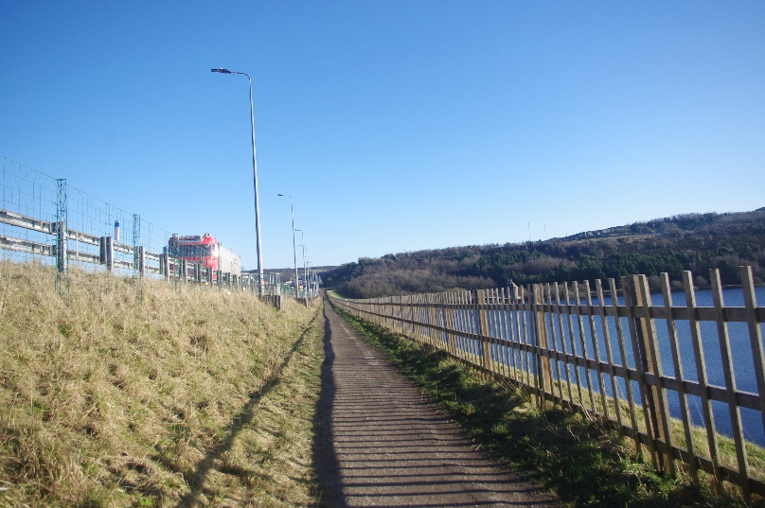
Stand with your back to the motorway and look out across the reservoir.
- What do you notice?
- Do you feel any sense of contrast? The noise of the motorway and the serenity and peace of the reservoir.
- Sometimes noise can be a distraction so for a few moments cover your ears to block out the noise and again concentrate on the water.
- How different is this experience?
- What does this experience make you feel like?
- While the world rushes by it is good to stop, think and focus on the things that give calmness and peace. How do you do this?
SPIRITUAL
- Think about in the busyness of the world we hear behind us. Where is it you go to, to be at one with creation and the Creator?
- How do we cope with ‘being in the world, but not of the world?’
- How do we find peace and contentment in a world that shouts to get our attention.
JOURNEY ON
At the end of the fenced path turn right and retrace the first part of the walk back up the zig zag path to the car park.
Lord God thank you for journeying with us today. Amen.

