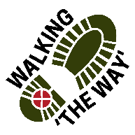 Judy Woods
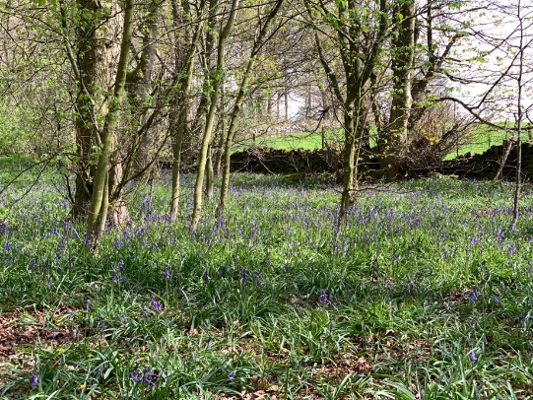
The walks around and through Judy Woods are delightful at any time of year.

Getting there and parking

Judy Woods is located at Wyke, south of Bradford just off the A641 Huddersfield Road on Station Road opposite Green Lane. Take the A641 heading towards Bradford, turn left immediately before the zebra crossing onto Station Road. Roadside parking on Station Road – no charge. Entrances to the woods are beside the roadside. The walk begins at the right hand entrance.

Other information
Walk length 2.5 miles.
Dogs to be kept on lead.
Toilets only available in the local pubs – The Old White Beare and The Pear Tree.
Before you begin make sure you have the right footwear, equipment (poles if needed) and clothing. This woodland walk can be muddy in places, with one set of steep steps to climb and roots are exposed in places.

Route Details

Enter the woods via the kissing gate and follow the path ahead bearing right. Leave the main path as it bends sharply left, to turn right following a path. After 10m take a path off to the left.

Follow this path down some steps to cross a stream and rise on some steps beyond. The path then veers right following the boundary line of a field. Continue past the corner of the field to cross a series of footbridges.

Reflection 1 – Footbridge
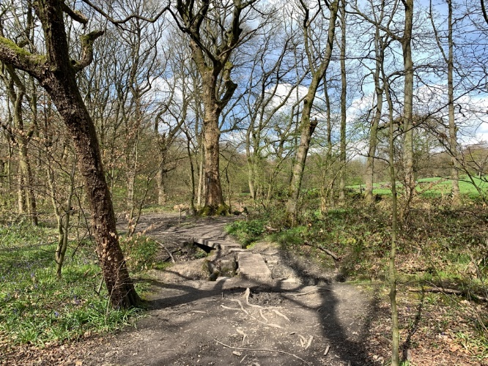

REFLECTION:
- Be still for a few moments, slow down your breathing and take in the views around you.
- What do you notice? What grabs your attention?
Before you, you can see a simple bridge crossing. This is just a simple structure that enables you the walker to continue on your journey easily and safely.
Perhaps if you were just walking through the woods you may not even recognise it being there and not give it a thought.
- What are the simple everyday things in your life that you might take for granted?
- What things in your life make your life easier than if it wasn’t there?
Perhaps you might like to give thanks for those things or those people who help you on life’s journey.

SPIRITUAL- Think about times in your life where you have been blessed by a gift or by the help of someone out of the blue.
Perhaps you might like to give thanks to God for providing the help and support we have in our lives.

JOURNEY ON.

Continue on the path following the border of another field (this can be muddy).
On reaching a clearing circled by several trees, bear right (following a field boundary). Press on to reach a metal fence bordering Royds Hall Lane.
Pass through the fence and turn right, then after only 8m turn left through a gap in the wall to join a woodland path. Progress ahead on this path as it rises slightly and continue ahead passing a path to the left (can be boggy in middle).
The path continues ahead up a short steep mound to then rise progressively. Follow the path as it arcs left and uphill (fields on right).
Continue on the path as it winds to the perimeter of the wood and a field wall on the right. Progress to the corner of the field and wood to reach an old metal barrier (on left). DON’T go onto the lane, instead take the hairpin left turn down an obvious track and stay within the track boundaries.
As as you start down the path look out to the right at a clearing to see over the fields and to the Pennines in the distance.

Reflection 2 – Field and Pennines
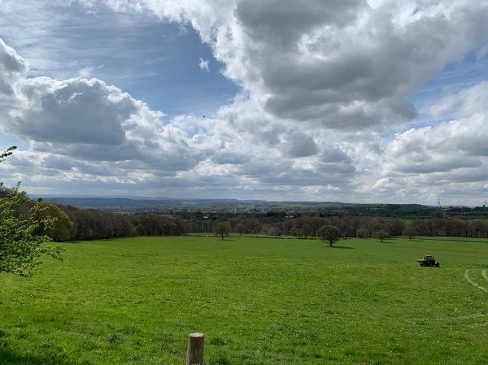

Stop for a moment and take in the views.
- How far can you see? What is the furthest thing away you can recognise?
- Now look at something really close by. Think about what that might look like under a microscope.
- If we had binoculars, a telescope or a camera with a long lens on it we might be able to see something further away and clearer.
- Look again at the thing you first noticed, this time either kneel down or sit down if you’re able and look again.
- How has the view changed? Can you now see something completely different?
Sometimes when we stepback from a situation and get a different perspective or if we look through a different lens or view point we may see something very different.
- Over the past few years have your views changed because you have seen something from a different point of view?

SPIRITUAL- For some people they can see God through the lens of the Church only. However being out in creation, or sharing a meal and conversation, or being shown kindness may help us to see God differently.
Has your view of God been helped by looking from a different perspective?

JOURNEY ON.

Continue down the lane (woodland path runs parallel and eventually joins the lane) with fields on the right. The lane becomes walled and continues past the corner of a field, the lane then broadens.
Continue on the lane as it bends left to meet a junction with another lane.

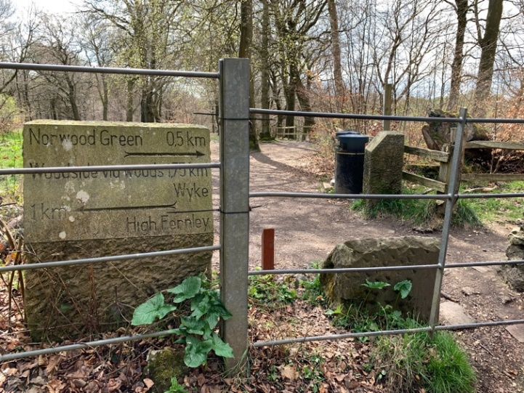
Reflection point 3 – Way markers

Take a look around. What do you notice?
Take a look at the way markers which give an indication of which way to go and how far away each place is. They give helpful guidance on a journey which may be planned or not.
Perhaps you have been guided through your life, perhaps not with physical marker posts like these but in the form of people or through some form of learning or elsewhere.
If we want to know the way to go or how to get somewhere now adays we have Google maps, or other ways to help us.
- Think about the people or things that have helped to guide you on your life so far.
- Take a look behind you and notice where your footsteps have come from and the steps you took to get to this point here. Think about the conversations or thoughts you have had so far today and look at those with whom you are sharing the journey with.
- All of us have had companions on the journey through life and they will have helped to guide us and show us the way at times and hopefully we have likewise helped them at times. Give thanks for those people who have guided us on our life’s journey.
SPIRITUAL- On one occasion Jesus says to his disciples, you know the way where I am going. One of the disciples responds with, ’We don’t know where you are going, how can we know the way?’ Jesus replies, “I am The WAY, The TRUTH and The LIFE.” Think about what this might mean to you.
JOURNEY ON
Turn right down the lane signposted ‘Norwood Green 0.5km’. On reaching the bridge turn right down some steps to walk above a stream to the left.
Cross the footbridge and bear immediately right up the stairway. Climb to the top.

Reflection point 4 – Top of stairway
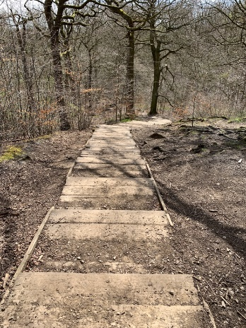

While you get your breath back notice your breathing how it is longer trying to take in more oxygen with each breath.
- As you breathe in and out look back at the steps you have just climbed up. How do you feel about getting to the top?
- Were you anxious to get to the top as soon as possible or did you take it nice and steady?
- If you took it slowly what did you notice around you as you journeyed?
- Think back at the times when you have had to slow down either through illness or injury when you could not do what you normally do at living a fast pace.
- Do you think living at a slower pace is more beneficial?
- Do you think you notice more and take the environment in more?
- As you stand at the top of these steps having stopped and your breathing has a more natural rhythm what do you now notice?
- Do you prefer time to just be or would you prefer to be rushing around?
- When do you get your slowing down time?
SPIRITUAL- On many occasions Jesus went off by himself to have some quiet time, to think, reflect and pray. Where are your ‘top of the step’ places where you need to just slow down, take in the views and just be?

JOURNEY ON
Continue ahead and as you reach the wall at the intersection of the fields, turn right. Walk down with the wall to the left and through a kissing gate. Press ahead following the edge of the field (wall and fence to the left) and through the wide gap in the wall. Rejoin the walled lane by turning right.

You are back at the three waymarkers. Proceed ahead through the gap in the fence. Take the right hand path (signposted 0.5km Station Road Wyke) beside the wooden fence. Follow the path as it veers left on the shoulder of the hillside for some time and continue to follow over a wooden footbridge.

Reflection 5 – Tree roots
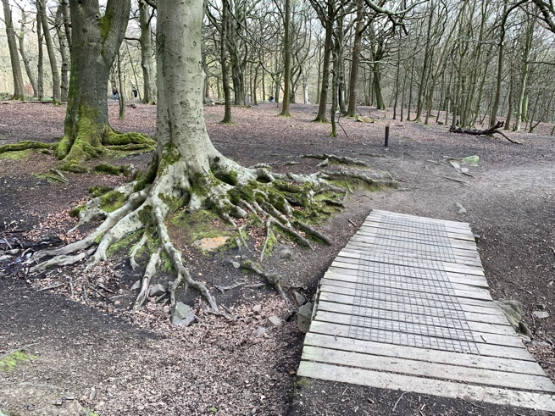

Take a look around what do you notice?
Look at the tree roots and think about how far down they might go in order to keep the tree stable and providing it with the nourishment and minerals it needs to grow.
- Where are your roots? What are the things in your life that keep you anchored and sustained?
Notice the bark on the tree and notice how the bark gives this tree a uniqueness from others. It may be a similar species of tree but will be unique from any other through its bark and branch spread and leaf spread. Now look at your fingerprint and recognise your uniqueness.
- We are all human beings, but what makes you unique from anyone else?

SPIRITUAL- We are all made in the image of God as human beings and yet we are all unique and different in some way. Just like the trees in this wood some are similar some are very different but they are all trees and created and cared for by God. Do you know that you are loved, that you are unique and special to God just like everyone else?
Perhaps you might like to think about that for a short time.

JOURNEY ON

The path continues then veers right (streams to left and right), progress along the path until you reach and cross a stile onto Station Road. The start point is up to your left.

