WALKING The WAY Sowerby Bridge – Mytholmroyd 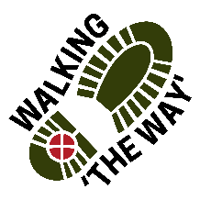
Start in the Market Place and follow the Rochdale Canal (on your right) and continue under the bridge. Carry on until you come to a tunnel.
POINT 1 TUNNEL
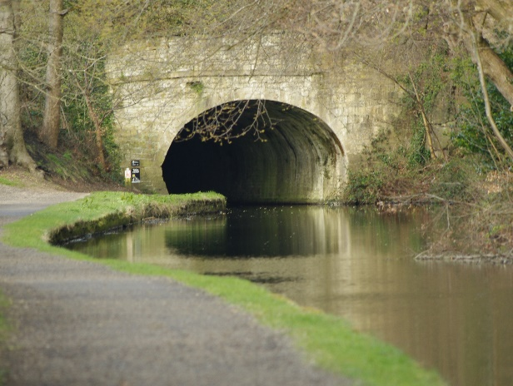
- As you enter the tunnel and walk through think about what you see, feel, hear.
- OTHER SIDE Be still for a few moments.
- Think about what you just experienced
- What did you feel like?
- As you exited the tunnel did your feelings change?
- Did the journey through help being with other people being present?
- Appreciate and be thankful for experiences you have in life, good and bad, scary and joyous.
- Perhaps you might like to say Thank you to God for walking with you through those times.
- MOVE ON continue towards Luddenden Foot woodland on left and old buildings on right.

POINT 2 Dilapidated building
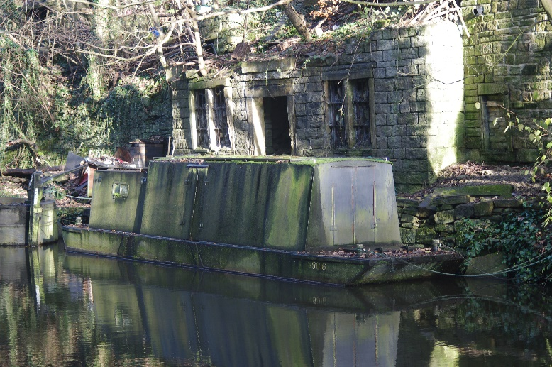
- Be still for a few moments
- What do you notice?
- Look at the building before you which is dilapidated and worn out. What would you do to help make this space livable again?
- Think about what resources you would need?
- Sometimes in life we become tired and worn out, what do we need to help us to have life again?
- Think about what resources you would need and where you get them from.
- Be thankful for those things that help us to live
- MOVE ON a short distance with the Park and car park on your left.

POINT 3 LUDDENDEN FOOT- WOOL BALL
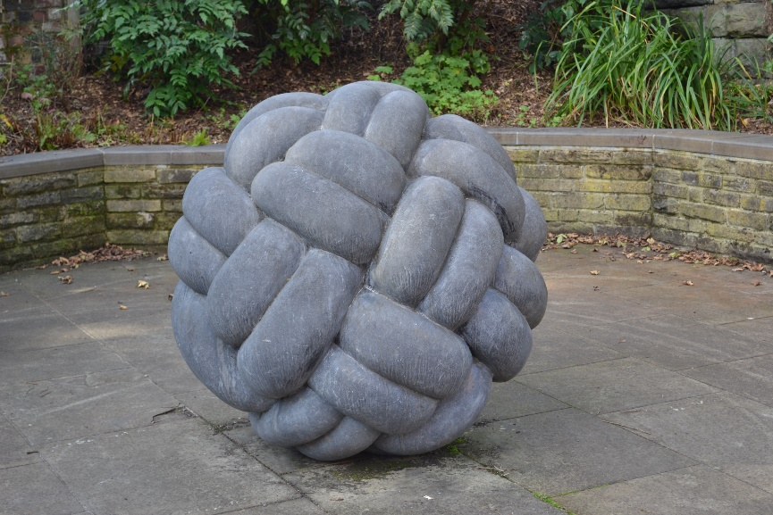
- Be still for a few moments.
- Take a look at the woolen ball sculpture and think about what it says to you.
- Think about the past industrial heritage and history of the area in which you are walking.
- Consider the conditions of those who worked in the heavy woolen industry or cottage industries and what they endured.
- Think about the harsh conditions in which these people found themselves living in.
- READ: Matthew 6:25-26 “Look at the birds of the air; they do not sow or reap or store away in Barnes, and yet your heavenly father feeds them. Are you not much more valuable than they?
- Think about that passage as you hopefully see the ducks/ geese. Think about how God has provided for you.
- Appreciate and be thankful for those things you have as you have considered what the people in the past have had.
- Perhaps you might like to say Thank you to God for giving you all that you need.
- MOVE ON to the Bowling Green on your left.

POINT 4: BOWLING GREEN
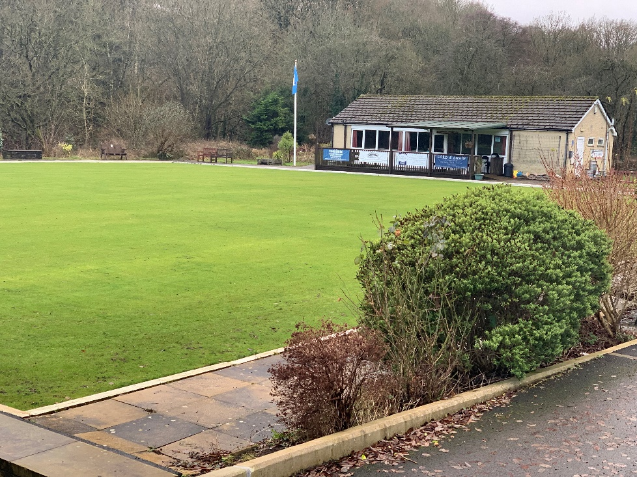
- Be still for a few moments.
- Take a look around and look at the bowling green and clubhouse and the canal.
- Think about your leisure time, what do you do to relax or switch off?
- Think about how important and valuable it is to have this time.
- Be thankful for those places where you can go and do something you enjoy and which gives you life.
- Think of and be thankful for those who you share that time with.
Return back to Sowerby Bridge along the Canal with it on your left.
At the end of the journey Liturgy
Lord we thank you for all we have seen, heard and experienced along this journey and seen something of you and your creation. We thank you for those who have journeyed so far with us and have blessed us along the way. Amen

