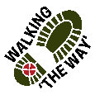
Skircoat Green Circular
Getting there and parking
Start the walk at the Standard of Freedom public house, New Lane, Skircoat Green, Halifax. HX3 OTE.
Parking - Street parking on New Lane and Dudwell Lane near the start of the walk.

Other information
Walk length 2.5 miles
Circular walk
Moderate Ability – gradual pull uphill through two woods, flagged steps and cobbled path.
Walking boots and poles are advisable - as we will be walking through two woods with tree roots, flagged steps and a cobbled path on an incline.
Standard of Freedom PH may be open for refreshment/toilet facilities at the start and end of the walk.

Opening Prayer: As we walk along on this journey together, may we be mindful of all around us, may we see God in the beauty where we walk and in those who accompany us along The WAY. Amen

Route Details and reflections

Starting at the Standard of Freedom PH on New Lane, HX3 OTE, with the pub on your left walk along New Lane.

Half along New Lane you will see a gap in the wall leading down to a stone stairway into the woods (Long Wood).
Stop at the top before going through the stile

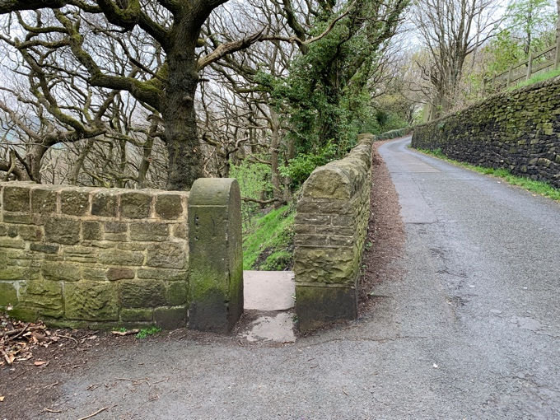
Reflection (0.5miles)

- For a few moments close your eyes and listen, what can you hear?
- As you readjust your eyes what is the first thing you notice?
- On many walks you will notice stiles of many different structures and built of many different materials. Think about those different kinds you have come across in your wanderings.
- Think about why there are stiles and what their purpose is. Stiles are to allow access but only those who can fit through them or able to go over them, they stop bigger animals from escaping their enclosure. What obstacles or things in life that at times prevent you from continuing your journey through life?
- Think about going through stiles with a backpack on, sometimes you have to take it off to get through. Perhaps you might like to think about the backpack weight of the world we carry that we need to take off in order to continue on our journey.

Journey on

Continue down the path into the wood.
At the crossroads of the path, turn right.

Reflection (1 mile)
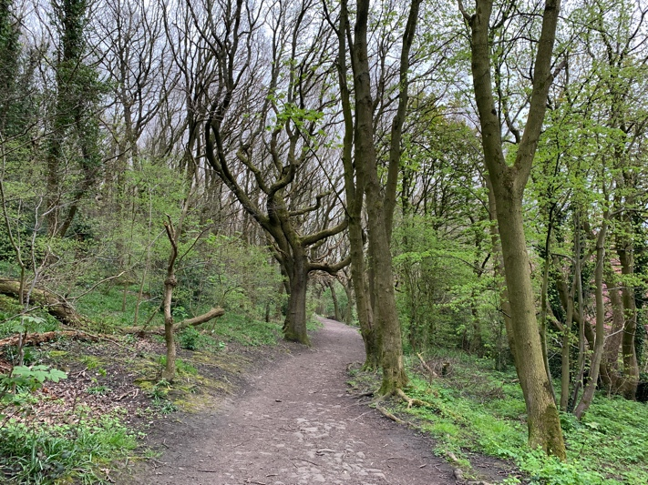
- Stop for a moment as you reach the road. Look back into the woods to see where you have been.
- On our journey through life we leave a footprint of the places we have been, perhaps our footprints will be along a similar path to others whom we have shared the journey through life with. Who have been our companions on the various journeys we have taken, perhaps in a moment of quiet you might like to give thanks for them.
- We do leave footprints through life as a mark of where we have been and what we have seen and experienced. Nowadays you might take a photo on your phone of a special or beautiful place you have been. Give thanks for those places of awe and wonder where we have spent a moment looking at The Creators handywork.
- At different times of the year we will experience something of the wonder of creation whether it be a carpet of bluebells on the woodland floor, the life giving buds on the trees or the golden colours of autumn. Be still for a moment and take in the experience of being part of creation.

Journey on
Exit Long Wood, cross the road bearing slightly left to take a path into the woods, passing through the wall on the opposite side of the road (pass to the right of the Scar Bottom road sign).

On reaching the crossroads in the path progress straight ahead (it bears slightly left).
On reaching a steep cobbled pathway progress up the hill passing Wood View Cottage on your left hand side.
Alternatively if you cannot take the steep incline you can take the right turn along the path that runs parallel to Albert Promenade
As you leave Scar Wood turn right along Albert Promenade (a broad flagged pathway)

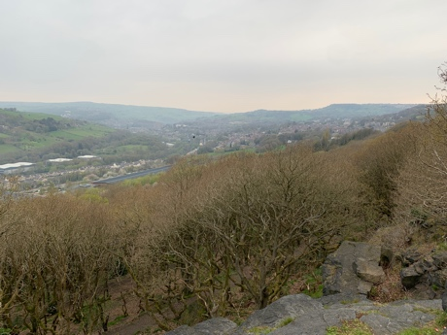
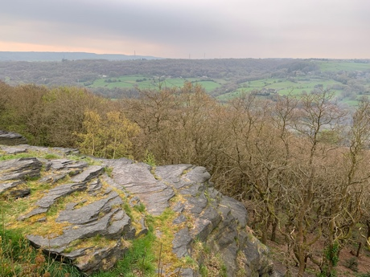
Reflection

- Be still for a moment and take in the view.
- Close your eyes for a moment and then open them, what do you notice first?
- Our eyes enable us to see the wonder and beauty of creation where was the last time you remember seeing a memorable view?
- Our eyes help us to watch things and help us to experience things. Think about a memorable thing you have seen and experienced with your own eyes?
- Our eyes also help us to see the tasks we do or help us to see creativity and bring something creative to life. Give thanks for your eyesight and all that it enables you to see and do.
- On one occasion Jesus made some mud and placed it on the eyes of a blind man who was then able to see, think about how he must have felt, suddenly being able to see everything around him for the first time.
Thank God for the everyday things we often take for granted.
Journey on

On reaching the bollards turn left into Rocks Road

Look down at the Cherry Blossom trees down Kensington Road.

At the end of Rick Road, cross Dry Clough Lane to enter Saville Moor Park. Head towards the lodge, fish and chip shop, diagonally to your right, towards Manor Heath Park. Pass New Lodge Fisheries to your left. Head towards the left hand corner of the wall straight ahead and downhill

Continue to pass the corner of the wall and progress to enter Manor Heath Car Park.
At the finger signpost bear left to follow the Wildflower walk. Then, as you progress, take the stone stair way to your right.

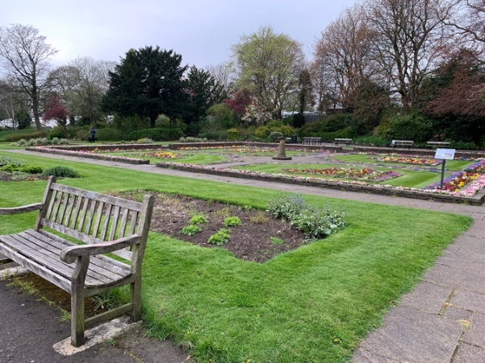
Reflection

- Take a look around
- Think about the space you are looking at what does it provide?
- Think about green spaces and what they do in helping the environment.
- Think about the eco-diversity that goes on with the grass, flowers, trees, insects and birds.
- There was a phrase ‘giving nature a home’. Think about what you do or can do that encourages wildlife to thrive and flourish in your locality.
- Sometimes we need to give a helping hand by having bug hotels, bee houses, nest boxes, bat boxes bird feeders around our gardens or small spaces. What do you do that encourages life to flourish in your garden?
- Where are the places you go to, that help you flourish?

Journey on

Continue down the path towards the children’s play area, progressing to the bottom right hand corner of the park, to exit the park.

Exit the park and turn right into Skircoat Green road.
Cross Dry Clough lane and continue along Skircoat Green Road.

At the triangle, turn right up Dudwell Lane to return to the Standard of Freedom PH.

