Ogden water Circular Walking The WAY Dec 2023 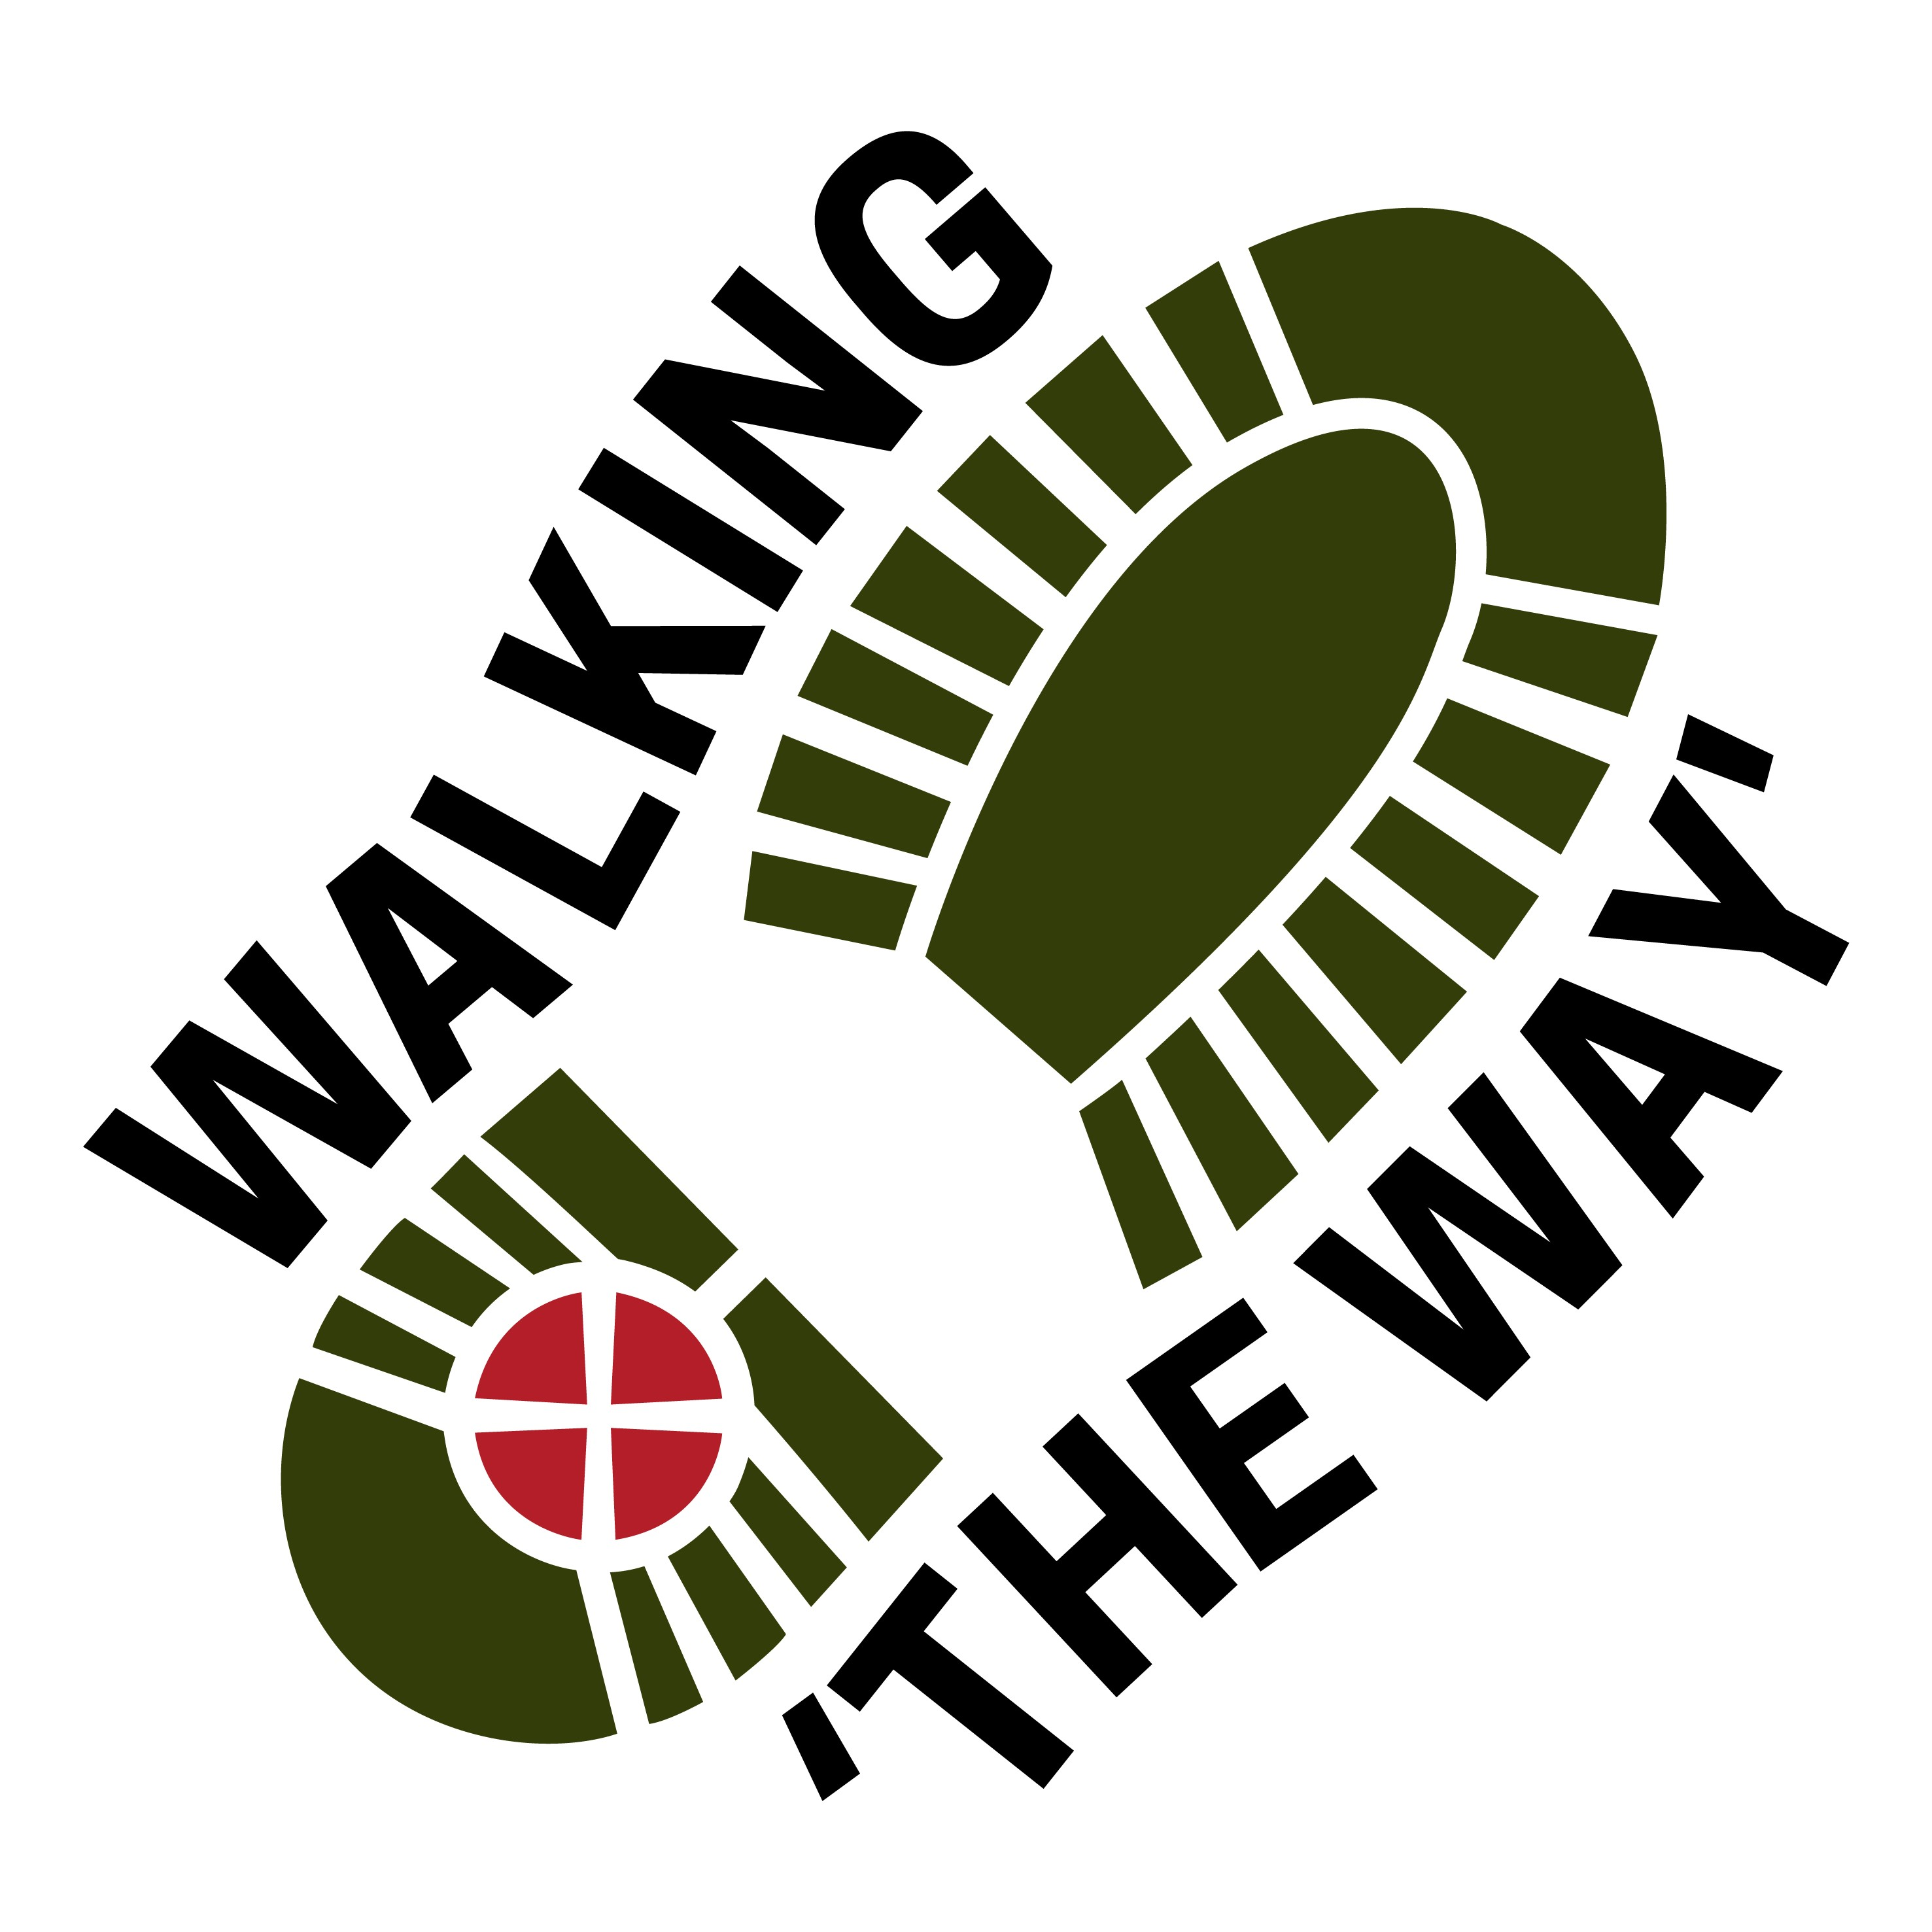

This walk was originally done in Advent. Perhaps as you walk you might think about the journey that Mary and Joseph took to Bethlehem about 100 miles.

Start the walk on Keighley Road just past the Moorlands (on right) and just before Rocks lane (on left).
Go across Rocks lane and then about 100 yds following the wall on your left take the left turn down the track. (Be aware that there may be cars on the track)

Follow the track down into the bottom and then it starts to rise up hill.

Follow it to the top and continue up the hill going to the right at the top and go through the gate (on the left) below the visitor centre with the reservoir on your left.

On your right you will see a green space perhaps with picnic benches head up to the top of the wall and you will see a well spring.

REFLECTION POINT 1 Well Spring in Wall

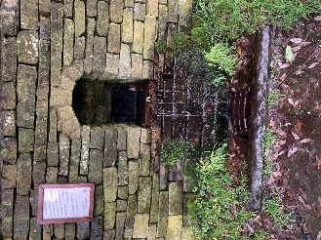

- As you look around what do you notice?
- What can you hear?
- Think about the journey you are on and the evidence of water that you can see around you.
- Perhaps you might be thankful for the fresh water that you can easily have to drink.
- Think about those in other parts of the world who have no running water or even clean running water
- If you are doing this walk in advent think about Mary and Joseph on their journey and the thirst they may have encountered
- As you look around, take a look at where the water comes from and how full or low the reservoir is depending upon the time of year.
- If you have a drink with you, perhaps you might like to have a sip of it and think about what it is doing as you drink it.
- Perhaps you might like to think about the story of the woman at the well and who it was that was asking for a drink.
READING:
READ: John 4:7-10 ⁷ When a Samaritan woman came to draw water, Jesus said to her, “Will you give me a drink?” ⁹ The Samaritan woman said to him, “You are a Jew and I am a Samaritan woman. How can you ask me for a drink?” (For Jews do not associate with Samaritans.[]) ¹⁰ Jesus answered her, “If you knew the gift of God and who it is that asks you for a drink, you would have asked him and he would have given you living water.”
- Think about this passage for a moment and think about what might be meant by Jesus offering ‘LIVING WATER’.
- Perhaps you might like to think about that a bit more as you journey on.
JOURNEY ON

Continue with the reservoir on your left until you come to a green bridge. Stop before going over the bridge. Make sure there is enough room for people to get past safely.

REFLECTION POINT 2
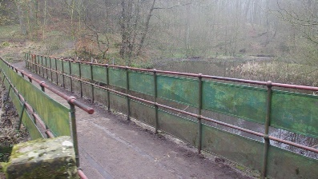

- Take a look around what do you notice?
- Notice the difference between the two volumes of water each side of the bridge, think about how much water is in them.
- Reservoirs are made to hold water and release water at appropriate times. Think about that someone is in charge of this, think about the responsibility that person has.
- Think about the things you are responsible for.
- You may not be responsible for making sure people have fresh water to drink, but the things you are responsible for also has an impact upon your own or someone else’s well being.
- How does this make you feel?
- Sometimes we can become overburdened with responsibility, a burden we do not have to carry alone and can be shared with others.
- Jesus once said, ‘Come to me all you who are heavy laden and I will give you rest.’ How does that make you feel?
- For a moment think about the things that you are burdened by.
- As you cross the bridge continue in silence and with each step let go of those things and give them over to God/Jesus to take from you.

JOURNEY ON

Once over the bridge you can go left and stay on the level and continue with the reservoir on your left until you get to the metal kissing gate.

Alternative route!

Alternatively (taking care on parts of the path later) for an extra reflection point you can go right and go up the path and follow it up and at the top around to the left you will come to a small cross roads where you will find a footprint in a square stone.

REFLECTION POINT 3- Footprint in stone
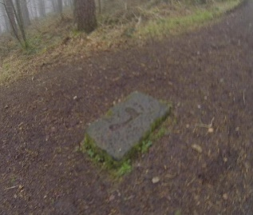

- Be Still, take a look around, what do you see?
- Notice the footprint etched in the stone. As you look at it what do you imagine?
- Think about your own feet and how far they have carried you over the course of your life.
- Think of some of the amazing places you have been and the people you have met on those journeys.
- Think about how limiting life would be without the use of your feet.
- We often take our bodies for granted and only perhaps realise how fragile we are physically when something isn’t working as it should. Think of those times when you have been restricted by the limitations of your body.
- Bring to mind again those occasions when you have been able to do something that your feet have enabled you to do.
- Be still for a moment and perhaps you might like to be thankful for what you have been able to do and experienced in your life.
JOURNEY ONWARDS
(Taking care) Follow the path straight on all the way until you come back to the reservoir and continue with the reservoir on your left.
As you reach the metal gate near the dam head pass through the kissing gate, and you will see a metal picture frame up to your right. Go up to the metal picture frame taking care as you do so.

REFLECTION POINT 4- Picture Frame
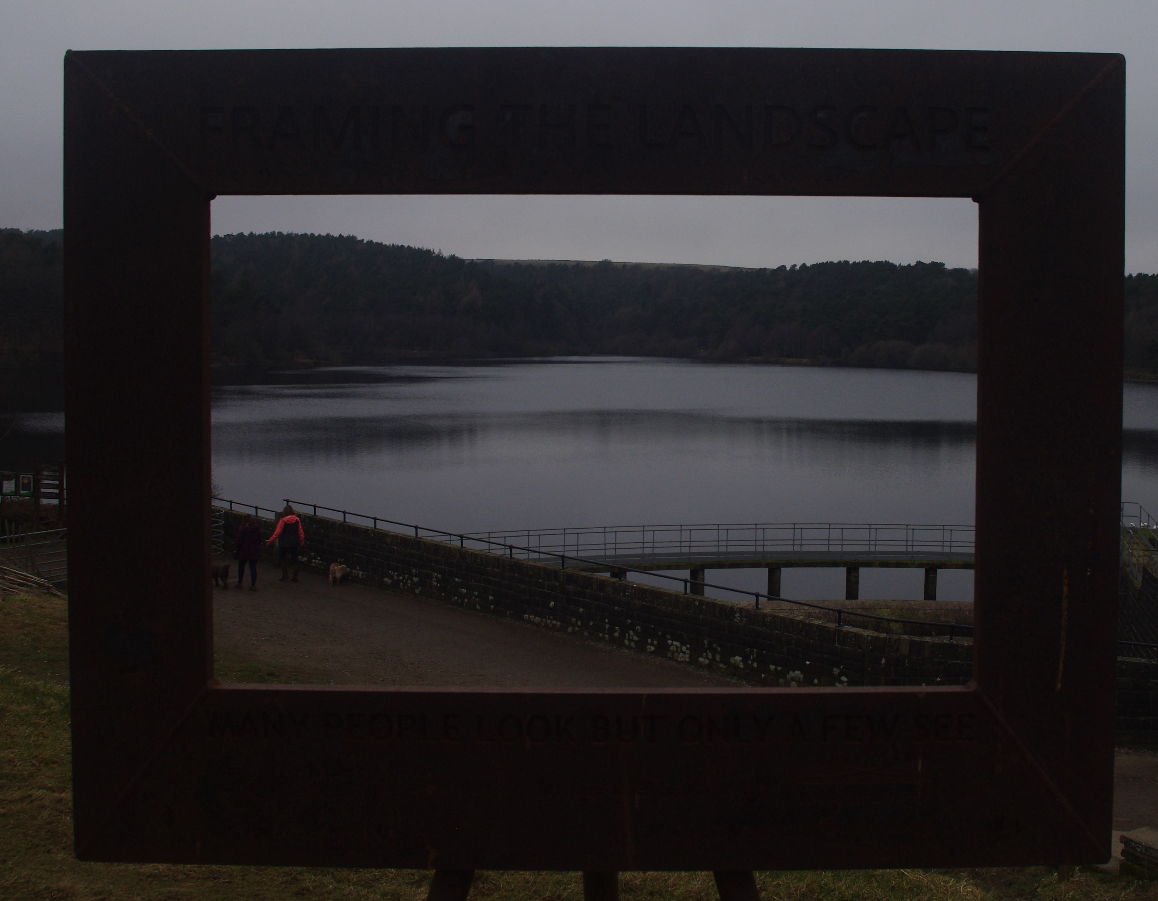

- Take a look around without looking through the picture frame, what do you see.
- Have a look through the picture frame and notice how it changes your perspective.
- What do you notice in the landscape scene
- Now for a moment look outside of the frame (PAUSE)
- Now look again through the frame and pick something out in the scene that draws your attention. Think about what it is and why you might have been drawn to it.
- How does it make you feel?
- Do you see anything of God in this scene?
- How does that make you feel?
- Give thanks for an awareness of seeing something of God through this view.
- Lord God, we give you thanks for the wonder of creation and for showing us something new of your presence today. Amen
JOURNEY ON

Now continue across the dam back up towards the Visitor Centre (if Open you can have a drink) or turn right back down the lane to where you began the walk.

