MOUNT TABOR WESLEYAN CHURCH

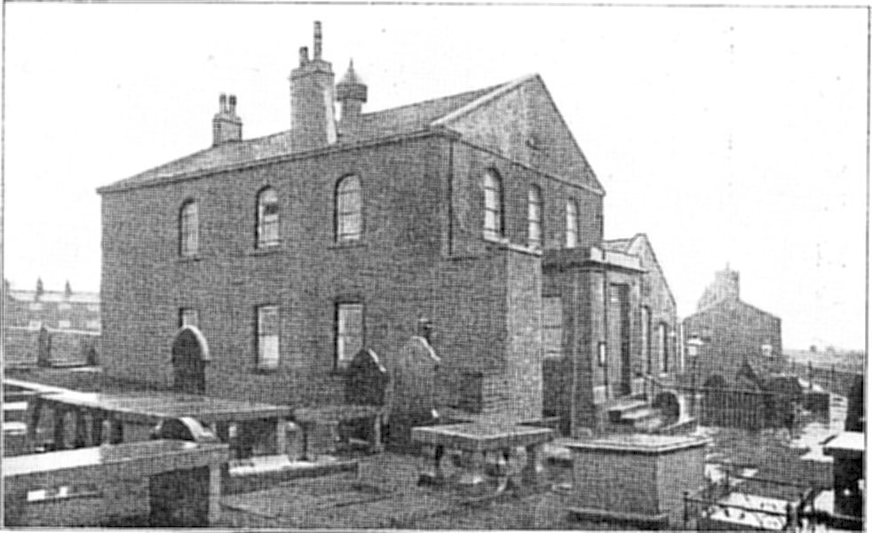

1820

Centenary Year

1920

A SHORT HISTORICAL ACCOUNT
OF A CENTURY OF METHODISM
IN MOUNT TABOR

Prepared for the Centenary Celebrations
Sept 18th and 19th 1920

Centenary Celebration

1820 – 1920

Saturday September 18th

3 o’clock Divine Service. Preacher Rev T Allcock. (Bradford) a former circuit minister

4-30 and 5-30: PUBLIC TEA

6 o’clock: Letters and messages of greetings from homeland and abroad will be read

6 –30: GREAT CENTENARY MEETING

Speakers:
Rev T Allcock, Messrs R D Ward, John Sutcliffe, W H Longbottom and Mark Stansfield

Supported by the Circuit Ministers
Mrs Wm Bentley | Mr J Bates | Mr G Sutcliffe B.Sc
Mrs George Clegg | Mr L Lumb B.A. | Mr J Greensmith
Mrs Isaac Dewhirst | Mr W D Parker | Mr E Horsefall
Miss Dewhirst | Mr J Dealey | Mr G Sutcliffe B.Sc.
Mrs W H Greenwood | Mr H Carter | Mr L Tattersall
Mrs T Parker | Mr A Clegg
Mrs Mark Stansfield | Mr L Stansfield

Chairman: Mr J Hoyle (A Senior Trustee)

Sunday September 19th
10- 30: A CENTENARY SUNDAY SCHOOL SERVICE

For, Past and present Scholars. Teachers and Friends
The Parents of Scholars are especially invited to attend

Speakers: Rev S Marriott and Mr W H Longbottom

2-30 and 6 o’clock: Public Worship

Preacher: Rev A H Walker B.A. Manchester
Some old Methodist Hymns and tunes will be sung

A CENTENARY FUND is being raised, when it is hoped that not less than £500 will be realized for a thorough renovation scheme of the Chapel and School and other purposes

FOREWARD

At times it is interesting and helpful to look back along life’s road and, in imagination to tread some of the way again. Such a retrospect is not only a source of interest and pleasure, but it also revives for us the experience of the past, and so enables us to meet with greater confidence and knowledge the problems of the present. So it is in the life of the Church.
The story of the lives and work of those in whose footsteps we tread is interesting, helpful and inspiring.

This booklet aims at giving a brief survey of the history of Methodism in Mount Tabor. The written records of the church here are largely incomplete. Consequently, reliance has had to be placed chiefly on the memories of those who attended the School and chapel over fifty years ago.
For the information they have so readily and ably given, deep gratitude is expressed.

HISTORICAL SKETCH

Perched upon the hilltop, over 1,000 feet above sea level, the village of Mount Tabor is a fine point of vantage for surveying the beauties of the hills and dales which help to form the Pennine Range. To the north stretch the moors, glorious alike in the heather-clad beauty of summer and the white desolation of winter.

Westward the land slopes steeply down to the woods and stream in the lower part of Luddenden Dean. Beyond, cultivated fields, dotted with picturesque farmhouses slope upwards to the moors. To the south we see where the white road leading to the town of Halifax where blackened chimneys and roofs are clustered at the foot of the surrounding hills.

On the eastern side Wheatley Valley stretches from the town upwards into Mixenden. Beyond it are the hills again, the slopes of which form a patchwork of green fields separated by black stonewalls. Yet, though it thus commands a view of such fine scenery, the village of Mount Tabor itself lays little claim to picturesque-ness. There is an attractive-ness, however, in its wild ruggedness. The grey stone walls and buildings, the rough roads, the quarries, the lack of trees and flowers, and the wildness of the wind, all serve to convey an impression of blunt vigour which appeals in spite of the lack of gentler charms.

The characteristics of the land are to some extent reproduced in those of the people. Their lives share something of the rigour of the hills. This trait was more pronounced fifty and a hundred years ago than it is today, for fewer workshops and factories then claimed the working hours of the inhabitants. Their labours were chiefly wrought in the open fields and quarries. The ruggedness of the hills also entered into their religion, and the story of this church is one of these stern lives simply lived in the service of God.

THE RISE OF METHODISM IN MOUNT TABOR

During the latter half of the eighteenth century Halifax, like so many other districts in England, was greatly moved by the preaching of John Wesley and of George Whitfield. During that period and in the early nineteenth century, several chapels were built in this area by the followers of these men. Amongst the earliest were Luddenden, built by the Wesleyan’s, and Mixenden, built by the Congregationalists.

Previous to the year 1816 it was in these two places that the Nonconformist inhabitants of Mount Tabor worshipped. It was from the Mixenden Society that the one at Tabor took its rise. On the death of the Mixenden Minister in 1816 the trustees there could not agree as to a successor.

A division resulted and several left the church and commenced meetings at Mount Tabor. One of these trustees, Edward Birtwhistle by name was the owner of a barn situated at Grey Jacobs. By his permission this was used as a meeting- house, and local preachers from Halifax began to conduct services there.

Their work was so successful that in a few months demand arose for better accommodation. A room was secured at “Bedford’s House” in the centre of the village, the residence of Mr Cawkwell. After suitable enlargement and preparation it was used as a preaching room for about three years. A Methodist society class was formed with a membership of eight or nine, under the leadership of James Rothera. The number of members and attendee’s steadily increased with the result that still a larger meeting place became necessary.

ERECTION OF THE CHAPEL - 1820
It was decided that a chapel should be built. Accordingly a plot of ground was obtained by purchase from John Oldfield Bates, and the work of erection began. Stone was provided by the local quarry owners whilst the workmen freely gave their labour in the task of dressing and carting the stone and in the building of the chapel. This considerably lessened the expense and the building was completed with a debt of only £180.

FOUNDERS OF THE CHURCH
Among the trustees to whom the property was conveyed, the following local men are named.
John Crowther, Edward Birtwhistle, John Greenwood, Joseph Bentley and James Rothera.

These men largely carried out the Pioneer work of the church. James Rothera, who has been mentioned as the first class leader, had seven sons and several daughters who in their turn became active workers for the cause. One of the daughters later married Mr James Clegg, the grandfather of our esteemed circuit steward Mr A Clegg. The Skelton, Crowther and Greenwood families were also large and for many years formed the bulwarks of the church.

Joseph Bentley was the master mason in the building of the church. Other early workers were John Ellis and Mrs Dewhirst; the latter became class leader with her sons William and John. Afterwards doing much good work in the village.

FIRST LOCAL PREACHERS

The work of the first local preachers deserves especial mention, for their untiring efforts were chiefly responsible for the early prosperity of the cause. The difficulties under which they laboured were great. They lived in the days when buses and cars were undreamed of, anyone who could afford to travel on horseback was considered fortunate. The weather then as now was frequently a great hindrance. Speaking was often done in the open air and sometimes met with a hostile reception.
The chief laymen who conducted the Sabbath services in these early days were
Thomas Birtwhistle, John Oldfield Bates, Jonathan Denison and Jonathan Saville. The story of the latter’s life is one of remarkable romance.

JONATHAN SAVILLE

He was born near Bradford of poor parents, his mother died when he was only three years of age and his father, unable to support him sent him to the local poorhouse. He was then given into the charge of the manager of some neighbouring coalmines, where compelled to do laborious and exhausting work. He gradually sank beneath the hardship, and his master found it necessary to remove him from the drudgery of the coal-pit to his own house where he was employed at the spinning wheel.

He was still treated cruelly, and on one occasion was so wickedly belaboured that his leg was broken. No medical aid was called in and the poor lad still had to work. Happier times came when his employer returned him to the workhouse. Here, through the kindness of the master, he regained considerable strength and was able to learn the rudiments of reading and writing.

His industry in a few years enabled him to take up a position with Mr Swaine of Cross Hills Halifax. About that time he was converted and arduously applied himself to the work of God. He became prayer leader, class leader and local preacher. He traversed the whole district of Halifax for the purpose of establishing and holding prayer meetings, exhorting his hearers to diligence and faithful service.

EARLY EXTENSIONS OF THE CHURCH

The chapel, built in 1820 was somewhat small. Four years later it was enlarged almost to its present dimensions. A considerable debt was incurred, but as the sittings were well let and congregation’s large, little inconvenience was sustained. A plain but commodious school was built in the year 1836. Its early usefulness is denoted by the fact that in its first year the number of scholars was 199 and of teachers 69. In considering these figures it must be borne in mind that at this time the growth of Halifax as an industrial centre was very marked. This involved the erection of many buildings and consequently gave an impetus to the stone trade, which made Mount Tabor a very busy area.

EARLY WORKERS

Two of the stalwarts who carried on the work soon after the erection of the school were Luke Hoyle and William Dewhirst. The former was born in 1797 but was not intimately associated with the work at Mount Tabor until he was 31 years of age. The following is an obituary notice of him, which appeared in the Halifax Methodist Messenger for the year 1871
Mr Luke Hoyle of Wainstalls near Mount Tabor died on May 6th 1871 after a sickness of about seven weeks. He was in his 74th year of age, and so far as is known has not been confined to bed throughout the previous 50 years.

He lived an ungodly life until his 27th year. About this time his wife, who was the daughter of Methodist parents had often been seriously impressed became converted. After some opposition to her Mr Hoyle was brought under concern for his soul and in March 1825 both of them joined the Methodist Society in Luddenden.

For about three years Brother Hoyle’s Christian experience was not of a very decided character, but about that time, moving to Wainstalls to the house where he died, he and his wife began to meet in another class of the same society. The leader of this class and the members were generally earnest and zealous and of true Methodist type. After a season of depression our brother received at one of the meetings a renewed and much clearer sense of sins forgiven. He often said he could go to the flag on which he was kneeling at the time.

Thenceforth he went on his way with new spiritual life and power; he became an earnest worker in the vineyard of the Lord. He laboured much for ten years in the company with his brethren in conducting cottage prayer meetings in Cold Edge, both morning and evenings on Sunday and also on week evenings. Often going two miles to a 7 o’clock Sunday morning meeting. Having lost his way one dark evening at Mythlom, he took off his shoes and stockings and forded the stream rather than return home without finding a prayer meeting. In company with Mr Stockie he travelled the district for three years collecting for mission.

He also engaged in the service for the Sunday school at Mount Tabor, in which he laboured as teacher or superintendent for nearly forty years. In March 1839 he was admitted to the office of class leader in Mount Tabor, which office he held to his death. For thirty years, winter and summer he has gone a distance of a mile after a hard days work to his class, scarcely ever hindered by cold or wet, by the darkness of the night or the badness of the roads. During thirty years he was never absent from the circuit quarterly meeting.

Our departed brother strongly insisted on the Christian duty of visiting the sick and attended it accordingly. Many remember his visits with gratitude. During the last six or seven years of his life, he had increased opportunities of instructing the sick, praying with them and encouraging them while travelling on business. He was a strict observer of the Sabbath, and in this respect went beyond many good people. Twice or thrice with rare exceptions, he would be at the house of God on that sacred day

He was thoroughly in accord with Methodism as to its doctrines and discipline, while it’s peculiar means of grace – its class meetings etc, were quite suited to his highly social nature. But our friend did not neglect to show piety at home: he laboured to excess at his arduous calling that his family might have every comfort. He was devotedly attached to his wife, on whom he attended with the greatest tenderness during her periods of suffering. Both he and his wife endeavoured to bring up their children in the fear of the Lord and by his blessing they succeeded.

About a fortnight before he died, his daughter in law expressed a wish that she might have the same peace of mind when she came into like circumstances. He replied emphatically that he had no more fear of stepping into Jordan, than of putting his foot off the bedside.

In his long life of 73 years our brother met with many troubles, especially as the father of not a small family, for whom he had to provide out of his severe employment as a wool-comber.

He lost two of his sons just when they arrived at manhood, one of them in the most distressing circumstance. This was a heavy stroke, all the more severe because of the painful effect it produced on his wife. Forty years of official connection with the church brought its share of trials. Still he kept steadily to his post of duty, and though at times weary in his master’s service, he was never weary of it. While he found that ‘sufficient unto the day is the evil thereof,’ he found also that as his day so was his strength. This strength he ever renewed by the means of grace, and often wept for joy while in the house of God, receiving his meat in due season.

He passed away from our midst to enjoy the more immediate presence of the Master he served on earth. His cheerful smile no longer welcomes the messenger of truth, or cheers the young beginner but his influence abides, another proof that ‘the memory of the just is blessed’
The writer of the above tribute to Mr Hoyle was William Dewhirst, his friend and colleague, who resided at Kell Fold, Wainstalls; he also took a very prominent part in the work of the Church and Sunday school. The minutes of the teacher’s meetings record that he filled all possible offices there including those of librarian, secretary, teacher, treasurer and superintendent. On one occasion when efficiency was needed for proving refreshments he was appointed to the post of ‘muffin warmer and tenter’” In the chapel he was equally diligent, for many years being class leader, trustee and leading singer. His descendants, especially his son Isaac in their turn, have given valuable assistance to Mount Tabor.

Mr James Clegg and Mr William Parker often called Stutely Parker were other workers who took up and continued service. Both vigorous men accustomed to hard labour during the week, they carried their vigour into Sunday school and Church. Mr James Clegg is particularly remembered as Sunday School Superintendent. Some of the oldest of our former scholars will no doubt recollect that every Sunday for four years he opened the school with his favourite hymn “Begin my soul some heavenly theme”. His son, Mr George Clegg acted as teacher and secretary in the school, also for a short time as superintendent until business took him to Halifax, where, along with Mr Hollingrake, he built up a firm, which still bears their names.

Mr Thos Parker, son of Mr William Parker, similarly worked for the church in his younger days, but on account of business was compelled to leave the village. Both he and Mr George Clegg transferred their religious activities to Rhodes Street. Other well-remembered names of this period 1840 –1870 are those of Mr Abraham Skelton, John Starkey, Thos Whiteley, Thos Helliwell, John Longbottom, James Ambler and Mettulus Wade

THE SERVICE OF SONG

The manifold labours of Luke Hoyle and William Dewhirst included the establishment of an excellent orchestra and choir. Their work in this direction was ably supported and continued by their children who took prominent part, not only in the singing, but also in the playing of the harmonium, clarionette, flute, fiddles and double bass. Abraham Skelton and his many brothers and sisters and James Ambler, commonly called “Jim Lucy” also excelled in this direction. James Ambler and later William Marshall trained the children in their singing at the anniversary and Jubilee celebrations. Abraham Skelton, himself the composer of one of the hymn tunes, conducted the singing for many years. The musical part of services in those days differed considerably to that of today. Lack of hymn- books and the ability to read necessitated the reading of hymns by the preacher two lines at a tome throughout.

FEASTS

John Starkey, and afterwards James Haigh and John Longbottom were chapel keepers who, in addition to the duties involved by the holding of that office, willingly undertook a large share of other work. Their services were especially valuable at Whitsuntide, Christmas and Jubilee Celebrations, when they took pride in providing material wants of the community. John Longbottom and his wife in particular established the fame for Mount Tabor tea and “fatty cakes” which is still sustained. The prices at the time may prove of interest. Flour was 4/- per stone, currants 1/1 per lb, sugar 10 &1/2d per lb, coffee 3/2 per lb. Among the refreshments supplied were also “bread, beer, and cheese.

CHRISTMAS DAY CELEBRATIONS

The Christmas day meeting, which followed the tea, was the event of the year. An appetite for speeches seemed to grow as the appetite for food was satisfied. When the tables were cleared, seven or eight of the elders would hold forth at considerable length. The children and the choir also took their turn in the proceedings.

PRAYER MEETINGS

The more directly religious work was of a forceful character. Conversations of a pronounced character were aimed at, so that the chapels became known as “converting furnaces”. The members were “mighty in prayer”. They loved intersession, expected conversations and got them. An hour before the evening service the minister’s vestry would be crowded with men and women pleading for conversions during the ensuing meeting. Prayer meetings before Sunday school services and also during the week were frequently held, not only in chapel and school, but at various houses in the district. In the winter months combined prayer meetings were held with the members from Luddenden, Luddenden Dean and Wheatley. On some of these occasions the “wrestling with God” would be carried on into the small hours of the morning – often with gratifying results. Drunkards, cock fighters and pigeon flyers were brought in and saved.

LOVE FEAST

The love feasts at which members of the congregation gave their testimony to the power of God in their lives were also a time of great blessing. An unusual feature of these meetings was the partaking of refreshment. Two large cups of water and baskets containing buns were passed round. At one time admittance was only by ticket of church membership. So popular were these services that the chapel gallery where they were held was usually crowded to overflowing. Collections were made for the poor of the district. The class meetings were held in addition to the prayer meetings and were attended by practically all the members. Old time hymns, requiring strong lungs and a wide vocal range, were sung with great zest. James Clegg for many years had a class of 60 members.

LOCAL PREACHING

The type of preaching prevalent is illustrated by a story told of the celebrated preacher Isaac Marsden. On one of his visits to Mount Tabor he took a piece of chalk and drew a line on the floor of the chapel to invite his hearers to step over into eternal life or remain forever in outer darkness. Another local preacher was Thomas Greenwood from Luddenden Dean. His popular name was “Tommy o’th’Dean. His duties as farmer were of a binding nature and to save the time the time taken in changing clothes, he would often conduct the service in his clogs and working garments. The simplicity of the times is illustrated by several stories concerning this worthy. A circuit minister preaching at Dean was entertained by Tommy o’ th Heys. The frugal meal consisted solely of a large bowl of porridge. Unused to the fare of this kind the good man hesitated to partake of it. Where upon Thomas said, “Fotch im a thaum o butter lass”. The hostess left the table and returned with a piece of butter on her thumb. This she put in the porridge, Thomas remarking as she did so, “Oss na’ thas t’fat of t’land I front o’ thi”. (Fall to know, you have the fat of the land in front of you).
It is also said of him that, after acting as treasurer of Luddenden Dean Sunday School for a year, at the auditing of books, he produced an old teapot from which he poured money, remarking as he did so,”Ive put all in theer all aat I’ve drawn, an I’ve ta’en aat all I’ve paid.

It should be mentioned that about 1856 four or five leading members, were not in entire agreement with the doctrines of the Wesleyans, began meeting at Wainstalls and founded the United Methodist Church there. These included William Eastwood, Joseph Crowther and John Wade.

LATER EXTENSIONS

One result of the prayer meetings was a great revival of the work of God in the church. The fruit of this was manifested in the clearing off of a debt of some £360 in 1868 and in the building of a more commodious school in 1871. £700 were raised by subscription for this purpose. Of this sum Mewburn and Edwards of Halifax, £50 by Mrs Lassey of Mount Tabor, and £50 by Mr John Appleyard of Halifax. The ceremony of laying the foundation stone was performed on July 8th 1871. The teachers, scholars and friends met in the chapel when the service was opened by Rev Jacob Morton. On behalf of the trustees, he presented Mrs Lassey with a silver trowel, with which she afterwards laid the stone to the glory of God.

Gifts of money were placed in the newly laid stone and a bottle containing documents referring to the scheme, the names of teachers and scholars and a few coins were placed in a cavity in the stone. Some two hundred sat down to tea in the schoolroom. In the evening a public meeting was held in the chapel when the Rev J Morton presided. The friends were addressed by Rev J.A. Barraclough of Halifax. And Messer’s Parkin, Lee and Dewhirst of Mount Tabor.

LATER WORKERS

The work of the chapel and school for the next few years was carried on largely by a number of young men who had been converted during the revival services previously mentioned. Some of these were John Ibbotson, a converted pigeon flyer, who took up the pulpit work with great ardour and became well known as a preacher in the whole Halifax district. Benjamin Sykes, Daniel Bates and William Sutcliffe whose names will be remembered as Sunday School superintendents and energetic church workers. They were inspired by the noble example of George Clegg, Thomas Parker, Joseph Foster, James Haigh and John Lassey, who immediately preceded them in the work. They were followed by Messrs, Joseph Hoyle, William Hey, Wainhouse and George Haigh, who, up to leaving the village were engaged in constant service in the Church and Sunday School.
Messrs, J Hoyle and W H Longbottom are at present trustees of the chapel.

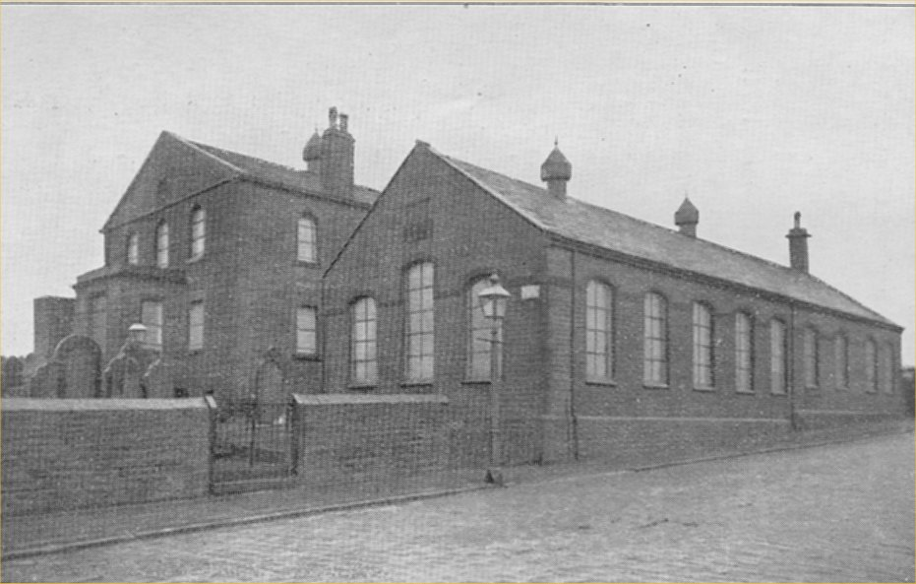

FURTHER EXTIONS AND IMPROVEMENTS

Being so small a place and lying so far from the town Mount Tabor has suffered much through the loss of many of her best young men and women. She has however, been singularly fortunate in that her children, though widely dispersed, have remained loyal to her. This fact was especially demonstrated when large alterations in the Church building were carried out in 1887. They were largely the outcome of a memorable old scholars’ gathering held in 1886 when Mr Isaac Dewhirst promised to defray the cost of installing an organ in the chapel. His uncle Mr John Dewhirst, offered to cover the cost of building a recess for the organ. Other magnificent offers for help to the installation followed. Accordingly in addition to the installation of the organ, a porch entrance was built at the front and the whole church re-pewed and renovated. The cost of the alterations amounting to over £1000 was almost immediately met by generous gifts from the Dewhirst, Parker and Clegg families, by the proceeds of a bazaar held in the school, and by collections at the re-opening services.

The latter were held in January 1888. On the Saturday afternoon and evening meetings were held which, were addressed by Rev F Kellett, Rev D Solomon, Rev T Baron and several lay friends. The Sunday services were taken by the Rev J Moorehouse and Rev F Greeves, D.D. The organ was opened in March of the same year by an organ recital and music service. The organist was Mr S E Worton R.A.M., to whose specification the instrument was built.

Some three years later gas was put into the chapel and school, the expenses being paid by Mrs Murgatroyd. The church has since benefited by a legacy of £200 left by Mrs Murgatroyd. Other recent gifts include that a piece of land for burial purposes from Mr Wavell.

RECENT WORKERS

About the time of the renovations, the two main workers of today, Mr John Sutcliffe and Mr Mark Stansfield, together with Mr William Bates took up and carried on the bulk of the work. The last named died some nine years ago. Of gentle demeanour and Christ-like character he endeared himself to teachers and scholars alike. Whilst we regret the loss through removal of Messrs John Bates, Jethro Dealey, Daniel Briggs, Leonard Tattersall and Clement Crawley, we rejoice in the knowledge that their activities are continued elsewhere.
By the death of Mr Lister Lamb in December 1918 the chapel lost one of its most beloved characters. Genial and homely he performed the work of doorkeeper and sexton for nearly twenty-five years in a markedly able manner. His cheery laugh and quaint mannerisms will long be kindly remembered by those who knew him.

In common with other church’s Mount Tabor mourns the loss of those who have made the supreme sacrifice during the Great War. Arthur Tattersall was for many years’ secretary and teacher in the school and was dearly loved by all. Max Farnell, Harry Horsefield and Wilfred Kirkbride were constant in their attendance at Sunday School and Chapel, and are sadly missed from amongst us. Clement Bedford, John W Parker, Clifford Speight, John Spencer and Horace Mottram were old scholars who also died in their counties service.

THE PRESENT AND THE FUTURE
The zeal and prosperity of the Church in the past is apt to make us deplore the apathy of those times. We must remember that the period through which we are passing is one of exceptional difficulty. The psychology of the nation has been tremendously disturbed during the last six years, with the result that everywhere a feverish unrest prevails. It is our privilege and opportunity to demonstrate that the great soul need of humanity is supplied only by the divine power of Christ in the individual heart. We are inheritors by birth and by grace of the knowledge of this truth. Let us faithfully guard our heritage that we may pass it on to posterity unblemished. This we shall do only by trusting, neither in creeds nor philosophies, not in science, nor organisations nor philanthropy, but wholly and entirely in Jesus, the Son of Man. By his grace, then let us face the future with faith unshaken and hearts inspired by invincible hope.

Rev. Ministers who have travelled in circuits to which Mount Tabor has been attached.

1820 | W Miles | 1848 | G Turner | 1873 | J Hey
 | C Whiteside |  | H H Chettle |  | W Kendrew
1821 | J James |  | H Jackson | 1875 | J Brash
 | E B Lloyd | 1851 | G Jackson | 1876 | S Wikinson
1823 | Wm Theobald |  | R S Hardy | 1877 | R Martin
1824 | T Lessey |  | W B Pope |  | W J Marris
 | W Vevers |  | J W Barritt | 1879 | T Rae
1826 | G Chambers | 1852 | J Carr | 1880 | G Walker
1827 | J Waterhouse |  | J Burton |  | J H Corson
 | G Marsland |  | J Little | 1882 | S Forrest
 | Z Yewdall |  | M Cousin | 1883 | S Dazell
1829 | J J Topham | 1854 | J Lyth |  | G H Appleby
1830 | A E Farrar | 1855 | J Lambert | 1885 | H F Kelvey
 | R L Lusher |  | R Felvus | 1886 | D Solomon
 | R Crowther | 1857 | J Randerson |  | Sanderson
1831 | J Bumbey | 1858 | J Loutit | 1888 | R Killip
1832 | W M Bunting |  | G Mather | 1889 | I E Page
1833 | T Galland |  | J D Dodgson |  | J H Jones
 | A Aylmer | 1860 | G T Morrison | 1891 | T R Pickering
1835 | P Duncan | 1861 | E Walker |  | G E Young
 | G Turner |  | H L Church | 1892 | J Martin
 | J Jennings |  | W J Brown |  | J Nancarrow
1836 | W Hinson | 1862 | J B Holroyd | 1894 | T Allcock
1837 | R Dugdale |  | J Shearmon | 1895 | W Sarginson
1838 | J Roberts | 1863 | J Bonsor M.A. |  | J H Hodson B.A. B.D.
 | S Kay | 1864 | J H Lord | 1897 | H G Payn
 | R Thompson |  | J A Mcdonald | 1898 | J Rhodes
1839 | F A West |  | C R Kelvey | 1900 | H G Attwater
1841 | A Stead | 1867 | T James | 1901 | A Martyn
 | P Hardcastle |  | T J Guest | 1903 | C Wilderwood
 | J W Barriett |  | G H Smith | 1904 | W R Stewart
1842 | S Dunn |  | J E Clapham | 1906 | A E Butler
1843 | G Taylor |  | T W Johnston | 1907 | C N Dove
 | W Brailsford |  | J Loutit | 1909 | W S Hackett
1845 | A Learoyd | 1868 | J Morton | 1910 | A Hann
 | T Llewellen | 1869 | M Randalls | 1912 | W S Weddell
 | W Exton | 1870 | A Barrowclough B.A. B. D. | 1913 | S Marriott
1846 | J McOwen | 1871 | E J Robinson | 1915 | W H Warren
1847 | J Miller | 1872 | R Morton | 1916 | J E Crawshaw
 |  |  |  | 1919 | S Marriott
 |  |  |  | 1920 | G S Cann

FIRST LIST OF TRUSTEES 1819

Joe Brook | Joseph Crowther
Thomas Bates | John Crowther
William Thompson | Edward Birtwhistle
Joseph Skelton | John Greenwood
Jas Ratcliffe | Joseph Bentley
Samuel Crowther | James Rothera

SECOND LIST OF TRUSTEES 1845

J Brook | James Clegg
T Bates | John Geoffrey
W Thompson | Francis Roper
J Skelton | Joseph Wood
J Ratcliffe | Jas Wiseman
S Crowther | John Clegg
J Crowther | Thos Ford
Abraham Skelton | Michael Hyde
Wm Dewhirst | Isaac Bate

THIRD LIST OF TRUSTEES 1886

George Clegg | George Patchett
J W Rothery | Wm Hy Greenwood
Jas Farrar | Thos Parker
Hy Keighley | John Sutcliffe
W H Longbottom | Thos Mitchell
R D Ward | Joseph Hoyle

FOURTH LIST OF TRUSTEES 1897

Jas Farrar | Mark Stansfield
W H Longbottom | Jethro Dealey
R D Ward | John Bates
Wm Hy Greenwood | Arthur Clegg
Thos Parker | Saville Greenwood
J Sutcliffe | Reuben Crowther
J Hoyle | Harry Farrar
Wm Bates | Wm Uttley

Superintendents of the Sunday School

1836 - 1840 | John Ellis | 1867 –1869 | Benj Sykes
1836 - 1860 | Luke Hoyle | 1876 | “
18 40 - 1860 | Wm Dewhirst | 1873 –1876 | W H Longbottom
1844 – 1845 | Abm Skelton | 1874 – 1876 | Wm Brierley
1845 – 1849 | Thos Whitley | 1876 –1877 | Jos Hoyle
1864 – 1870 | “ | 1880 –1881 | “
1845 – 1847 | Jas Lawton | 1888 – 89 | J Johnson
1846 | John Starkey | 1881- 0882 | John Sutcliffe
1848 – 1853 | James Clegg | 1884 – 1887 | “
1861 – 1865 | “ | 1889 – 1898 | “
1870 – 1873 | “ | 1904 – 1920 | “
1857 – 1859 | Thos Helliwell | 1883 | William Bates
1858 | Thos Greenwood | 1890 – 1891 | “
1859 | Nicholas Eastwood | 1899 – 1911 | “
1863 | George Clegg | 1899 | J Dealey
 | Thomas Parker | 1899 – 1901 | W Marshall
1864 | John Ibbotson | 1912 – 1919 | D Briggs
1865 – 1866 | William Parker | 1884 - 1888 | Mark Stansfield
1882 – 1883 | “ | 1893 – 1899 | “
1885 - 1888 | “ | 1902 – 1903 | “
1865 | Wm Sutcliffe | 1914- 1920 | “
1866 | Daniel Bates
1877 – 1880 | “
1866 | John Longbottom

PRESENT OFFICIALS

Society Stewards Poor Stewards
Mr Jas Sutcliffe Mr M Stansfield Mr L Stansfield Mr G Sutcliffe

Chapel Stewards Chapel Trust Treasurer
Mr John Sutcliffe Mr Jas Sutcliffe Ald. R D Ward J.P..

Chapel Trust Secretary
Mr W H Longbottom

Sunday School Superintendents Organist
Mr John Sutcliffe Mr M Stansfield Mr Sharman

Roll of Honour

Clement Bedford Albert Mann
James Bedford Herbert Moore
Reginald Briggs Horace Mottram
Irvine Briggs Leonard Mottram
Shaw Briggs George Newell
Horace Cockroft David Parker
Ralph Crossland John W Parker
Clement Farnell John Robinson
Maximillian Farnell Harry Sutcliffe
Walter Farnell Clifford Speight
Harry Greenwood John Spencer
Maurice Greenwood Bentley Spencer
Almon Horsfield Verity Spencer
Edmund Horsfield Lenton Spencer
Leonard Horsfield Joe Smith
Harry Horsefield Leonard Smart
James Kirkbride Pearson Snowden
Harry Kirkbride William Stott
Wilfred Kirkbride Clifford Tattersall
Thomas Kendall George Tattersall
Herbert Lassey Leonard Tattersall
Milvert Lassey Arthur Tattersall
Ernest Lassey Ronald Turner
Priestley Lassey Joe Wilson
Wilson Lofthouse Frank Wormald
Herbert Mann Harry Whitham

