Holy Week & Easter Services – Additional to Normal Service Times

Bethesda
Blackshaw Head | 7.00pm 01/04/21 | Informal Fellowship Meal (via Zoom) Please bring your own food!
Boothtown &  Southowram | 7:00pm 02/04/21 | Good Friday Reflection – P Prosser (via Zoom)
Brighouse Central | 7:30pm 01/04/21  12:30pm 02/04/21 | Maundy Thursday Communion - Cheetham  Good Friday Service - Cheetham
Christ Church LEP | 7:30pm 01/04/21  2.30pm 02/04/21  10.30am 04/04/21 | Maundy Thursday Service – G. Smith  Good Friday Service – Sherwood  Holy Communion – Sherwood
Clifton
Cross Hills | 6:00pm 01/04/2021  10:30am 02/04/2021 | Maundy Thursday Reflection – Welch (via Zoom)  Good Friday Walk Reflection starting @ Mount Zion – Welch
Hebden Royd | 2:00pm 01/04/21  10.00am 02/04/21  8.00am 02/05/21 | Maundy Thursday Service – Heathcoat (via Zoom)  Good Friday Service – Heathcoat (via Zoom)  May Morning Service @ The Praying Hole, Colden Clough
Heptonstall | 10.00am 04/04/21  8.00am 02/05/21 | US starting @ Heptonstall & ending at St. Thomas – Kent  May Morning Service @ The Praying Hole, Colden Clough
Highgate | 7:30pm 29/03/21  7.00pm 01/04/21  10:30am 02/04/21 | Service of Evening Prayer – Astwood (via Zoom)  Join with service at Stones - Keen (via Zoom)  Join with either St. Andrew’s (am) or Stones (pm) – Keen (via Zoom)
Illingworth Moor | 6:00pm 01/04/21  10:30am 02/04/21 | Maundy Thursday Reflection – Welch (via Zoom)  Good Friday Walk Reflection starting @ Mount Zion – Welch
Mount Tabor
Mount Zion
Northowram
Salem | 6:00pm 01/04/21  10:30am 02/04/21 | Maundy Thursday Reflection – Welch (via Zoom)  Good Friday Walk Reflection starting @ Mount Zion – Welch
Southgate | 8:00am 04/04/21 | Easter Sunday Morning Communion – Sherwood
St. Andrew’s | 7:30pm 01/04/21  10:30am 02/04/21 | Maundy Thursday - U  Good Friday Service – Keen
St. Matthew’s LEP
St. Paul’s | 2:00pm 01/04/21  10.00am 02/04/21 | Maundy Thursday Service – Heathcoat (via Zoom)  Good Friday Service – Heathcoat (via Zoom)
Stones | 7.00pm 01/04/21  2.30pm 02/04/21 | Holy Communion – Keen  Gathered at the Cross - Keen
Todmorden

New beginnings are never easy. They can be created by a range of circumstances, some under our control because of decisions we have made, some are forced upon us through circumstances. The disciples knew about new beginnings when Jesus was crucified. Their world had fallen apart, what next? They huddled together for support when Jesus appeared amongst them. I wonder if they began to think that things would get back to normal.
Over the last year, many have lost so much, and life is no longer the ‘normal’ they had become used to. Many are also desperate for a resurrection for their lives, a new hope, a new vision for their future. Sometimes the hard part is not seeing the future but letting go of the past. I offer the following prayer as a resource to help you pray for yourself and those around you. I encourage you all, whether as individuals or as churches, to offer the past to God and seek his resurrection journey for your life and for those you love.

Lord Jesus Christ, we remember today how you rose again, bringing new beginnings out of what had seemed the end, a new chapter in the life of your Church which is still being written today.
We recall how your resurrection changed life for the disciples, calling them to let go of the past and embrace the future - their role no longer simply to follow but to lead, to go out in your risen power and proclaim the good news. We know that life must change for us too, but sometimes it is harder than we first anticipated, moving on a painful business, asking more of us than we feel able to give.
Reach out to all who are finding endings hard to bear. We think of those reeling from the loss of a loved one, the termination of employment, the breakdown of a relationship or eviction from their homes.
We think of those coming to terms with unfulfilled ambitions, let down by broken promises, or overcome by sudden catastrophe.
We think not only of others but also ourselves. Show us those areas in our lives where it is time to draw a line and move on - forms of service which are no longer fruitful, activities no longer appropriate, dreams no longer viable.
Give us the wisdom we need to understand when it is necessary to accept change and even to welcome it and give us courage then to stride out in faith, confident that you will lead us from the old to the new.
Lord Jesus, remind us again today that endings can lead to new beginnings, that from the old, new life can spring, and may that confidence touch our lives and bring hope to our troubled world.
Receive our thanks for all that has been and open our hearts to all that shall be. We ask it in your name. Amen.

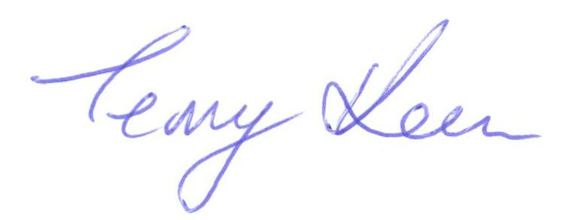
Yours in Christ
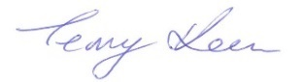

Rev Terry Keen

