Christmas Fayre and Tree Festival

27 November 2021

WHERE: Boothtown and Southowram Methodist Church, Beverley Place, Ackroydon
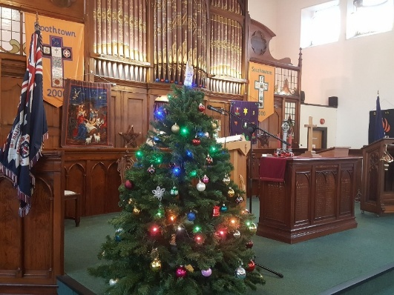
Watch this space for more details on timings etc

TO BOOK A STALL OR TREE: boothtownsouthowrammethodist@gmail.com

Trees are to be bought and decorated by each individual or company (they could be used to promote your business)

