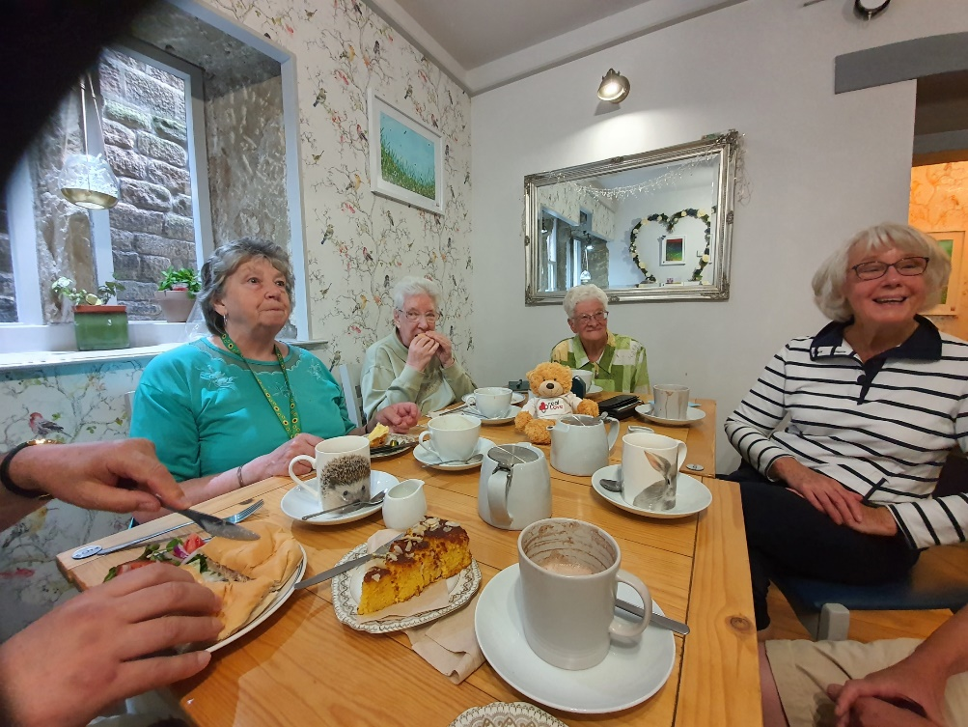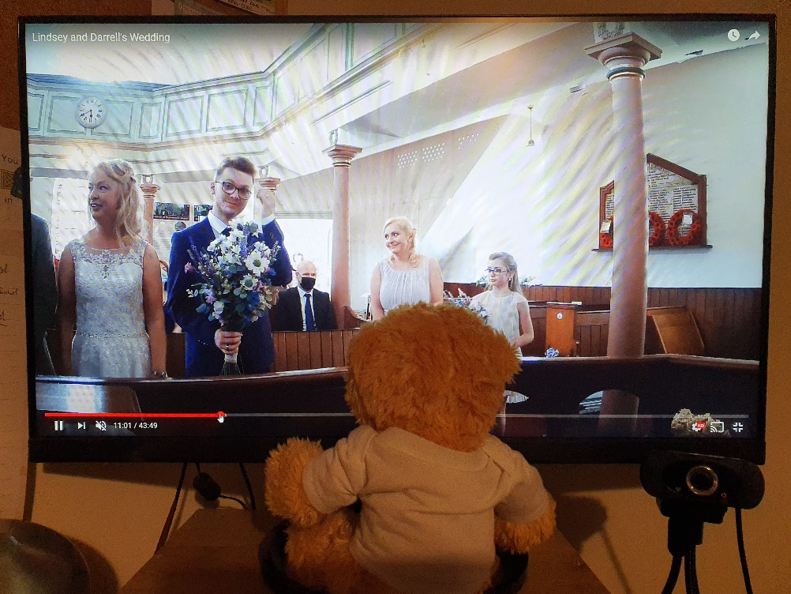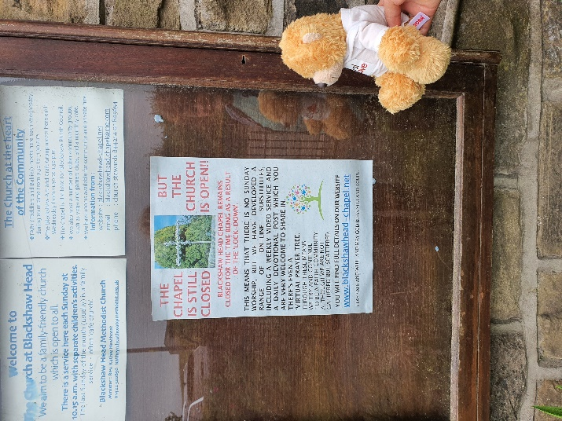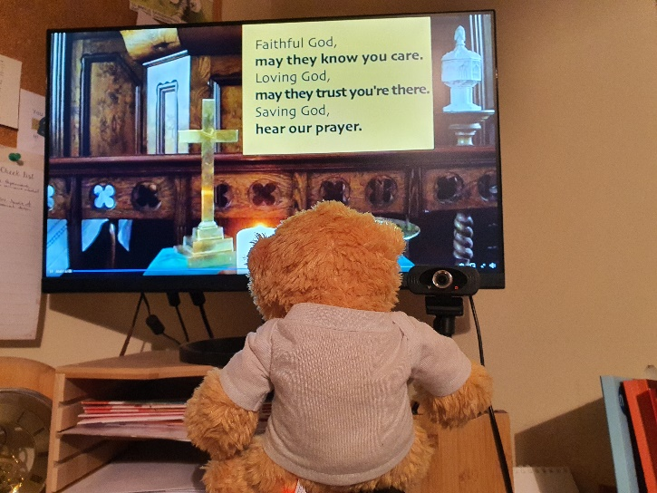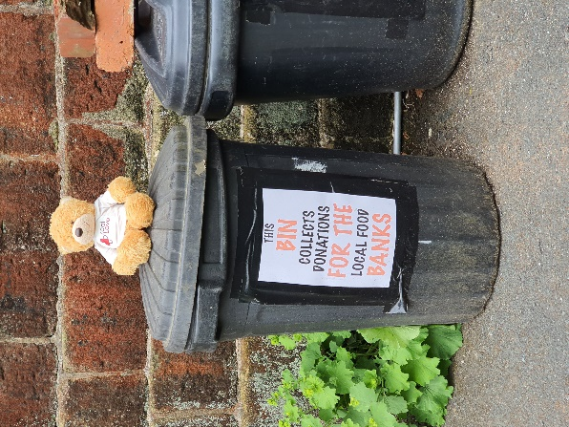

*At Blackshaw Head, Wes saw the food bins that have been set up to collect community donations for the local foodbanks; looked at the poster telling the local community what the chapel was still doing during lockdown; and shared in one of their online services. He now understands why this small chapel has gathered over 150 followers because it was very good. He was disappointed not to be able to share in the Sunday lunches which the congregation have been delivering to elderly members during lockdown. He is sure it would have been delicious.*

*At Heptonstall, Wes was impressed with how they had overcome the challenge of lockdown when family and friends from other countries were unable to attend significant life events such as weddings and funerals. Despite the lack of internet access, they still managed to record or stream services so that no one was excluded. He also very much enjoyed the afternoon get together in the local tearoom, supporting a new business that had opened during the pandemic. He heard about the way the members had kept in touch during the lockdowns, and swapped jigsaws to keep themselves occupied. The get together was to reassure those who were nervous about getting out and about that it was safe to meet up again. There was a lot of chatter, and cake!!*

*At Hebden Royd, Wes joined in a Church Family picnic. The congregation had prepared “Bee Green” bags, which were given out to members of the public to encourage them to think about the way they treat God’s creation. Wes also had an interesting adventure as he abseiled down the river wall to inspect the temporary repairs to the sewage outflow. Since they discovered that the outfall pipe from the church had broken, Hebden Royd members have been showing real love to the community and the environment by crossing their legs and not using the toilets until the pipe is repaired! Wes was helped to abseil by members of the Sunday Club.*