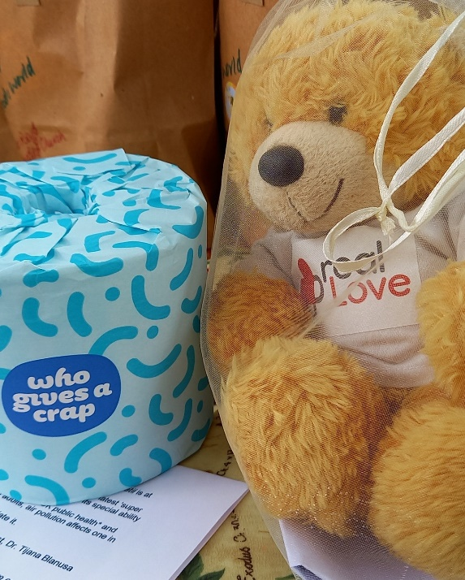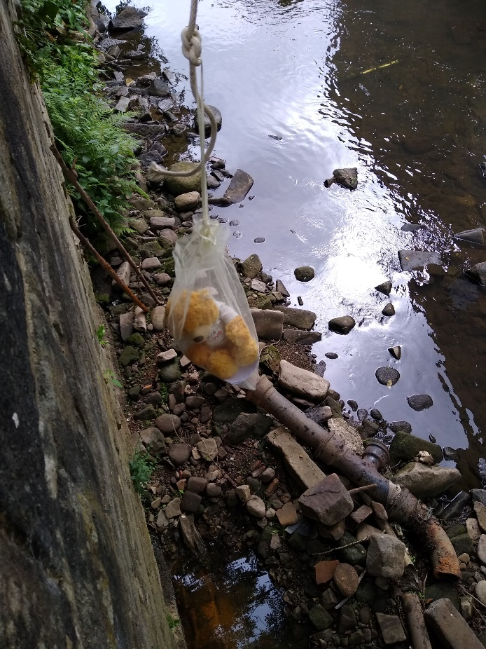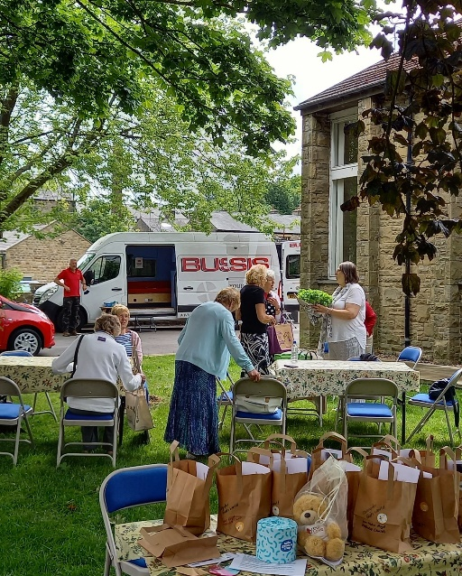

*At Hebden Royd, Wes joined in a Church Family picnic. The congregation had prepared “Bee Green” bags, which were given out to members of the public to encourage them to think about the way they treat God’s creation. Wes also had an interesting adventure as he abseiled down the river wall to inspect the temporary repairs to the sewage outflow. Since they discovered that the outfall pipe from the church had broken, Hebden Royd members have been showing real love to the community and the environment by crossing their legs and not using the toilets until the pipe is repaired! Wes was helped to abseil by members of the Sunday Club.*

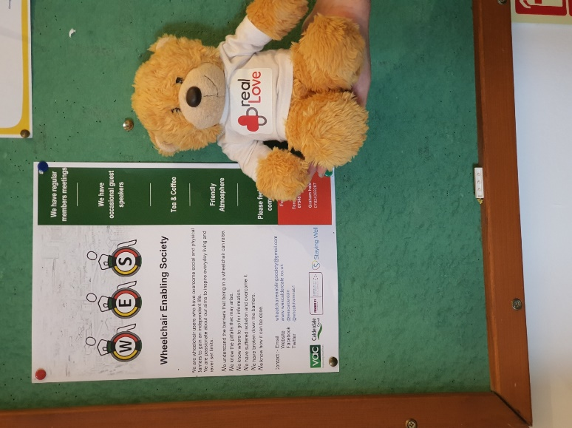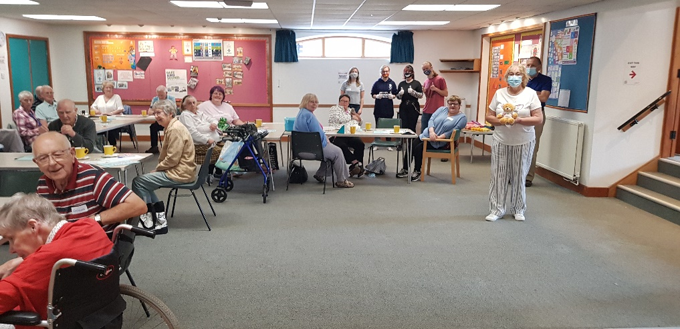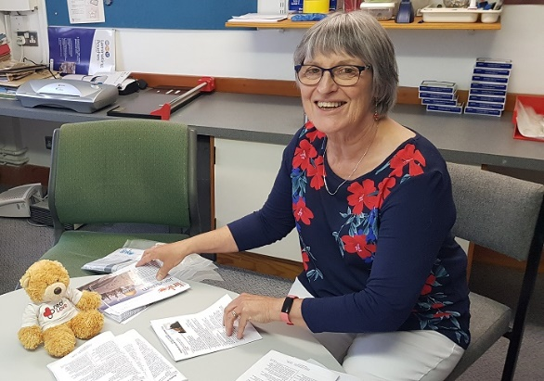

*At St Paul’s, Sowerby Bridge, Wes helped Angela to print and fold Kindling Flames and the Worship at Home material that have been helping to keep people connected during lockdown. He also visited Memory Lane, who help people with memory loss, and their carers. They were the first community group back in the building after lockdown, and being able to meet again was their way of showing real love. Wes was also delighted to discover that St Paul’s supports something with his own name – the W.E.S. the Wheelchair Enabling Society.*