Walking The Way 1 - Shibden Circular (January 2022) 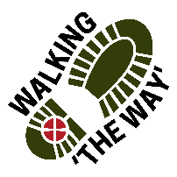
Meeting point @ Cafe

• Turn left towards the lake. Walk with a lake to your left.
• Take the first path to the right heading up hill.
• At the signposted junction turn left — signposted playground and toilets.
• Where the path forks, bear right.
• After 30 yards bear right following the sign for Shibden Hall. Steep track for several hundred yards.
• Bear left on reaching the pond.
• Pass through the gates to the hall. Some steps ahead.
• Walk around Shibden Hall garden (rectangle on map).
REFLECTION POINT 1
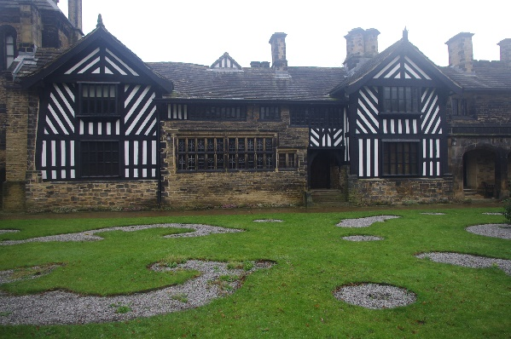
As you look around take a deep breath and take in the air. Breathe in and out consciously listening to your breathing.
As your heart rate and mind starts to slow down and relax take a good look around you. What do you notice?
Can you hear anything?
What do you notice about this building?
What do you notice about the gardens?
Do you prefer the order and conformity of the garden outside the front of the house or the wildness of other parts of the estate?
Sometimes our lives are ordered or free spirited when do you feel happiest?
When life is chaotic where do you turn to?
GOING DEEPER- SPIRITUAL
Perhaps you might like to reflect on those times and hand them over into God’s hands to deal with.
JOURNEY ON
• Take steps up from the start of the garden (tree at bottom).
• Bear left and take the terraced steps. Follow the path around to the right. Exit by the gate and continue a head up to the car park.
• Cross the road, bear left slightly and take the green gate opposite. 0.75 miles walked so far
Cunnery Wood (this is the additional 0.4miles not marked on the map)
Before doing this think about what it might be like under foot and the footwear you have on. Perhaps best done in Summer months.
After 30 yards bear left through another green gate to enter the wood.
Follow the path to the left.
· Branch off left under the archway of trees. Keep bearing left.
· Point of interest - There are four big pillars behind a wall in the centre of the wood if you want to go off track.
· Turn right before the hooped willow fence.
· Follow the logged stairway up.
· Go over wooden footbridge and bear right.
· Continue to follow the path down.
· Observe the former brick pathway if you scrape the leaves away on the path with your feet.
· Ignore pathways either side and just go back down the hill.
· It then bears left back to the green gate.
· Go through the gate and turn left to get back onto the official route
· 0.4 additional miles (1.15 total miles walked so far)

Back on the official route
• Continue up the hill along the shale path.
• Continue ahead, passing through the green gate. Note - Turret to your left.
• Continue on the path through the green gate passing through the stone wall.
• Pass through another green gate.
- Continue up to the signpost at the crossroads
Reflection Point 2
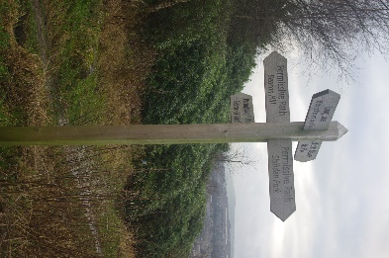
As you stand and look at the signpost and all around what do you notice?
There are different places that you can choose to go that will lead you on a different journey. Think about the crossroads in your life and the choices you have made at that time.
We all have different choices to make in our lives and sometimes we need help discerning the way to go. Who or what has helped you to make those choices or did you decide on your own? How did those choices work out?
Going Deeper- Spiritual: Have you ever prayed or asked God for direction?
If so, reflect upon the outcome. If not was there a reason for not doing so?
Journey Onwards
• At the signpost continue straight ahead following the permissive path for Beacon Hill. Steep track, hopefully not too steep! Great views over Halifax. You’ve now reached the Beacon! (1.7 miles so far)
Point 3 Beacon
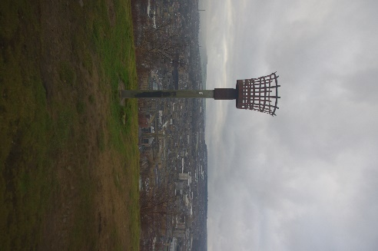
As you stand at the beacon, what do you see? How does this make you feel?
Beacons were lit to convey a message, those who saw the beacon lit knew what it meant when they saw the flame and in turn lit another beacon to pass the message on. Nowadays it is often lit as a celebration of an event.
What message of Good news have you received recently and what did you do with that message did you share it or keep it to yourself?
Going Deeper- Spiritual: At Christmas we celebrate the birth of Jesus and so that would be a good occasion to light a beacon. At Easter we celebrate the death and resurrection of Jesus again another reason to light a beacon. What events would you light a beacon for if you could?
The lighting of a beacon is significant as is the message of God’s love through Jesus. As you continue walking perhaps you might like to think of this or talk with someone on the journey with you.
Journey Onwards
• Continue to follow the path beyond on the Beacon.
• Turn left to follow a walled footpath. Ignore the footpath to the right.
• Proceed straight ahead through a wooden gate.
• Continue ahead passing to the left of the football field (Beacon Rangers). You are now at Barraclough Lane. Great view over Kirklees.
• Turn left. (2 miles so far)
• As Barraclough Lane arcs round to the right, bear left passing through a green gate and follow down a walled lane. You’re doing a loop.
Part way down there is a gateway looking towards one of the towers go and stand at the gate.
REFLECTION POINT 4
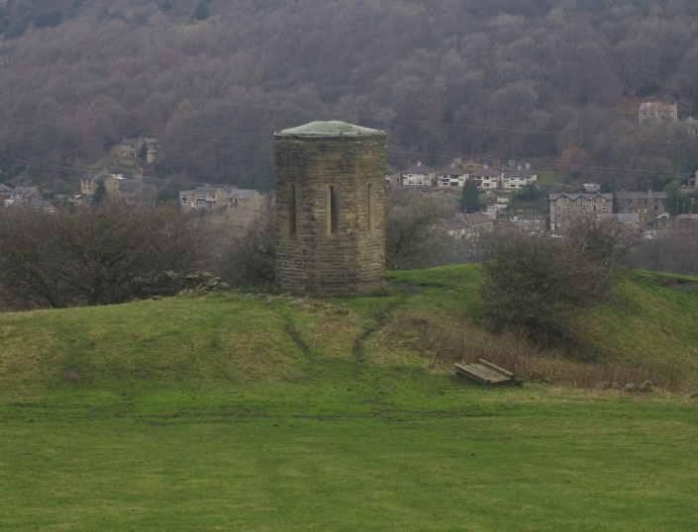
Stop for a few moments take a look around.
Have a look at the Tower what do you you think of when you see it?
As you look at the structure and age, think about the engineering and technology available at the time that enabled this to be built and how many people it would have taken.
Think about something that has taken you a while to do. How did you feel when you had completed it?
Perhaps you might like to spend a moment being thankful for that which you had achieved.
Going Deeper – Spiritual: We have talked about this tower and what it took to build. As you look at the landscape perhaps you might like to think about how that was formed and came into being and if you recognise God as being creative and imaginative.
Journey Onwards
• On reaching the signpost bear right to follow the permissive path back towards Shibden Park. That’s the end of the loop (2.2 miles so far)
• Trace your outward journey back down to Shibden Park to the top car park (2.6 miles so far). And back down to the café.
Alternative end to walk: Make sure you have good footwear for this. This official map tells you to turn right and go down Shibden Hall Road. This could be optional. You could just return to the café.
• Do not enter car park. Turn right and walk down Shibden Hall Road.
• Turn left down a narrow stoned footpath just before reaching Shibden Hall Croft (cul-de-sac).
• Pass through the railway tunnel.
• Continue straight ahead to enter the park with the children’s play area to your left.
• At the fork in the path, bear right down to the right of the lake.
• Follow the Lakeside pathway back to the car park. (3.4 miles in total, which includes the 0.4miles in Cunnery Wood)
