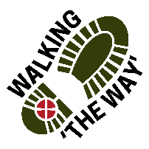Walking The WAY 1 of 6

Canal Walk 1.
Brighouse to Barge and Barrel Elland. 3 miles
Start Point- Car Park opposite ROKT. (Put 3hrs in meter)
On each walk you will find something you will need to collect or take along with you on the journey.
Use these sheets as a guide for your journey each time and take as much time as you need with each reflection.
Opening prayer. Lord as we take these steps on this journey, enable us to see you in the things we see, hear you in the things we hear and experience something of your presence and love as we journey on. Amen

TASK: Pick up a pebble along the way and hold it in your hand for a while then place it in your pocket or bag for the time being.

Walk for 15 minutes to Point 1. Along the journey pick up a pebble

STOP POINT 1: Lock Keepers Cottage Area 2 of 6
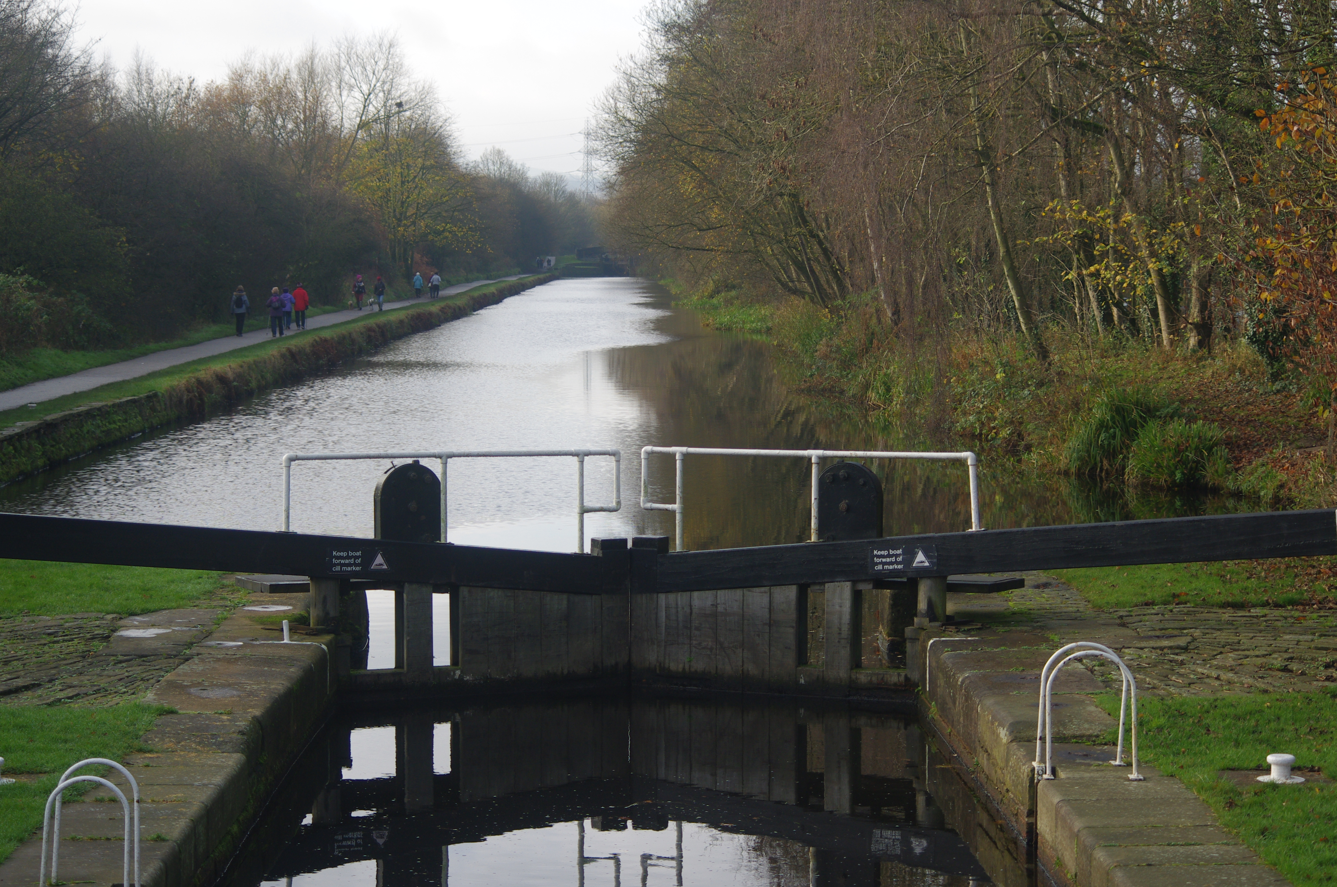
- Be still for a few moments.
- Take a look around.
- What draws your attention?
- Focus on one thing for a few moments, think about what is special about that thing?
- Appreciate and be thankful for that experience.
Perhaps you might like to say Thank you to God for showing you that thing.
As you journey onwards think about what you have just experienced.
MOVE ON and walk 15 minutes to Point 2.

POINT 2 CROMWELL BOTTOM 3 of 6
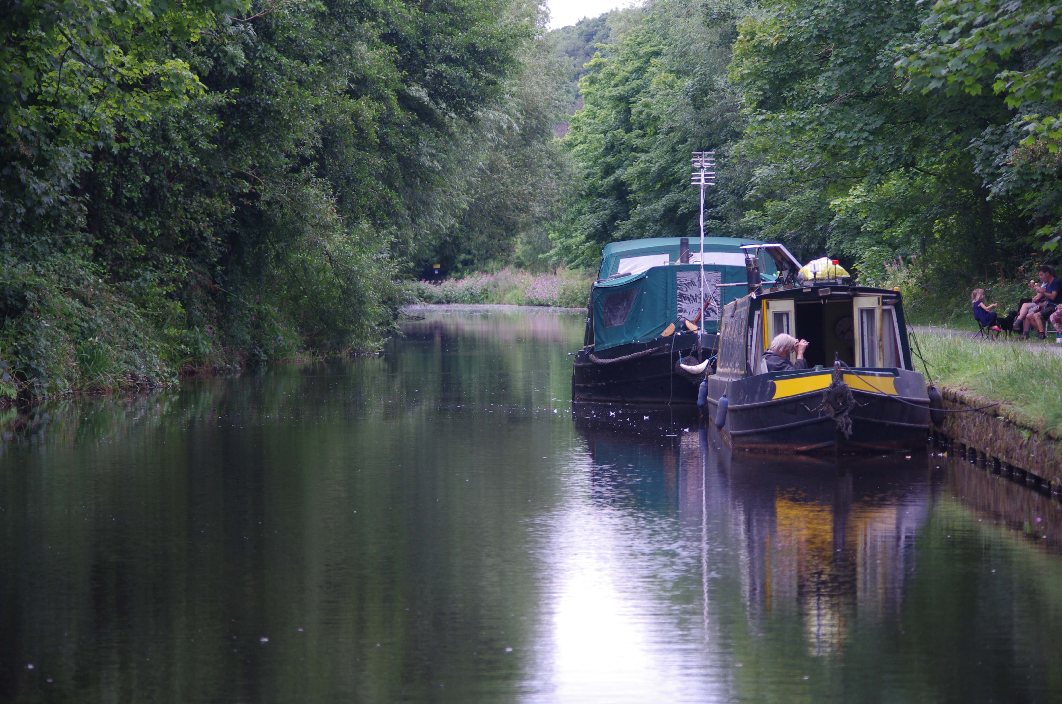
- Be still for a few moments. Take a look around.
- Now close your eyes a few moments and listen. What do you hear? Now open your eyes.
- Focus on that thing for a few more moments,
- What does that sound make you feel like?

Appreciate and be thankful for what you have seen and experienced. Perhaps you might like to say Thank you to God for showing you that thing and the thing you heard and experienced.
MOVE ON and walk for 10 Minutes to Point 3 Wooded area!

POINT 3: Woodland Area 4 of 6
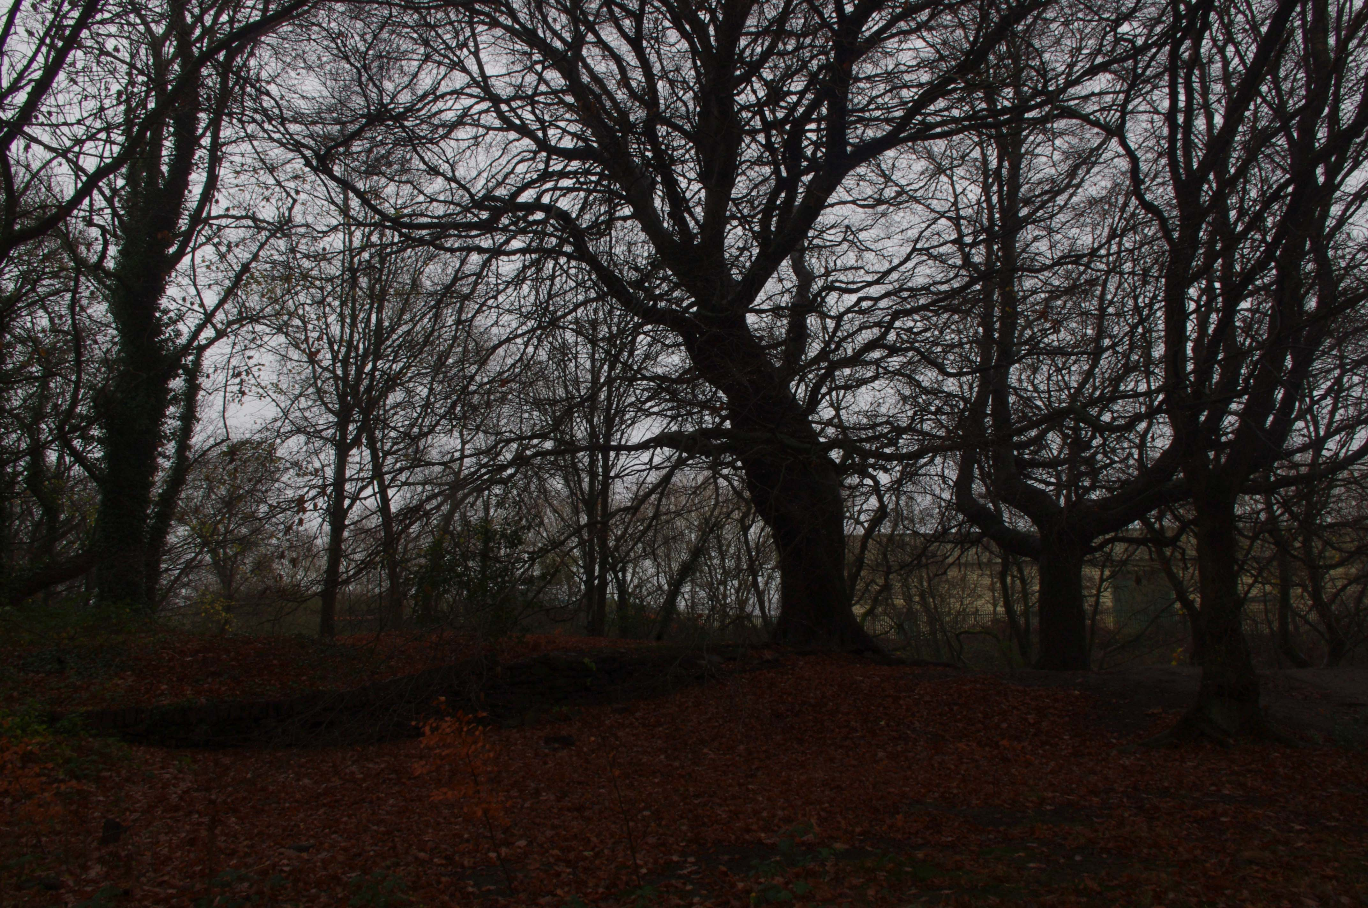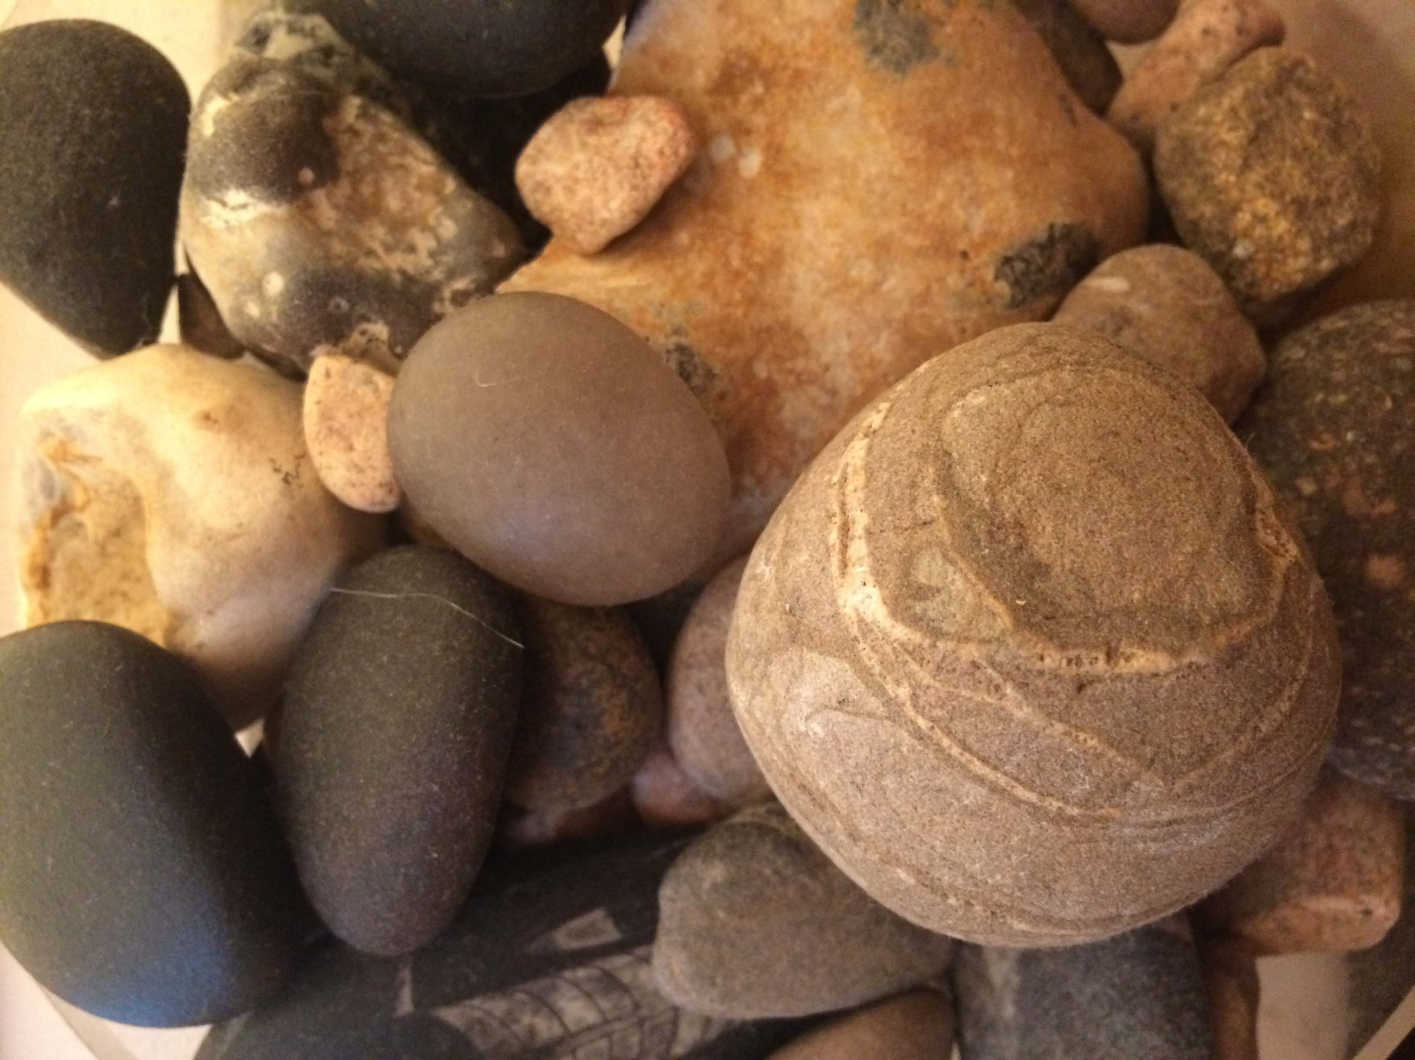
- Be still for a few moments. Take a look around.
- Take out your pebble from your bag or pocket and move it around in your hands. Feel the texture, the heat/ cold.
- Look at the pebble and think how it came to be where you found it. Think How did it get there? How old is it? Is it naturally formed or manmade?
- Think about how you got to be where you are and how you are formed as a person.
Appreciate and be thankful for that experience. Perhaps you might like to say Thank you to God for showing you that thing.
As you journey onwards think about what you have just experienced.

MOVE ON to Point 4 approx. 10 minutes. Lock keepers house near to Crematorium.

5 of 6
POINT 4: Lock Keepers Cottage near Crematorium
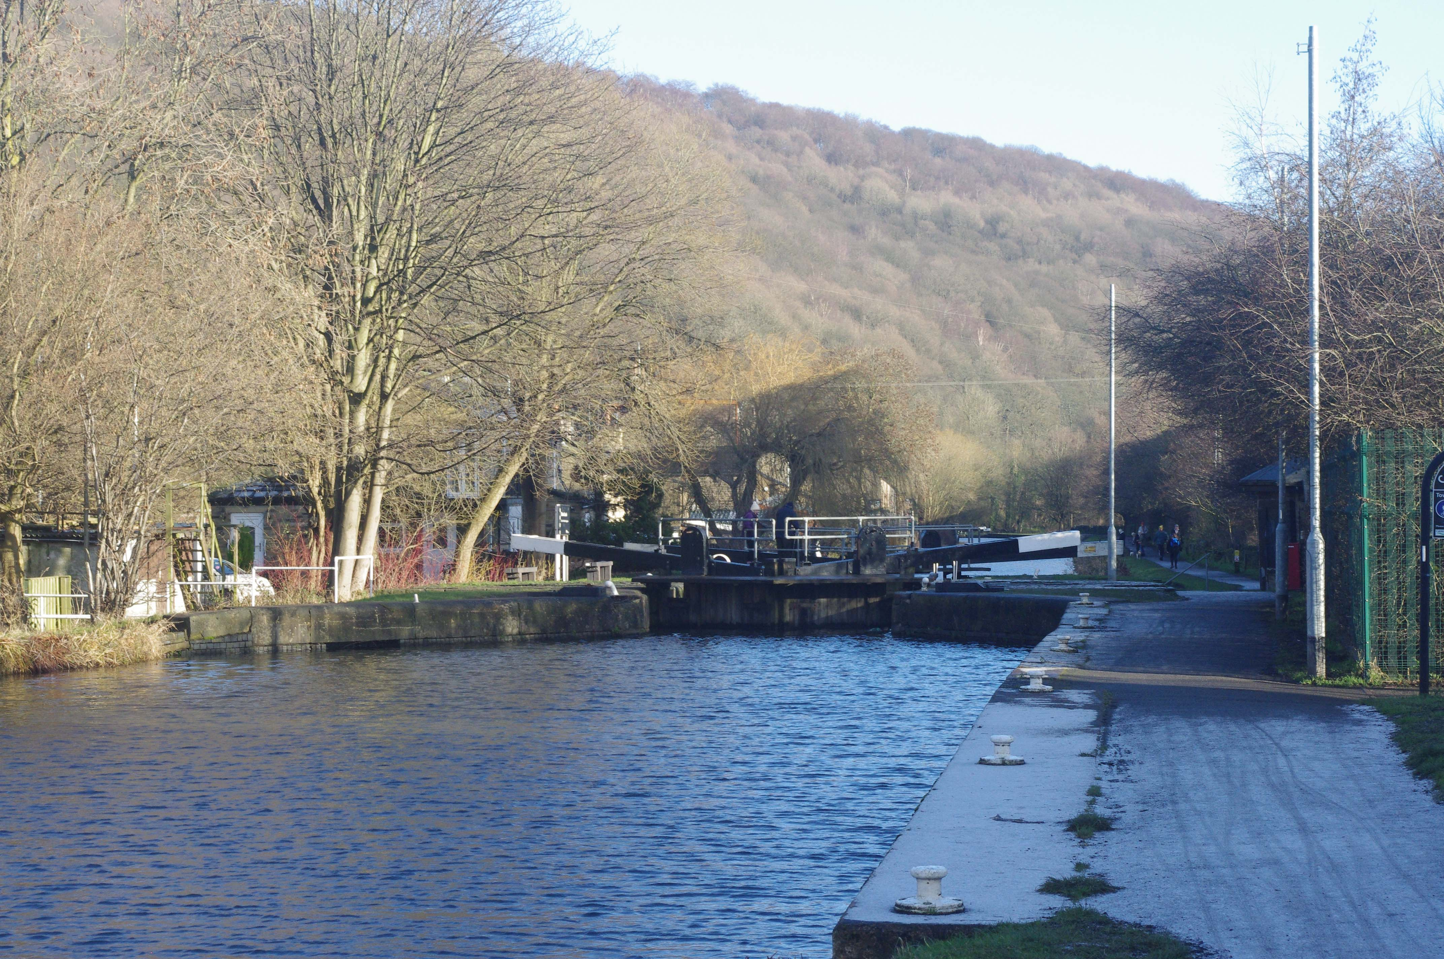
- Be still for a few moments. Take a look around and look at the water.
- What do you see? Think about where that water has come from. Think about where the water is going and the journey it is on and how it gets there.
- Think about your life again and the journey you have been on, think about the journey you are currently on and how you are enabled to move onwards.
- Think about Who or What are the Locks/gate keepers that allow you to move freely?

Appreciate and be thankful for that experience. Perhaps you might like to say Thank you to God for providing you with people who give forms of encouragement that help you to move on.
As you journey onwards think about what you have just experienced.

MOVE ON to Barge and Barrel Car Park far end. Approx 10 minutes

At the end of the journey Liturgy. Barge and Barrel 6 of 6
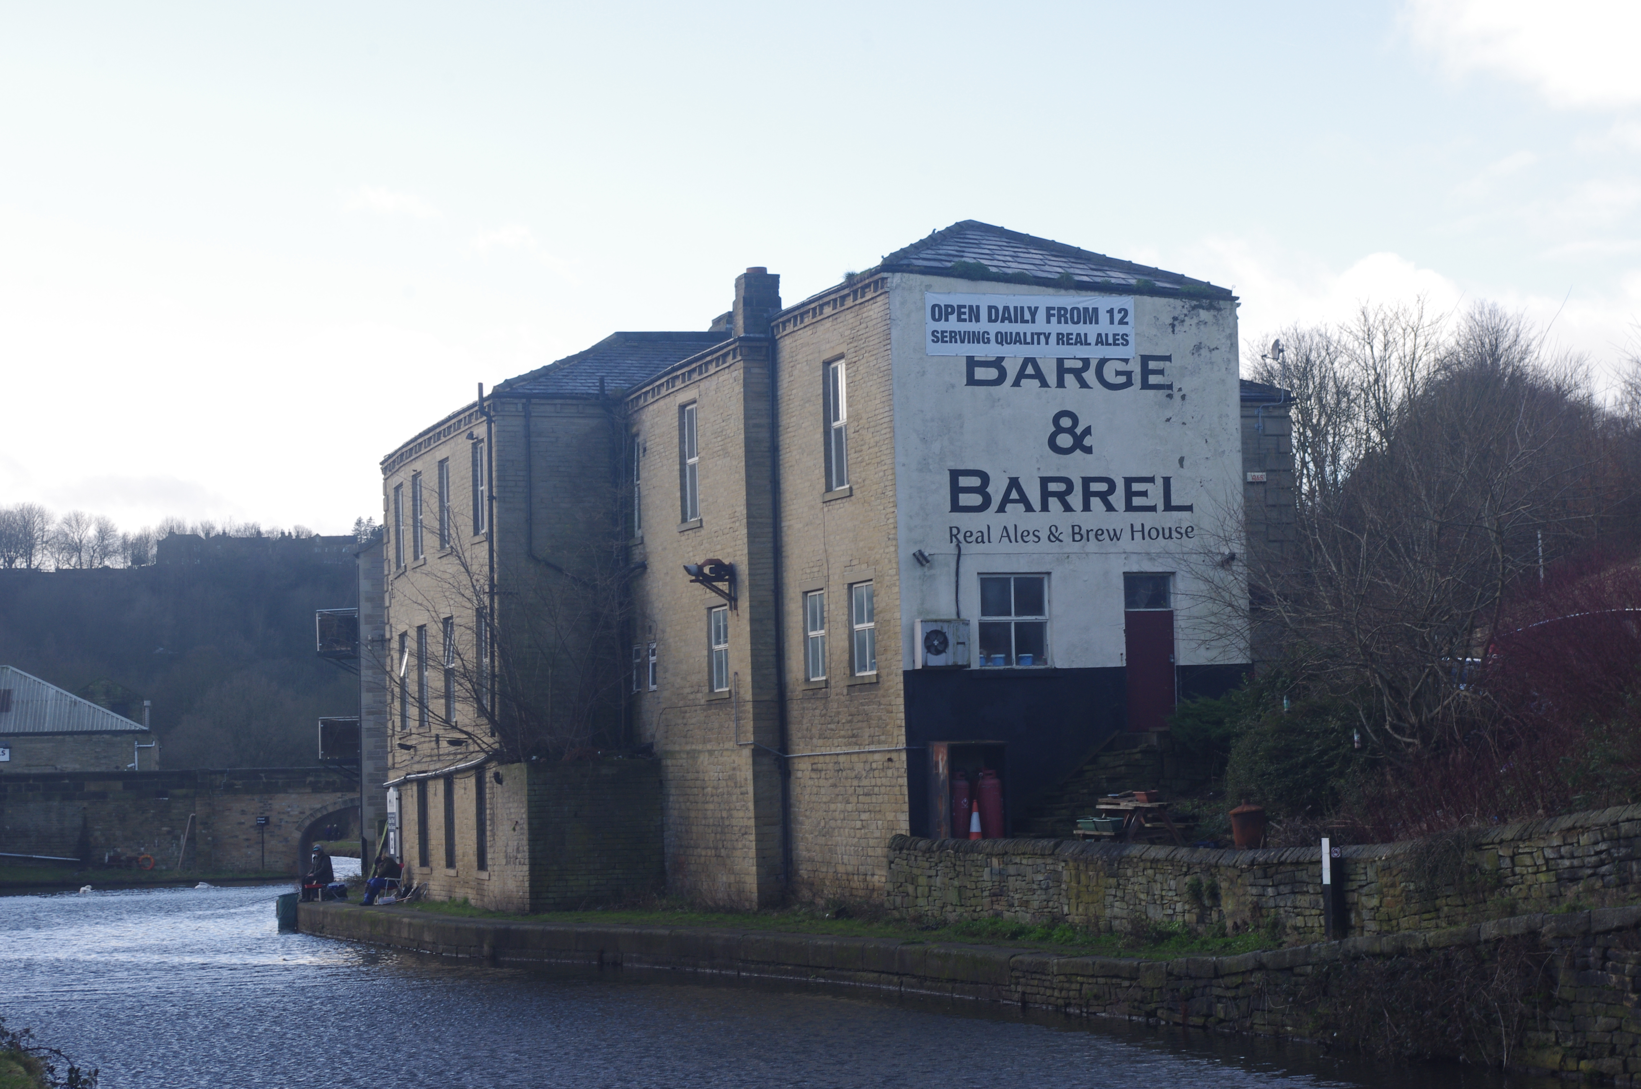
- Take out your pebbles again.
- Now instead of thinking about yourself, think about this pebble representing someone in your life or who you know who needs holding by God at this time and place them together to form a Cairn.
PRAYER. Lord we thank you for all we have seen, heard and experienced along this journey. We place these stones in this space, at this time and into your holding hands. We thank you for these people who are represented by these pebbles, who have journeyed with us and who now are and have always been held by you. We thank you for those who have journeyed so far with us and have blessed us along the way. Amen.
JOURNEY HOME and be blessed

