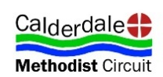
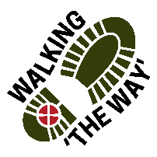 Walking The WAY 1of6

CANAL WALK 2
Barge and Barrel to Sowerby Bridge 3.7 Miles 1 hr 15 mins. approx
Lord as we take these steps on this journey, enable us to see you in the things we see, hear you in the things we hear and experience something of your presence and love as we journey on.
TASK: Today you will need to pick up a stick and carry it with you for the journey.
If you journey with someone else perhaps you might like to share your thoughts and experiences between Stopping Points.
Walk for Approx 8 minutes

Walk 2 POINT 1 WOODSIDE FLOWER MILL 2of6
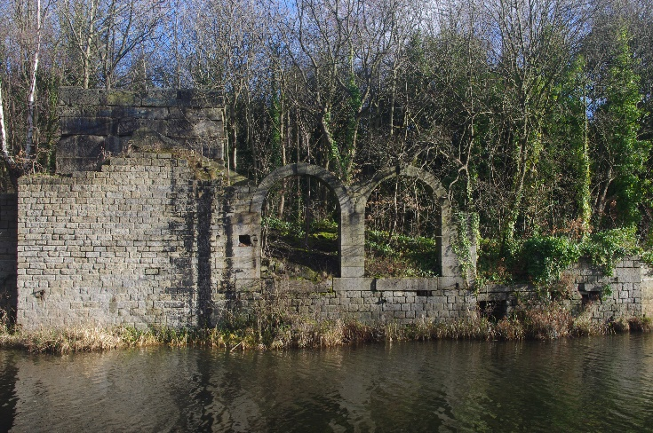
- Be still for a few moments.
- Take a look around.
- What draws your attention?
- Focus on one thing for a few moments
- What is special about it?
- Think about the history of this place and what went on here.
- Think of the people who worked here and their lives.
- Appreciate and be thankful for what you have seen and experienced.
- Perhaps you might like to say Thank you to God for showing you that thing.
As you journey on think about what you have just experienced.
MOVE ON: Walk approx. 17 minutes to Salter Hebble Lock Keepers cottage

3of6
Walk 2 POINT 2: LOCK KEEPERS COTTAGE SALTER HEBBLE
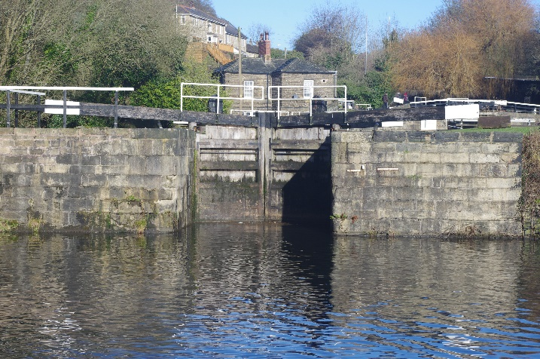
- Be still for a few moments.
- Take a look around.
- What draws your attention?
- Focus on that one thing for a few more moments
- What is special about it?
- Appreciate and be thankful for what you have seen and experienced.
- Perhaps you might like to say Thank you to God for showing you that thing.
- As you journey onwards think about what you have just experienced.
Journey On. Walk approx. 20 minutes to wooded area just past overhead iron bridge and before next bridge.

Walk 2 POINT 3: WOODLAND AREA / SPACE 4of6
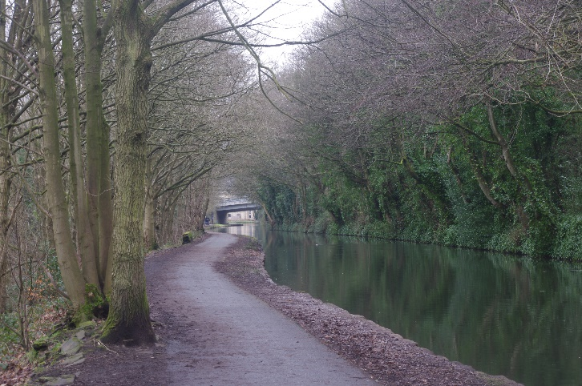
- Be still for a few moments.
- Take a look around.
- What draws your attention?
- As you look at the trees at the waters edge think why they are there.
- Take out your stick and think about how old it must be?
- Think about the stick in your hand. How did it get to the place where you found it?
- Think about how you got to be where you are and how you are formed as a person.
- Appreciate and be thankful for what you have seen and experienced.
- Perhaps you might like to say Thank you to God for showing you how he got you to be where you are at this point in your life.
As you journey on think about what you have just experienced.

MOVE ON! Walk about 25 minutes to Sowerby Bridge Marina between Top Locks.

5 of 6
Walk 2 POINT 4: SOWERBY BRIDGE MARINA- TOP LOCKS
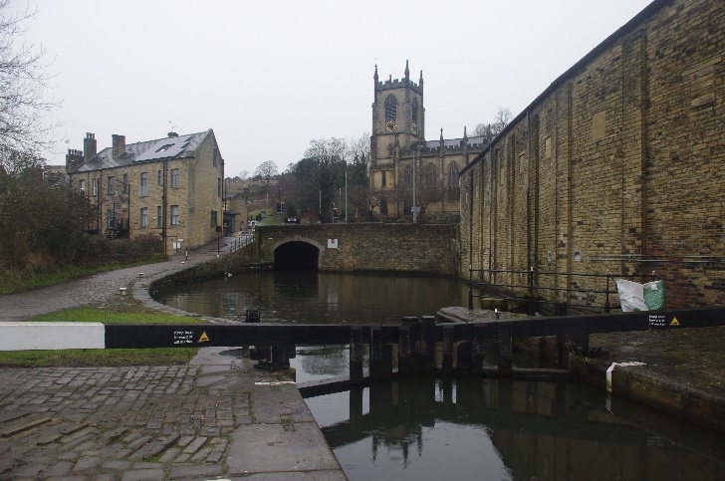
- Be still for a few moments.
- Take a look around.
- What draws your attention?
- Focus on the water, think about where that water has come from.
- Think about where the water is going and the journey it is on and how it gets there.
- Think about your life again and the journey you are on, how have you been enabled to move onwards.
- Appreciate and be thankful for what you have seen and experienced.
- Perhaps you might like to say Thank you to God for showing you that thing.
Take your stick and place it the other side of the fence along with others that have been placed there or have fallen there.
Lord we leave these sticks in this place as a reminder of our journey together. We Know you bring to birth new things, repurposing the old, and bringing joy and peace through them. We thank you also for people who have opened doors of opportunity for us, bringing about newness of life. Amen
MOVE ON to Market Place. Approx 3 minutes

6 of 6
Walk 2 End: Sowerby Bridge Market Place.
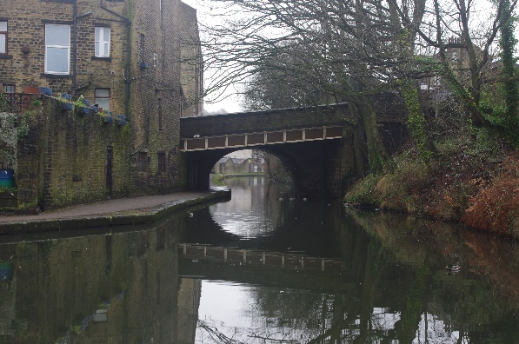

Lord we thank you for all we have seen, heard and experienced along this journey and seen something of you and your creation. We place our sticks together and are reminded that together we can be made into something wonderful and creative.
We thank you for those who have journeyed so far with us and have blessed us along the way. Amen
COFFEE

