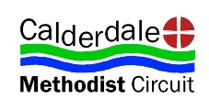
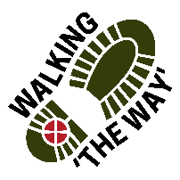 Walking The WAY

CANAL WALK 4 1 of 6
Mytholmroyd – Hebden Bridge:
Start at St Michaels.
TASK: Take note of people you see on the way.
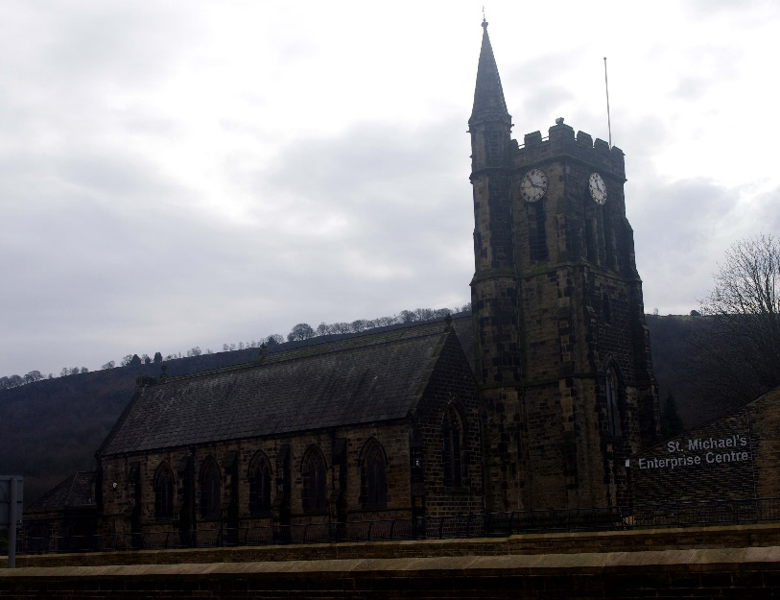

Lord as we take these steps on this journey, enable us to see you in the things we see, hear you in the things we hear and experience something of your presence and love as we journey on.
Cross Road safely to Remembrance Statue.

POINT 1: Remembrance Statue 2 of 6
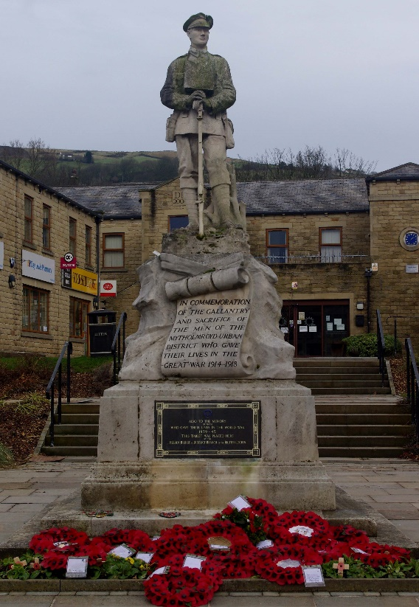
- Be still for a few moments.
- Think about what you see around you.
- Look at the monument, what emotions does it make you feel?
- Think about those who have lost their lives given for your freedom.
- Think about the freedom you have. What are you able to do?
- Think of others around the world on a different journey whose freedom is restricted.
- Appreciate and be thankful for the freedom we have in our lives.
- Perhaps you might like to say Thank you to God for the freedom we have and pray for those for whose journey is restricted.
MOVE ON! Enter the canal path next to Russel Dean furniture store and walk towards Hebden Bridge to Road Crossing. Approx 5 minutes.

POINT 2: ROAD CROSSING 3 of 6
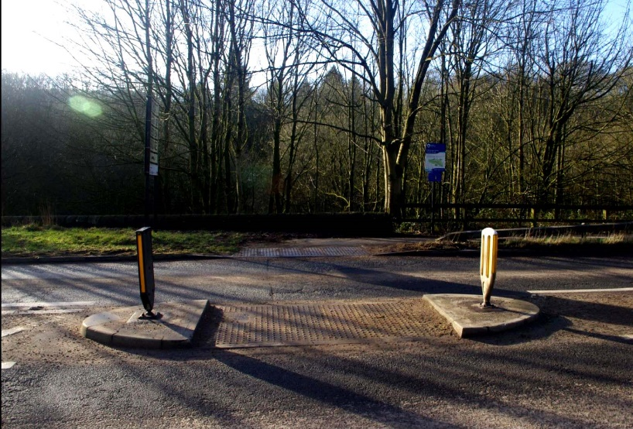
- Be still a few moments
- Listen and watch the traffic pass by
- Think about where these people may be going
- Now think about people on journeys and how sometimes there are obstacles like the road is an obstacle for us to continue on our journey.
- Think about what the obstacles are that you have.
- See these things as what they are just obstacles and not blockages.
- Think about the things that are there to help cross safely.
- Recognise who or what you have in your life that helps you navigate the obstacles of life.
- Appreciate and be thankful for the experiences you have in life and for those who help you.
- Perhaps you might like to say Thank you to God for walking with you through those times and providing others too.
MOVE ON! Walk for about 12 minutes to the Park

POINT 3: PARK – Leisure / Recreation 4 of 6
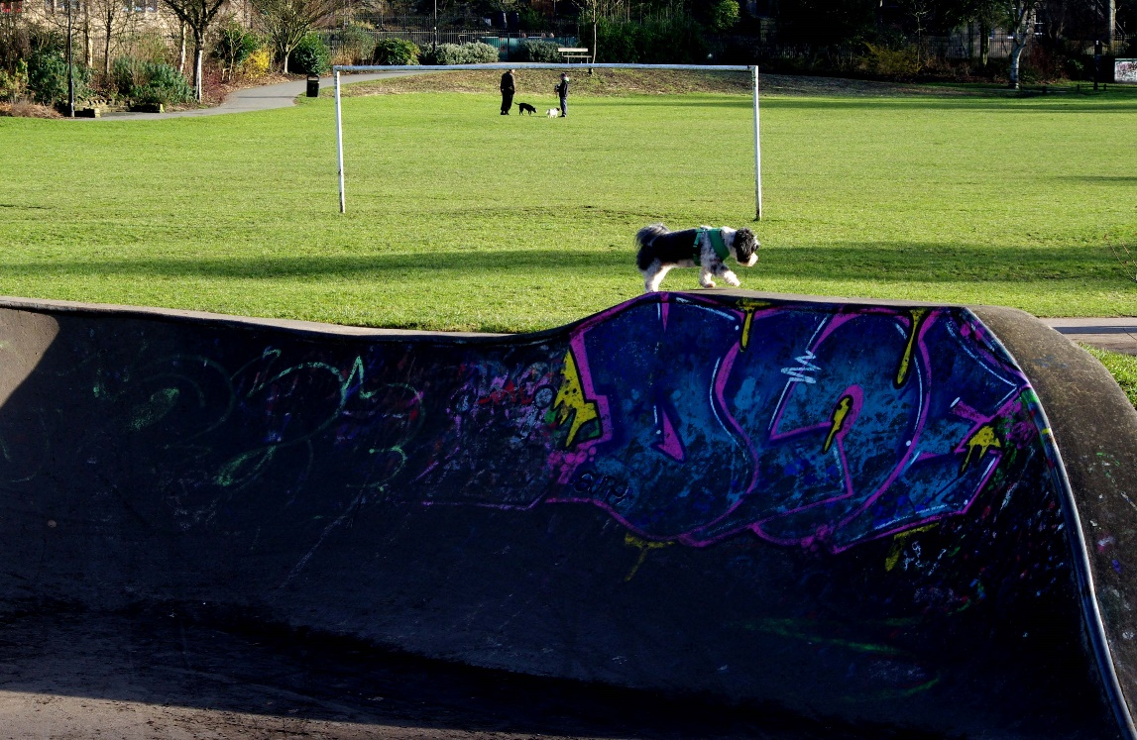
- Be still for a few moments.
- Think about what you see around you
- We are in a place and a space that people use for their well being and recreation.
- Think about that word ‘Recreation’ or perhaps ‘Re-Creation’.
- Where are the spaces or places you go to for your recreation or re-creation. What is special about those places.
- How do you feel in those places/spaces?
- Appreciate and be thankful for those places/spaces. Perhaps you might like to say Thank you to God for providing those places that help to re-create you.
- MOVE ON. Leave the canal by the Lock and head into the Town Centre where the Bridge crosses the river by the Coffee Shops

POINT 4: CAFÉ BY RIVER and Bridge 5 of 6
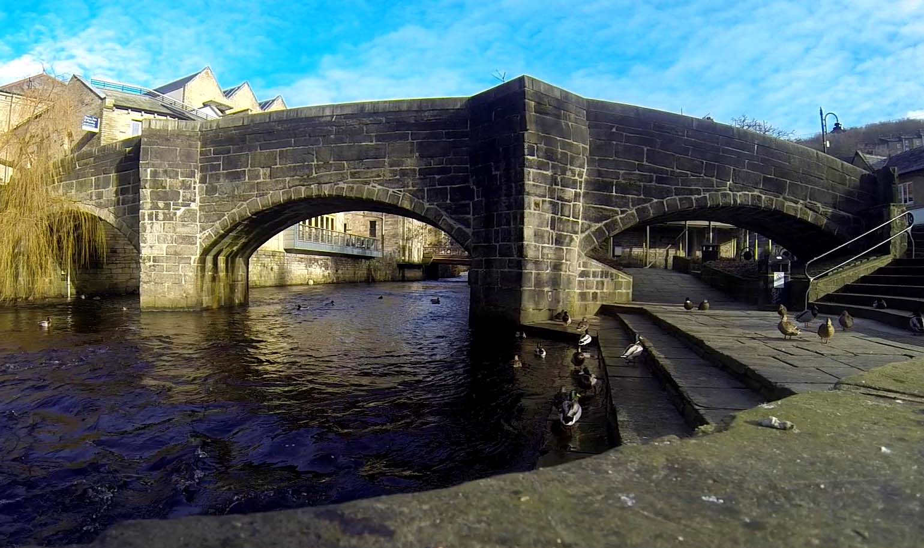

- GET COFFEE/ DRINK from Café of your choice.
- Be still for a few moments.
- Look around. What do you notice?
- As you sit/ stand in this place what do you feel about it?
- Concentrate on the river, a different form of water from the canal what do you see that is different with the river?
- Both are bodies of water essentially the same H2O and yet different in many ways. Think about that in the context of this place with its cultural diversity
- Appreciate and be thankful for the diverse cultures that improve the society in which we live.
- Perhaps you might like to say Thank you to God for being able to experience and accept different life choices.
MOVE ON! Head back to the Canal and proceed to next bridge and come off canal just before it. Walk down road over River to Hebden Royd Methodist Church on left.

Hebden Royd Methodist Church. 6 of 6
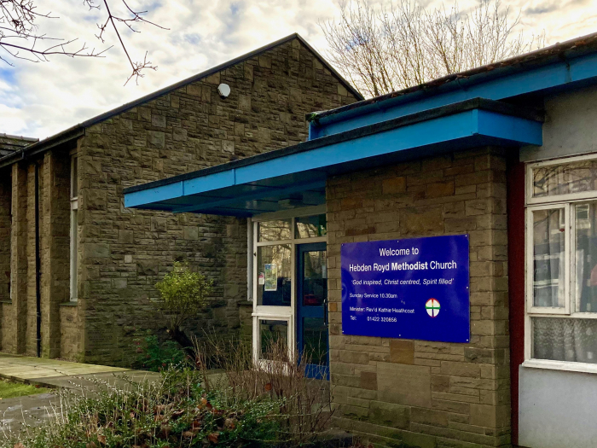
- Think about all those people you have seen on your journey.
- Perhaps some are memorable to you, why not ask God to bless them.
At the end of the journey Liturgy
Lord we thank you for all we have seen, heard, and experienced along this journey and seen something of you and your creation. We thank you for those who have journeyed so far with us and have blessed us along the way. Amen

Safely travel home and be blessed.

