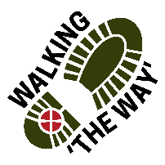 Walking The WAY 1 of 6
CANAL WALK 6

Shaw Wood Road Todmorden OL14 6DB – Todmorden Market Place
Park in Layby on right just after Shaw Wood Road (on left) also signposted Mankinholes and Lumbutts.
Walk down Shaw Wood Road and join the canal.
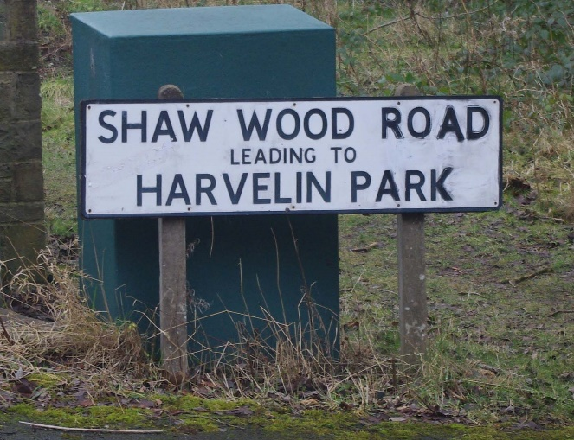
TASK: MONEY (Cash or Card). Have some in your pocket.
Starting Liturgy: Lord as we take these steps on this journey, enable us to see you in the things we see, hear you in the things we hear and experience something of your presence and love as we journey on.

Walk to stables on left before next lock. Approx 8 minutes

POINT 1: Stables: 2 of 6

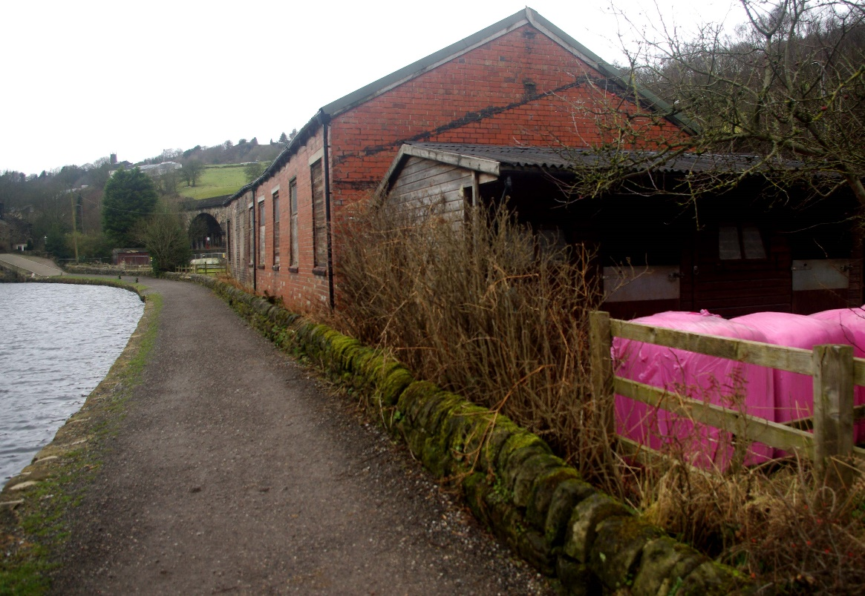

- Be still for a few moments.
- Take a look around.
- What do you see? What draws your attention?
- Stables provide shelter and security for horses and other animals. Where are the places you find shelter in your life on your journey?
- Think about what this shelter provides for you?
- Appreciate and be thankful for the places where you find shelter.
- Perhaps you might like to say Thank you to God for showing you the places of shelter in your life.
MOVE ON! Walk for about 10 minutes to Sunk boat before Lock

POINT 2: Sunk boat 3 of 6
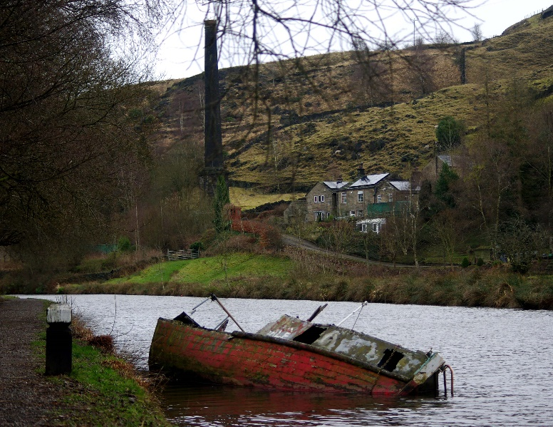

- Be still for a few moments.
- Take a look around.
- What do you see? What draws your attention?
- As you see the partially submerged boat, how does that make you feel?
- If you had the resources what would you do with this boat?
- Can you think of anyone whose life resembles this boat?
- What could you do to help?
- Appreciate and be thankful for the resources you have.
- Perhaps you might like to say Thank you to God for showing you that person whom you can help.
- MOVE ON! Walk about 10 minutes to the Marina.

POINT 3: Baltimore Marina 4 of 6
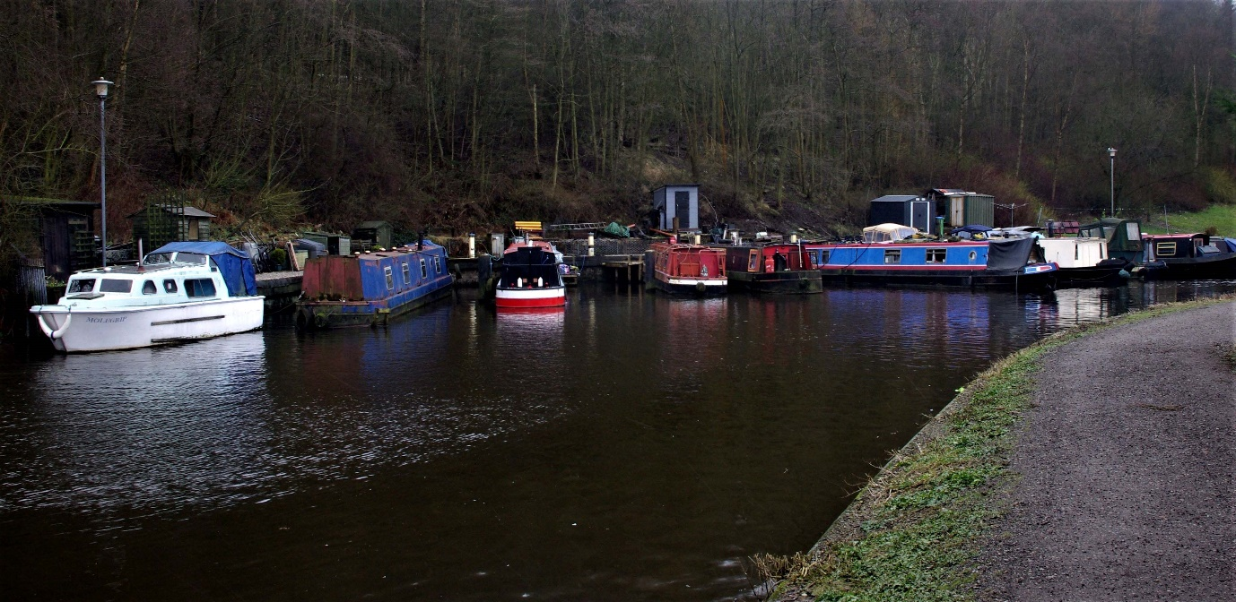

- Be still for a few moments.
- Take a look around.
- What do you see? What draws your attention?
- All of these boats are people’s homes. Where do you call home?
- Is home somewhere you physically live, or is it a different place?
- What makes you ‘feel at home?’
- Appreciate and be thankful for the home you have.
- Perhaps you might like to say Thank you to God for the place you call home.
- MOVE ON! Walk for about 5 Minutes to the Market Place
Come off the canal at the Car Park next to the Canal before the Lock and walk down the street safely cross the main road and walk into the Market Place.

POINT 4: Todmorden Market Place 5 of 6
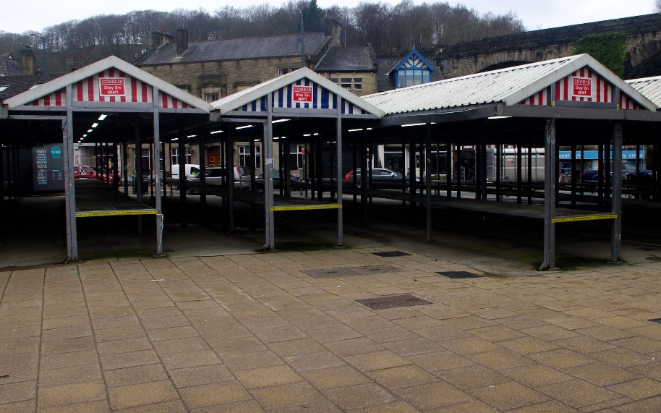
- Be still for a few moments.
- Take a look around.
- What do you see? What draws your attention?
- Think back to a time before supermarkets, these places were the hub of the community bustling with life. Where are the places you find fulness of life and energy?
- Where do you feel a sense of community and belonging?
- Think about what groups or communities you would like to belong to. Why not make enquiries about joining a group or community that will be life giving for you?
- Appreciate and be thankful for the groups or communities you belong to.
- Perhaps you might like to say Thank you to God for those groups.
- Perhaps you might ask God for wisdom to know which groups or communities to join.

6 of 6
- Stand in a safe place out of the way in the Market Place.
- Take out the money you have been carrying, hold it in your hands.
- Think about how money is relevant in this place and context.
- Think about the things Money enables you to do.
- Think of the journey so far you have been on and what money has enabled you to do up to this point.
- Think of those who live in poverty and are restricted in life because of their lack of money.
- Give thanks for everything that brings you life.
- Give thanks for those who bring life to others.
- Perhaps you may wish to make a donation to a Charity that helps bring life to others.
- Perhaps you might like to thank God for all you have that enables you to live life and help to give life to others.
Final Prayer: Lord we thank you for all we have seen, heard and experienced along this journey and seen something of you and your creation. We thank you for those who have journeyed so far with us and have blessed us along the way. Amen
Journey home safely and be blessed.
Look out for more walks from ‘Walking The WAY’.

