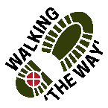 Walking “The WAY” Hardcastle Crags April 2022
Walk Time 1 ½ hours approx. Distance 3 miles approx.
You will need to pay for Parking in car parks £5 or Free for National Trust Members
Before you begin make sure you have the right footwear, equipment (poles if needed) and clothing. This walk along the riverside can be wet and slippy in places, having to walk down steep steps at times and up naturally made stone steps with roots exposed in places.
Start Point:- Begin at the kiosk looking wooden building (near the car parks) and walk down the road a very short distance . Turn right and go down the path down towards the river.
At the bottom go forward with the river on your left. Keep going, taking in the wonderful scenery and the sound of all you can hear until you come to a set of steps going down.

Reflection Point 1 STEPS
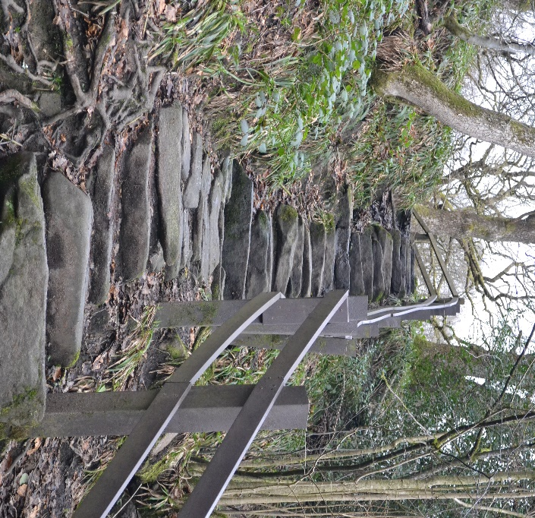
As you get to the bottom of the steps, find some space and look back up at the steps you have just come down.
- Think about the speed you came down those steps.
- What did you feel like coming down those steps?
- What did you do to help you come down the steps?
- As you were coming down the steps where were you looking?
- Did all those things help you descend safely?
SPIRITUAL- Like coming down the steps, sometimes in life the path is uncertain and we need help. Who has been a helping hand for you?
Continue on the journey with the river on your left.
At some point you will climb up and turn left down to a beach like area with stepping stones.

Reflection Point 2: - WEIR
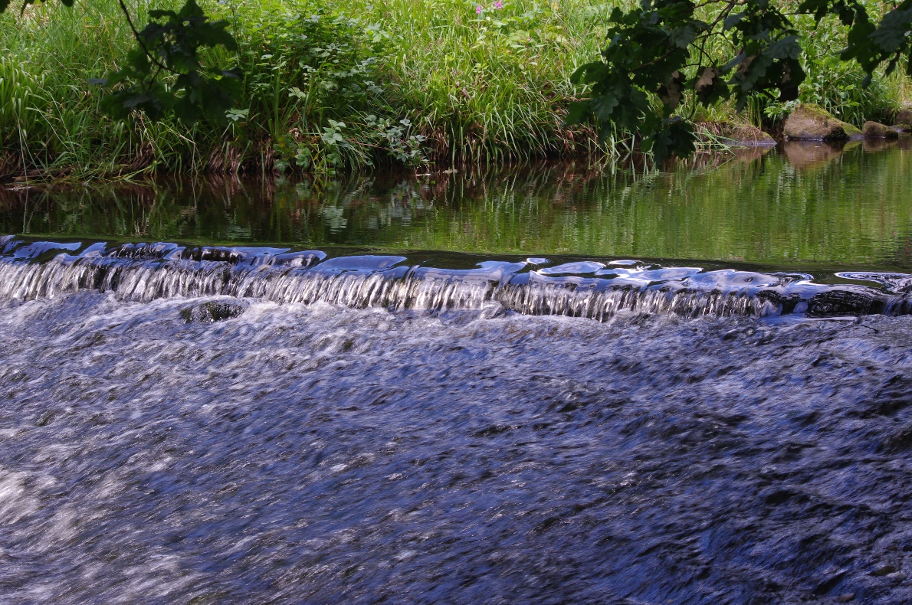
As you look at the weir briefly close your eyes for a moment and just listen to the water and note any other sounds you hear.
- What did you experience during that time of closing your eyes?
- As you look at the weir, think about the volume of water that is passing over it and depending upon the weather is it slow or fast?
- Think about where the water has begun its journey and perhaps where it is going and where it will pass through.
- This water is also on a journey and may end up in another part of the world and is being carried along.
- Think about your journey and who you have shared the journey with and carried along with.
SPIRITUAL- Often water is used as a symbol of the Holy Spirit cleansing, refreshing and even fluid in terms of not knowing where it will take you. Are we willing to be cleansed, refreshed and allow the Holy Spirit to take us along on the journey through life as we travel with others for a period of time?
Continue following the river all the way until you get to a clearing and you can see the Mill not far ahead. When you get to the mill go to the right of it on the main track road and go around the back and you will see a big pond.
Reflection Point 3: Beach like area 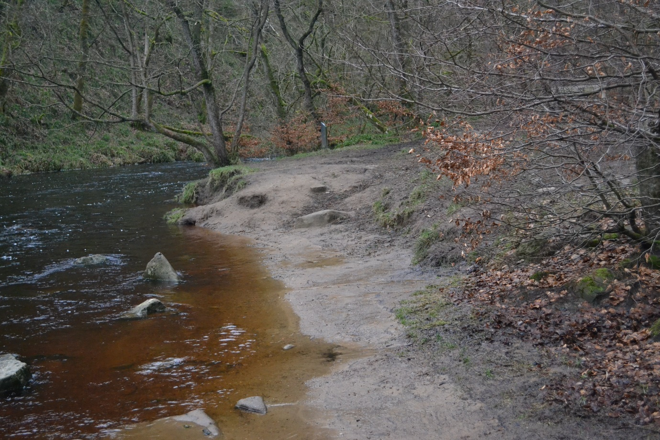
As you stand and look at the scenery perhaps you might like to firmly place your foot at the waters edge, not in the water but on the sand.

- Watch and feel what happens when you place your foot there. What does it feel like?
- Now take a step backwards and look at your footprint. This is a marker of who you are and where you are.
- You have left something of who you are and your presence in this place. Think about what other places you have left something of yourself on your life’s journey.
SPIRITUAL- Give thanks to God for those places you have been and invested in and left something of yourself.
Today this is a place you have been, you have left your mark in the sand and now it is time to move on. It is good to remember this time and place, we cannot forever be in this place as we have a journey and an adventure to continue and new things to see and experience. We have to leave things behind in order to move on. Journey on with the river on your left until you come to a weir.
Reflection Point 4: Gibson Mill Pond
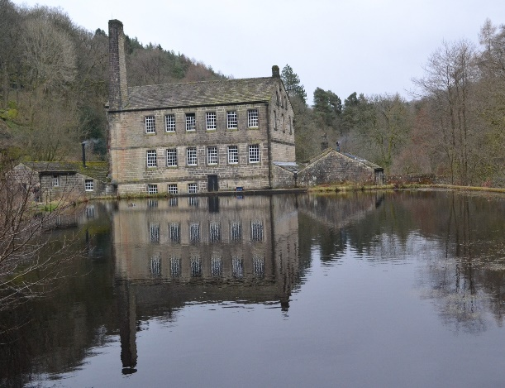
- As you look at the pond notice to see how still it is, look at the water what can you see in the reflection?
- Take a few steps either way left or right, backwards or forwards to get a different perspective and look again at the water and look what you can see in the reflection.
- The reflection we see will be different depending upon what angle we look at the water. In the same way in life we can see things from different perspectives if we are willing to move and look again from a different place.
- Think about things in your life where you have changed your view because you are able to see things from another point of view or perspective.
SPIRITUAL- When we decide to follow Jesus, we begin to see things from a different view point. We may even see a reflection of ourselves differently when viewed from God’s perspective.
When you see a reflection of yourself what do you see? Think about how you see God’s view of you.
God’s view of you is one of love, acceptance and worth. How do you feel about that?
Lord God, we thank you for this journey through life so far and all the things we have thought about on this journey today and thank you for travelling with us and continuing to do so. Amen
Make your way back to the car park following the track road with the river on your right. You may want to have some refreshments from the Café at the Mill before you return.

