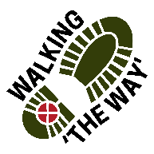
Norland Moor Circular

Getting there and parking
The walk starts at Norland Park, Sowerby Bridge. HX6 3RL.
Meet in the carpark (near the swings and slides).
To access the car park, take the narrow track beside the electric pylon.
No parking charges.

Other information
Walk length 3 miles (c. 1 1/2hrs)
Easy walk – terrain good and no steep paths.
Sandy, rocky path for most of walk
No facilities.
Exposed in places, so bring something to cover up if weather changable. Long trousers advised with moorland.

Route Details and reflections

- Leave the car park to follow the path to the left of the ‘Access information’ point.
- Continue straight ahead, ignore the path off to the left after 50 yards.
- Ignore further path off to the left and rise up a slight incline to a seat at the top of the hill.
- The path merges with another trail joining from the left but press onto the right
- Viewing point just after metal fence on right-hand side. Looks out over Sowerby bridge.

Reflection 1- View
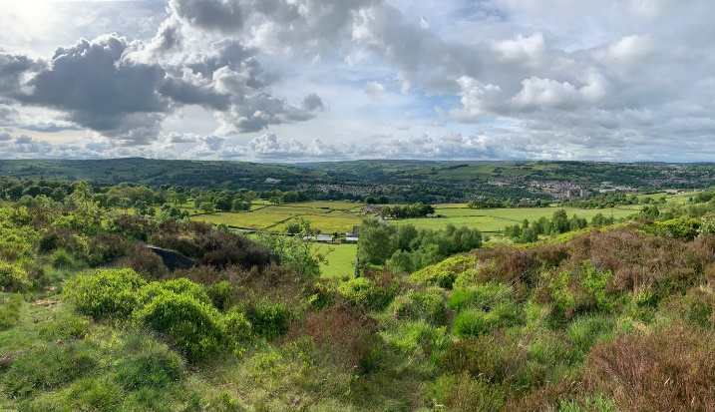

As you look out over towards Sowerby Bridge think about the densely populated area and the people who are currently there.
As they go about their daily lives think about what they might see if they were stood here and if they might feel different by standing here.
Sometimes its good to ‘be in other people’s shoes’ and seeing life from their perspective with their joys, sorrows, celebrations and struggles. When have you felt empathy with others?
Did that empathy lead you to make a change or action something within you?
SPIRITUAL: Jesus often purposely put himself in different contexts and places that enabled him to see things differently and that he acted upon. Have you done anything similar? What was your response?

JOURNEY ON

- Rejoin the main path.
- Just after a signpost ignore paths to left and right. Continue straight on.
- Notice the trig point off to the left but continue along a flagged path to the right.
- At the end of the flagged path you reach a rocky outcrop with great views over Calderdale and towards the Pennines. (You have walked 1 mile.)

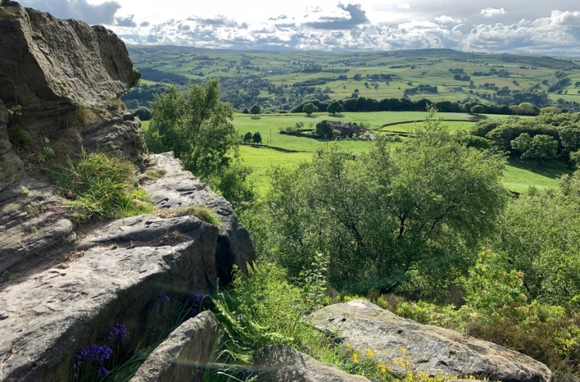
Reflection point 2- Rocks

Take a look, around what do you notice?
As you look at the rocky outcrop what do you notice about the rocks? Think about how long they have been here.
Think about what the rocks provide.
Think about how the rocks provide shelter from the wind and rain from a certain direction and how they help to nurture life in the crevasses.

SPIRITUAL: Often we may hear of someone, God or Jesus being identified as a rock. What do you think this means?
In terms of shelter from the storms of life who has been your cleft into which you move close to?
Rocks are a firm foundation who or what has given you a firm foundation for your life?
Perhaps you might like to give thanks for a few moments for that person.

JOURNEY ON
- Rejoin the main path to the right
- The Path descends towards the roadside. As you reach the static caravans, turn left up the path.
- Stay on the path as it progresses across the moor and, passing the corner of a field, continue ahead along the side of the wall.
- On reaching the stone pillar on your left, follow the path as it bends round to the left (1.9 miles).
- As you reach the corner of the field which is walled continue ahead as the path arcs round to the right.
- Continue ahead. Ignore a path off to the left beside a silver birch tree.

Reflection point 3 - Conical cairn.
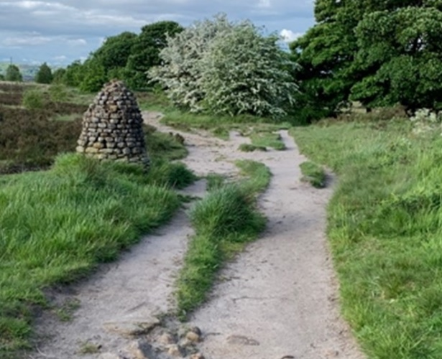

As you look around what do you notice?
Take a look at the Conical Cairn and notice the amount of stones that make up this unique shape.
Think about the uniqueness of each stone that goes to make this structure that shows the way.
Think about how each individual stone goes into making the whole structure to be what it is.
Think about those individuals who have played their part in your life who have helped to form a Cairn of help, love, support and guidance that has guided you on your life’s journey.

SPIRITUAL: Think about your own faith and recognise that each stone on this cairn could be seen as a building block of a step of faith in your life that can still be built upon.

This Cairn may seem complete but it is only one cairn of faith on life’s journey. Think about the Cairns you have passed and perhaps left something of your faith for others who walk the same path at times.

JOURNEY ON
Continue ahead

Reflection point 4- stream
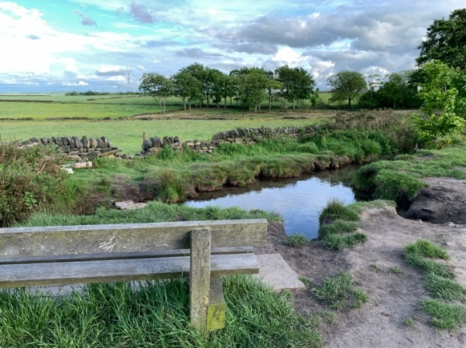

Sit or stand for a while and look and listen. What do you notice?
As you look at the water what strikes you about what you see?
Think for a few moments about the importance of water to our lives.
What would our lives be like without fresh water from a tap?
Think how different our lives would be if we had to fetch and carry water over a distance.
Think of those in other parts of the world who have no clean, cool or hot, running water in their homes.
Perhaps we might like to think and be thankful for what we have.

SPIRITUAL: On many occasions water was significant for Jesus. He was baptised in the water of the river Jordan, he turned water into wine, he would go fishing on lake Galilee and eat breakfast and other meals by the side of the lake. Water is life giving in many ways, where are the life giving water places for you?

JOURNEY ON

- Continue ahead with stepping stones to your right.
- As the path nears the road, turn left, passing between two boulders.
- On reaching the telegraph poles to your right, turn right at the crossroads of the path.
- This path returns to the car park.

