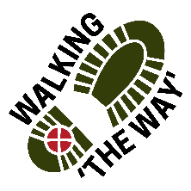Coley/Norwood Green

Getting there and parking
Start outside St John’s Church, Coley Road, Coley, Halifax. HX3 7SA.
Plenty of roadside parking. No charge.

Other information
Walk length 2.75 miles.
Moderate Ability
Dogs to be kept on lead in the fields.
Toilets not available.
Before you begin make sure you have the right footwear, equipment (poles if needed) and clothing. This field and woodland walk can be muddy in places, with some steep descents and up-hill pulls.

Route Details and reflections

If you come out of the Church gate turn right. With the Church behind you, proceed along the road path towards the pylon and wind turbine, passing Coley Church Hall on your left.

Just after a bus stop on the left you reach a red-brick bungalow on the right hand side (pylon in the back garden). Turn right along the signposted public footpath.

Proceed with the dry stone wall to your right passing through three metal gates. Continue along side the wall until you enter the wood.

Reflection point 1: entrance to the wood.
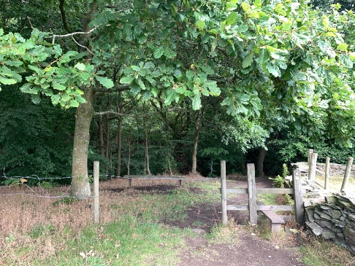

Reflection: Stand for a few moments. What do you see and notice?
Look beyond the stile and think about where this path will lead you.
In life we can see a short distance in front of us we cannot see the whole journey.
At times there are things like stiles that we have to go over.
These are good times to stop, think about how easy or difficult this may be to continue.
Think about the things in your life that have been your stiles.
What did you do? Did you asses the situation, did you stay there a while or did you just make the decision to move on?

SPIRITUAL: Sometimes the journey ahead is not very clear and yet it requires a bit of trust or faith to take those first steps.
Perhaps you had someone who helped you make the decision or even helped you to get over the obstacle in the way and move onwards despite not knowing what lay ahead.
Perhaps you might like to spend a moment thinking about your reaction and giving thanks for the faith to move on or for those who journeyed with you.

Continue on the journey:
Enter the wood via the stile. The path veers left for 15 yards as it starts to descend but then turns sharply right downhill to a footbridge over the stream.

Follow the path as it progresses up the hill side.

The path brings you to a stile, cross the stile and progress ahead into a field.

Continue ahead to the farm. On reaching the gate, turn right just before the gate through a stone stile onto a footpath following the wall of the field now on your left.

Walk through the break in the wall on the left opposite the farm barn and continue to follow the wall down (now on your right) passing a small a signpost on your right. Continue through the field down the hill and into the wood.

Enter the wood over the stile and cross the footbridge over the beck. After 20 yards bear right. (Not up the new laid path)
After a further 30 yards bear right along the fork in the path past a stone gatepost to briefly visit the waterfall.
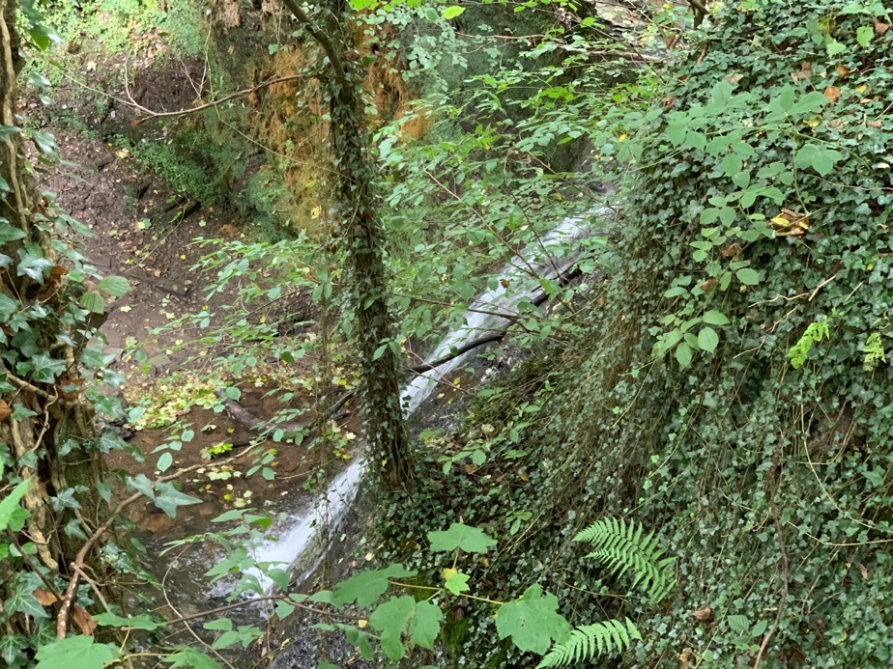
Reflection point 2 : Waterfall
Reflection: Stand for a few moments with your eyes closed and listen to the waterfall.
How does this make you feel? Does it help you feel a sense of peace?
The Running water of a waterfall is relaxing to listen to. As you stand here how relaxed do you feel?
There is a sense of movement and life as the water makes its way down into the base and off as it continues on its journey.
As you listen to the water bubbling and rippling away perhaps feel the anxiety and pressures of life going away with it.
Water brings with it purification, cleanliness and a washing away of the dirt of life we sometimes find ourselves being covered in even if only a thin layer.

SPIRITUAL: One of Jesus well known saying is ‘I have come that you may have life in all of its fulness’. Jesus is the water of life who washes, cleanses, restores and refreshes.
Perhaps when you feel life is dry, stagnant and pressurising then we might like to ask Jesus to wash us and refresh us in his life giving water.

Continue On the journey:
Retrace your steps bearing right to rejoin the main path, continuing uphill on the path. The path bears right along the shoulder of the hillside.

Emerge into a field and progress diagonally towards the top of the field to a stone style and wall.
The route proceeds into another field to follow a grassy path with a wall to your right. Exit the field taking the path through a wooden split stile, continuing to follow the obvious path.

The path emerges alongside ‘Middle Ox Heys Farm’. Continue along the lane until the Junction with Shutts Lane and turn right down hill.

Reflection point 3: Shutts Lane bridge in the valley bottom
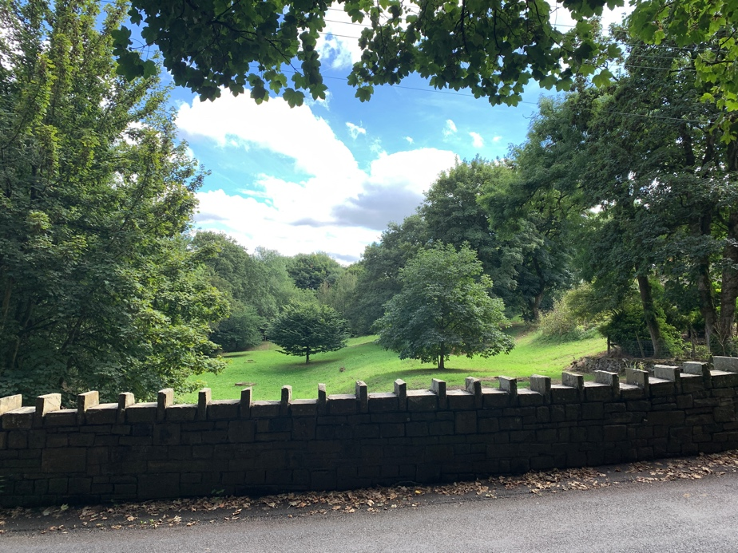

Reflection: As you look around what do you notice most?
Look at the isolated trees.
Think how old they might be.
Think about how they got to be where they are and not grouped with the others.
Notice how they are within easy distance of the older trees and perhaps how seeds from the older trees may have been sown and grown into these younger trees.
Who have those people been who have been in our lives who have watched over us, encouraged us and perhaps even sown those seeds of hope into our lives.

SPIRITUAL: Being part of a family or church or group like this is an indication that even though we may feel alone and isolated at times like these two smaller trees there is always someone there looking over us, helping us or encouraging us.
Perhaps you might like to give thanks for those people in your life who have helped us, encouraged us and have watched over us.
In order for the trees to grow they need good soil, water, sunlight and a bit of wind to help sow more seeds.
Think about God being our good soil, the water, the sunlight and the wind to help us to grow and to leave our legacy in the places where we are.

Silence

Continue on the journey up the Lane.

As the top of Shutts Lane bends to the left, turn right up the bridle path (Coley Hall Lane but not signposted), recognised by two substantial stone gate posts. This Bridle path leads back up to the church which will be on your left at the top.

