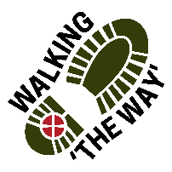WALKING ‘The WAY’ Mytholmroyd – Hebden Bridge Circular
Meet at Mytholmroyd Community Centre Car park
Out of the Car Park turn left along Caldene Avenue
At the end of the houses on the right take the path down to the right and follow through the industrial estate.
Upon coming to a road from the left and right continue along the path straight on with the river on your right.
Following the path you will come across some disused storage containers on the left.
REFLECTION POINT 1 Storage Containers
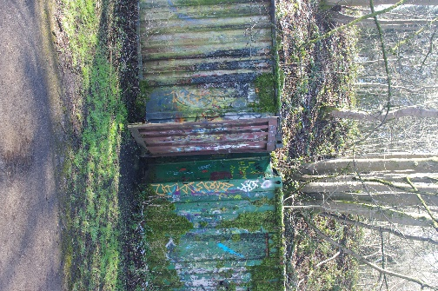
- Take a look around, what do you notice?
- Take a look at these storage containers what do you notice about them?
- Think about what may have been transported in them?
- What do you think they are here for?
- If you look closely at these containers would you say they are secure and in good condition?
- Think about your own things, where do you store them?
- What things do you keep stored away and why?
- What things in your life are precious to you?
- Perhaps you might like to be thankful for the precious things you have in your life.
JOURNEY ON

Continue along the path and keep going until you come to the Train Station.
When at the station perhaps you might like to go onto the platform.

REFLECTION POINT 2 – Train Station
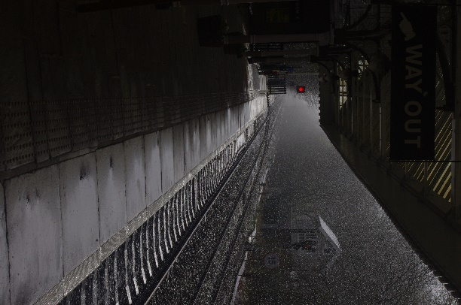
- Take a look around, what do you notice?
- Think about where you are and what takes place here.
- As you look at the board with the train information on think about some of the places you have been that pop up on the destination board.
- Think about those places and the experience you have of being there.
- As you look around think about the last time you went on a train and the experience you had travelling by train.
- If you could get on a train now where would you go?
- Think about the people at the station waiting to go somewhere or meeting someone coming by train.
- As you look down the track to the left notice the signal box.
- Think about how that enables people to travel safely by the right levers being operated.
- There are things in life we take for granted, perhaps you might like to think of something.
- Perhaps you might like to be thankful for those who help you in your life without you even recognising it or who has helped you.
JOURNEY ON

Go back out of the station and turn left following the road round to the right.
Before getting to the Canal turn left and go down the path towards the green space of the park.
Keep to the path on the right and follow it to the play area on the left. Go up past the play area on your left and turn right over the bridge.
Follow the canal with it on your left and follow the buildings on your right. At the end of the buildings before the bridge turn right and go down the road until you come to Hebden Royd Methodist Church on your left.
REFLECTION POINT 3- Hebden Royd Methodist Church
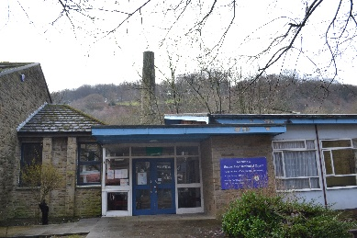
- Take a look around, what do you notice?
- What visible signs are there that this is a place of worship?
- What can you see that tells you what takes place here?
- If it is open would you go in?
- Think about why you would or wouldn’t?
- If you go to church think about why you do? If you don’t think about why you don’t.
- Do you think you need to go to a specific place or building to worship?
- Think about your preferred way of connecting with God.
- Think about if you wanted to grow in faith what can you do to help with this?
- Think about Who can you ask?
- On these walks we mention about journeying on, how do you think you would like to journey on in your faith?
JOURNEY ONWARDS
Go back in towards the Town Centre past the Co-op on your right. Continue over the bridge and at the traffic lights turn left and go into the market place.
Here is a good place to grab a drink.
Go back the way you came to the traffic lights and go straight across (school on your right) and when you get to the end of the street go left back over the canal and then follow the canal (on your left)
Continue past the lock and then stop and notice the boat community

REFLECTION POINT 4 – Boat Community
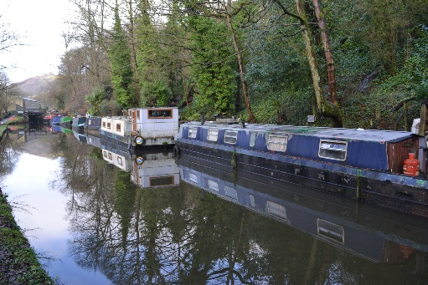
- Take a look around, what do you notice?
- Do you think you could live on a narrow boat?
- Living in this kind of community has positives and negatives. On the positive there is a freedom as to where you can go. On the negative there is no stability or assurance.
- How does this make you feel?
- As you look at the boats see how they are all different and unique in their exterior livery. What makes you unique?
- On the exterior some look fantastic and others look like they need a bit of care and love and time spending on them. Which boat reflects how you see yourself?
- All of these boats are boats and they all have a purpose no matter how they look and they have value and worth to those who dwell in them. We are all people and have value and worth to God just as we dwell within God’s creation. Think about that for a short time. How does that make you feel?
JOURNEY ONWARDS
Continue to follow thew canal (on your left) and then cross the road continuing to follow the canal.
Go past the lock and then at Bridge number 13 go right up the stone steps and then follow the cobbled road down to the main road.
At the bottom turn right and follow the houses on your right and then cross over the road and go over the bridge that goes over the river.
Just before the gate of the house in front bear left and then go right up the road and then at the top you will be on Caldene Avenue and return to the start point.

