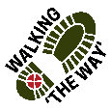
North Dean Wood Circular

Getting there and parking
Start at Brig Royd Car Park in West Vale HX4 8AL (at the junction of Stainland Road and Rochdale Road). Parking charges apply.

Other Information

Moderate ability – moderate inclines with the occasional short, steeper incline.
Distance 3.3miles.
Cafes in West Vale at the start and end of the walk. No facilities in the wood.
Muddy after rain, slippy leaves, tree roots, a few steps downhill without a handrail in the clearing, 1 stile – walking boots and poles advised.

Route Details and Reflections
Turn right of out of the car park and cross the bridge. As the road begins to rise, turn right into Clay House Park. Continue ahead past the house and, where the track forks, take the track ahead to your left with Heath Rugby Club ahead of you. Do not turn left onto the Calderdale Way beside the house.

Pass between the stone gate pillars, then immediately left, then immediately right up a track, to join the main track to your right.

At the first junction, take the left-hand fork heading up hill. Do not go straight ahead.
Join the Calderdale Way, bearing right.

As the path merges with another path, entering from the left, stop just in front of the bench marked ‘Where their love story began’.
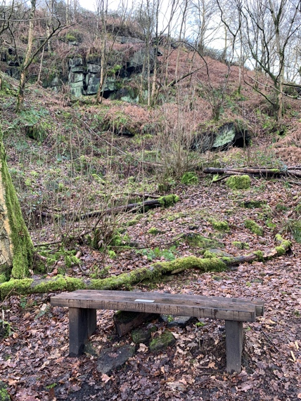
Reflection Point 1 – Bench (marked ‘Where their love story began’) and Crag

- Take a look around, what do you notice?
- Benches or seats are often welcome for those who need rest or who stop to look at a view. How do you rest?
- Do you have a favourite spot to go and just be and rest?
- This place marks a special place and memories for those who placed this bench here as the words on it says.
- All of us have stories of our lives and there are significant places, moments and people who are part of our story.
- Think for a moment where those places are.
- Think why those places are special to us.
- Think of those people who are part of our life story.
- If you were to have a bench somewhere what would you inscribe on it?
- Perhaps you might like to give thanks for those who are part of your story.

JOURNEY ON with the bench to your left.
As the path reaches a fork, bear right onto the lower fork heading downhill. Do not take the signposted path up to the left. Carefully descend the steps into the valley clearing.

Reflection 2 – Valley Clearing
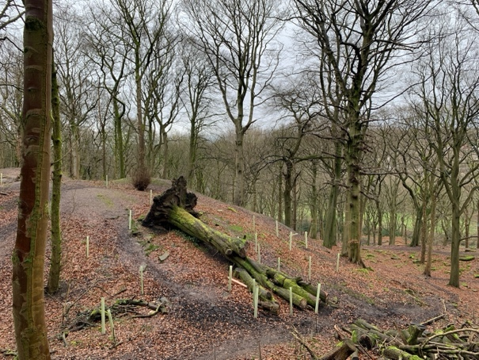
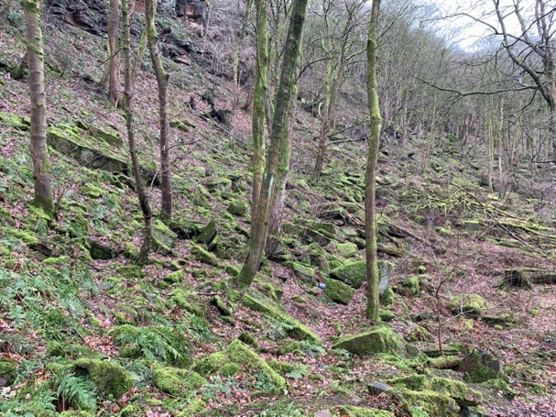

- Take a look around what do you notice?
- Look down at the ground and think about the root systems and fungi links that exist below your feet.
- Think about all this helps with the eco system that fills the woodland floor with leaves in the autumn and springs new life in the spring.
- The root and fungi connections send messages to each other all around the wood so that it helps to protect and nurture the woodland. Who are part of your network?
- Being part of the ecosystem that is the woodland has benefits not only to the various species in the woodland but also wider through releasing oxygen into the atmosphere. Think of the benefits you have of being part of a wider community.
- Think about how the trees take in carbon dioxide and breathe out oxygen. How does this make you feel?
- Perhaps you might like to think about Jesus being a tree taking in all the wrong stuff in our lives and breathing into us new life and opportunities. How does that make you feel?
- Perhaps you might like to be thankful for the blessings we have that we don’t often recognise like the air that we breathe.
JOURNEY ON

Continue ahead up the hill, following the path which goes round to the left, with the fallen tree on your right.

Continue along the path, generally bearing straight ahead, ignoring paths off to the right. You eventually reach a moss ridden wall. The path then bears sharp left up some steps to break through the wall at the top, at which point, you turn right. Ignore the immediate track down to the right-hand side to continue straight ahead on a broad, muddy track.

As you reach the white house (Lower Tinker Hey), cross the style and take in the views turning right down the track. Then carry on down the track to the church.
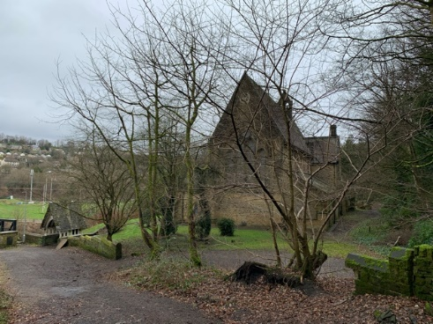
Reflection 3 – Church

- Take a look around what do you notice?
- Look at the church building. What do you notice about it?
- Think of what Church is, do you think it is a building or people?
- Think about any experiences of going to church that you have had. Was it a good experience, bad experience or indifferent?
- Think about what one word you would use to describe church?
- Think about if you don’t go to church, why not and if you do why?
- Do you think you need to be in a building to be church?
- Do you think that being on this walk today with others is or could be church?
- Think about what church might look like for you.
- Think about those whom you would like to be part of a worshipping community that you would be part of.

JOURNEY ONWARDS
If you have time and the church is open perhaps you might want to go and have a look and especially the stained glass windows.
From the church notice a gap in the wall to the right by the gate. Pass through the gap in the wall to re-enter the woods and follow the path to your left. The path soon forks, take the left-hand fork down to your left.
Just beyond the far end of the churchyard, the path forks again, take the left-hand fork, almost heading straight ahead. Take care walking alongside the river. Come off the path as you reach a steep mound, bear right, ahead of the mound, and follow the track through the base of a narrow valley.

Follow the track round to your left back towards the river. Rejoin the main path, bearing right beneath a partially fallen tree.

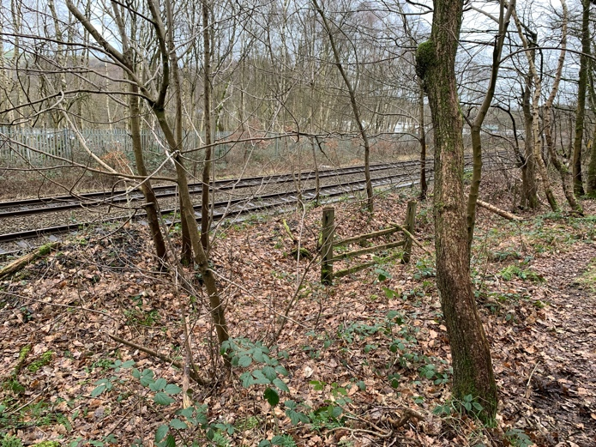
Reflection point 4 - Train tracks

- Take a look around what do you notice?
- Take a look at the train tracks and think about the process of how each metal piece of track got to be in this place.
- Think about how each metal track needs to be in line with the one before it, the one after it and the one next to it.
- Think about how if one track wasn’t in the right place what the consequences might be.
- Think about how the network of train tracks help people to get around the country.
- Think about how such a complicated system is managed and how important it is that everything is co-ordinated to enable the smooth running of the network.
- Think about those people who are part of the network and the part that they play helps the network to function as it should.
- Think about the people who are part of your network who help you to navigate through life.
- Perhaps you might like to give thanks for those people who are part of your life and help you on life’s journey.
- Perhaps you might like to think about how faith helps you or guides you.
JOURNEY ONWARDS

Continuing following the path beside the railway lines, eventually you reach the end of a wall. The path continues uphill to the left-hand side of the wall.

The path climbs, quite steeply in places for a short distance, to reach a broader path. Bear left on the broader path heading up hill.

As you pass the bench on the right-hand side, take the left-hand fork downhill. On reaching the gap in the wall to your left, pass through the gap and take the track ahead to your left.

Continue along along the path, ignoring the downhill left path, which was part of our outward journey. Follow the track round to the rear of Clay Hall and pass through the gap in the wall to your left.

Continue ahead to Clay Hall, passing under the pagoda to the right, down the steps to the side of Clay Hall, then turn right along the exit road. Turn left to return to the car park.

