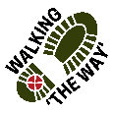
Sowerby Bridge – Triangle Circular

Getting there and parking
Start at Tuel Lane Car Park, Sowerby Bridge. HX6 2AF.

Other Information

Moderate ability – moderate inclines with one short steep incline and one short steep decent (onto and off the railway banking).
Distance 3 miles.
Public convenience available at the car park.
Cafes in Sowerby Bridge at the start and end of the walk.
Walking boots essential and poles advised - muddy after rain, slippy leaves, tree roots, a short steep incline and decent without a handrail, no stiles.

Route Details and Reflections

Leave Tuel Lane Car Park, taking a ramp down beside Althorp House to join the main road to turn right. Cross over the pedestrian crossing on the main road and continue to bear right.

Follow the main road as it bends round to the left and under the bridge to join West Street, passing The Loose Goose on your left.

Continue following the main road uphill until you reach the Shell Garage on your left-hand side. Immediately after the Shell garage, turn left to enter a track into some woods.

Reflection Point 1 – Gated entrance (0.65 miles)
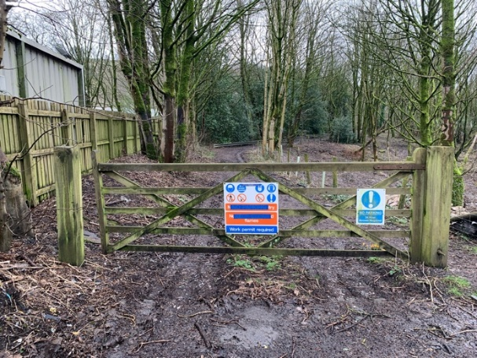

- Take a look around, what do you notice?
- As you look around, notice the track, is it easy to navigate or is it challenging?
- The paths we choose in life are sometimes not easy. Sometimes we may have to find a different route and sometimes we have to realise that we may have to stop and take a step back to see a better alternative. Think of a time when you have had to be more fluid in your decisions and change direction.
- Sometimes there are physical barriers to overcome like a gate and we have to think about the way through. Sometimes all that is required is a bit of unfastening and a little push to continue.
- What small challenges have you been able to overcome?
- When you have taken time to stop, look and figure it out, how have you felt and how did it help you carry on?
- Perhaps you might like to consider that challenges help us to reflect, learn and grow.

JOURNEY ON
Following the track, passing beside the large metal gates through a smaller gate to your left.

Continue along the track passing the substation on your left to follow the track to pass under a footbridge and join the disused railway track.

At the next metal rail footbridge the track ahead is boggy, almost ankle-deep, so climb up the banking on your right-hand side. Note – there is a man made water-shoot to your left. Do not climb that side.

Continue ahead along the banking.

Reflection Point 2 – Man-made wall & Natural Crag (1.4 miles)

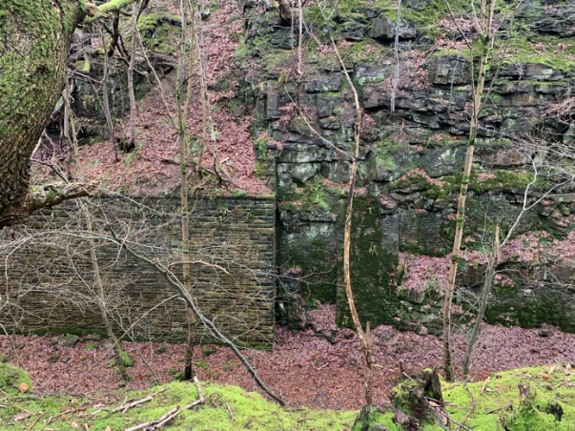

- Take a look around what do you notice?
- There is a natural wall of stone and one man made wall and they exist side by side. What do you think of when you see this?
- The constructed stone wall on the left is helping to retain the land behind it. Can you think of other things that coexist and help the balance of the natural world?
- Can you think of anything where it has been left and nature has come and taken back over?
- What things can we do to maintain a balance between nature and our human footprint?
- Perhaps you might be thankful of the things in nature that you see which brings you calmness and peace.

JOURNEY ON along the banking.

On reaching the bridge, turn right and walk down the cobbled part of the lane for about 50 yards, to turn right again to re-join a path just above the cricket club. Note – almost a U-turn but now on a slightly lower path.

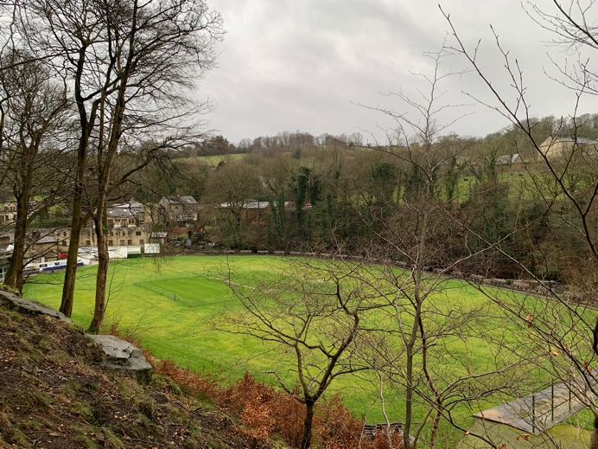
Reflection Point 3 – Triangle Cricket Club

- Take a look around what do you see?
- As you see the cricket field below, think about some of the games that you enjoy or have enjoyed playing or watching.
- Think about the benefits of playing games or sports.
- Physical exercise is good for our health and wellbeing, think about how you feel after doing some kind of exercise.
- Think about what you feel like when doing these reflective walks.
- Perhaps you might be thankful for being able to be out and about and doing this walk.

JOURNEY ON along the path, be mindful of the hazard of tree roots.

As the path drops down to the waters edge, look across the water at the industrial salvage.

Reflection Point 4 – Industrial Salvage
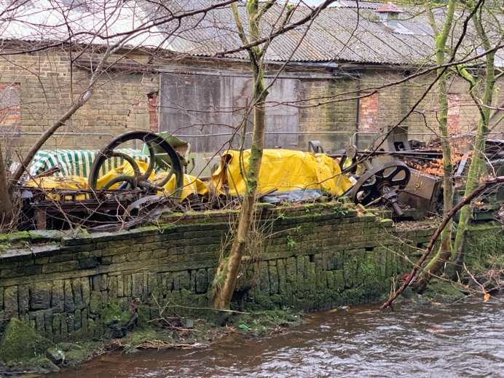

- Take a look around what do you notice?
- Notice the machinery and what you can see and think about what it used to do.
- Do you see this scene as a scrap heap and a place where decay and all thoughts of past life have been left to rot?
- When industries like the mills, mines and factories have closed do you think that the people who worked there felt like these pieces of machinery having no value and obsolete?
- Some of these machines could be restored, recycled and reused and invested in to enable something new to begin. Do you think that is possible?
- Think of those people too who may have been left on the scrap heap who with care, love and investment in, can regain hope and do something new with their lives.
- Jesus once said “I have come that you may have life in all its fullness” after looking at this scene before you, can you see possibilities of hope and new life?

JOURNEY ON, passing through an area of small industrial units to continue to follow the path, which gradually rises ahead of you from the riverside.

At the brow of the hill, pass the bridge on your right-hand side, continue straight ahead. Do not cross the bridge.

The path reaches a natural conclusion, at which point, you have to descend down to your right, taking care as it is quite steep and cross a shallow stream to rejoin the main outward path.

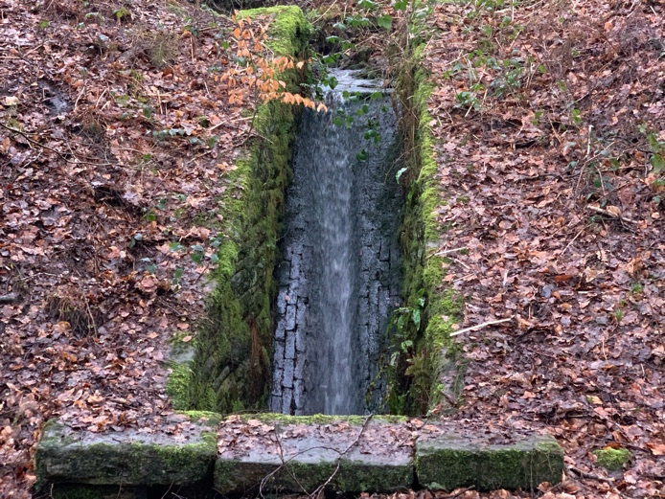
Reflection Point 5 – Man-made Water-shoot

- Take a look around what do you see?
- Again we see a collaboration between humanity giving nature a hand. What collaborations do you know of that work well?
- Who might we work well with and join in bringing about a change for good.
- Perhaps you might be thankful for those things we see that work well that enhance life.

JOURNEY ON, with the water-shoot in front of you, turn left to return on the outward path.

Turn right as you rejoin the main road, walking downhill, to return to Sowerby Bridge returning to the car park.

