Hipperholme Circular from Christ Church

Getting there and parking

Meet in the car park at Christ Church, Wakefield Road, Halifax. HX3 8AA (next to Hipperholme traffic lights). No parking charges.

Other Information

Walk length 3 miles.

Moderate Ability – Gentle up and down hill climbs. Need to be able to go over styles (c. 8 styles and two are double styles).

Toilet facilities at the church (when open).

Walking Boots essential and Walking Poles advised due to potentially muddy terrain.

Long trousers recommended as there can be nettles.

Route Details and Reflections

Exit the church from the church car park.

Cross over the two roads adjacent to the car park exit and turn left towards the crossroads. At the crossroads, turn right to ascend Denholme Gate Road.

Go past the Co-op and turn left onto Towngate (opposite Hipperholme Grammar School).

Go straight forward into the ‘No through Road’. Do not go downhill.

After Cockcroft Farm and before West End Barn, take the track on your left.

At the end of the path you enter a woodland. Take the right-hand fork.

Stop at the quarry for the first reflection.

Reflection 1 - Quarry

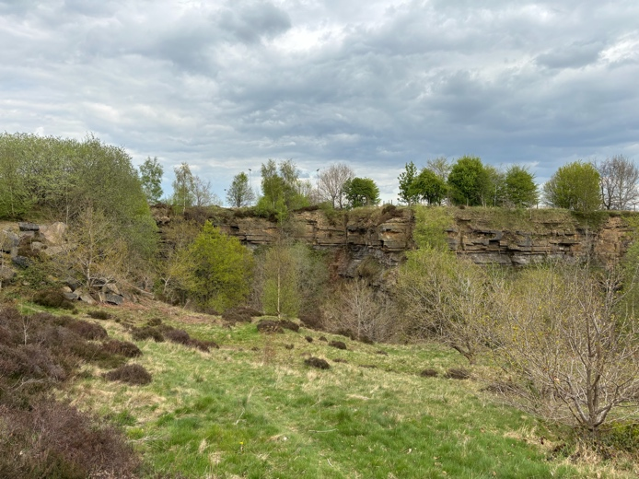

* A bit of history - Traditional industries in Hipperholme were the manufacture of silk and cotton goods, coal mining, quarrying, and tannery. Joseph Brooke's quarrying firm was founded in 1840 and was known for their non-slip paving stones patented in 1898. The stone works ceased trading in 1969.
* So quarrying up here isn’t so far in our distant past.
* Imagine how different it would have been up here less than 60 years ago.
* Imagine the life of the workers in this quarry at its prime. Hard labour? Exhaustion?
* Do you think they would have similar worries and concerns to what we have today?
* We remember those who have gone before us and those still labouring in difficult working conditions.
* But today we are up here enjoying the beauty. Let’s pause to give thanks that we are able to enjoy the beauty and the fresh air we now have up here.

JOURNEY ON along the track.

At the edge of the woodland, pass through or around the metal kissing gate. Join the track and follow it around to the right, passing Gaythorne Terrace.

You are now back on Denholme Gate Road.

Turn left and walk on grass verge. Go to corner (second lamppost) for the best crossing place. Cross the road.

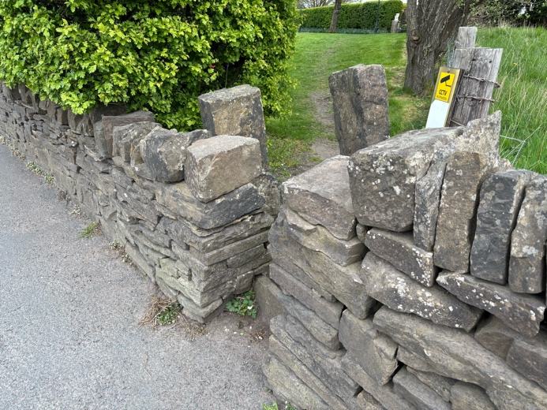Continue along the road for c. 50 metres and take the gap in the wall on the right before the ‘Coley’ sign.

Cross the grass and along the block paved driveway then take the gap in the wall at the end, into the field.

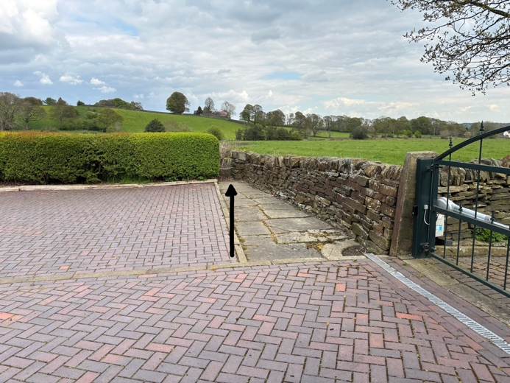

Stop in the field for the next reflection.

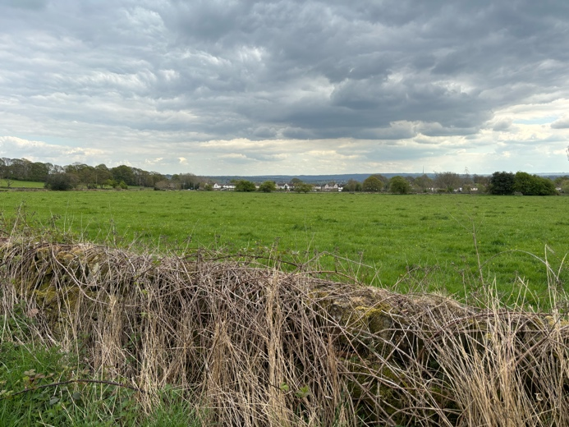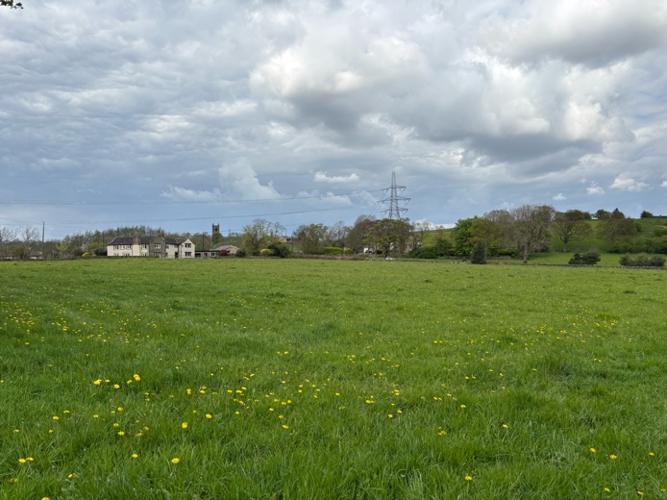Reflection 2 - Coley Church and fields

* Take a look around and enjoy the countryside. The views over the fields, the lush green grass.
* Pause to reflect and be thankful for getting off that main road and being back in nature.
* Can you hear any birds?
* Jesus said, “do not be worried about the food and drink you need in order to stay alive, or about clothes for your body. After all, isn't life worth more than food? And isn't the body worth more than clothes? Look at the birds: they do not plant seeds, gather a harvest and put it in barns; yet your Father in heaven takes care of them! Aren't you worth much more than birds?
* Spiritual Reflection: Your father in heaven takes care of the birds and you are worth so much more than the birds. How does it feel to know that we weren’t meant to spend our days worrying about things? How does it feel to know that you are cared for?

JOURNEY ON exiting the field over a stone style and turn right into the lane.

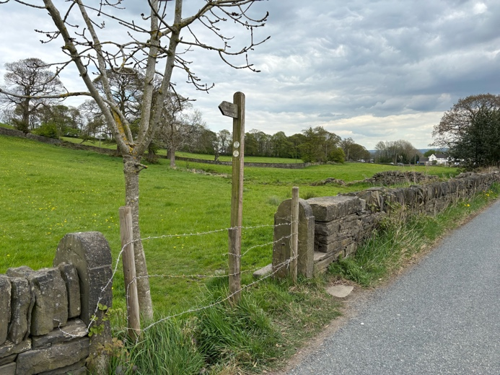After another 50m, cross the road and enter the field via a stone style

Walk up the hill and slightly to the right to the gap in the wall.

Pass through the style and straight on through the field aiming for the metal gate.

Pass through the gate. Immediately in front of you across the lane take the next metal gate into the next field.

Follow the path down the hill.

Reflection 3 - Stone pillars and boundaries knocked down

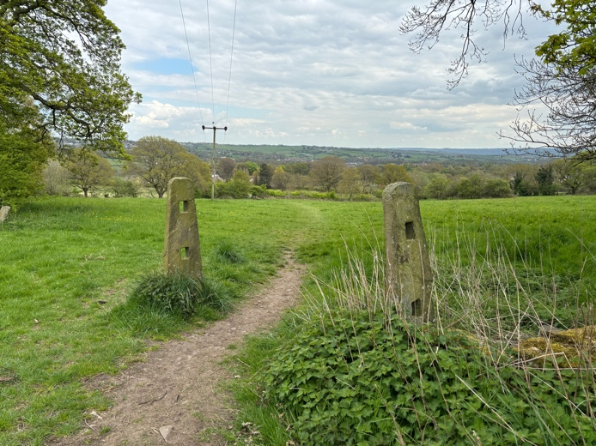

* Take a look at this boundary line. Why was a boundary originally there? Was it to keep things apart, keep things out, keep things safe?
* Do we sometimes put up boundaries in our lives?
* If so, why? Are they to keep us safe? Is it good to keep apart? How does feeling separated make us feel?
* The boundary line has been taken down. We do not know why but it obviously no longer served its purpose.
* Do we have any boundaries that no longer serve us but instead holds us back?
* As we journey on and over the coming days remember this dismantled boundary. Reflect on those boundaries that no longer serve us and consider what we need to do to dismantle them.

JOURNEY ON passing through the stone pillars. Cross the field downwards, heading for the wooden gate/style.

Pass through the double style. Straight down the field with the line of trees to your left. Heading for the wooden gate/style.

Cross the double style onto Shutts Lane. Cross over the road and turn left onto Syke Lane into Priestly Green.

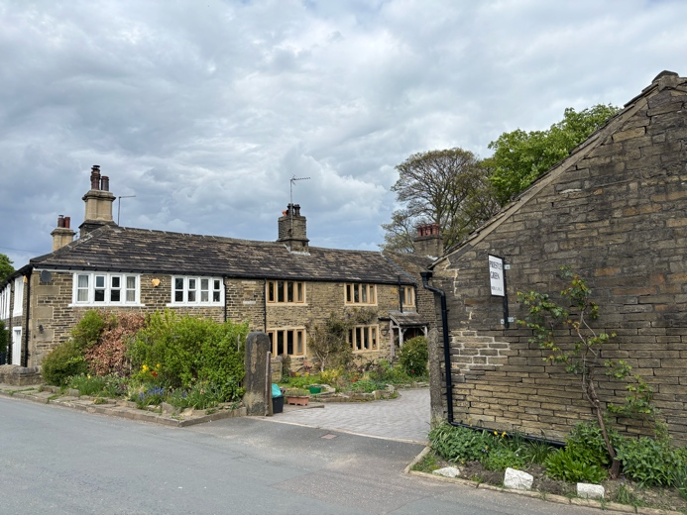Priestly Green - History

A community of monks settled here in the early Middle Ages and provided it with its name. Perhaps it had been regarded as a holy place long before that even, a conclusion which might be drawn from the concentration of holy wells in the vicinity of the hamlet.

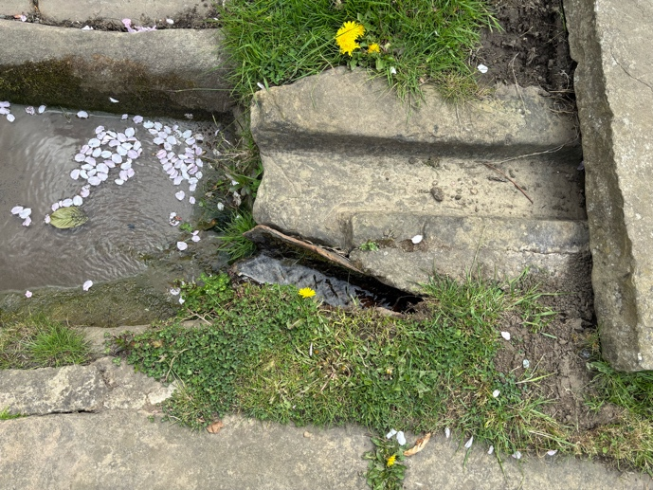The Sisters’ House stands directly behind Lister’s Well. A dwelling on this site is recorded as far back as the 13th Century but the current cottage was built in 1630. A 1904 reference records that Lister’s Well was believed to “possess magic cures for all who drank its crystal waters, and pilgrimages were made to it”.

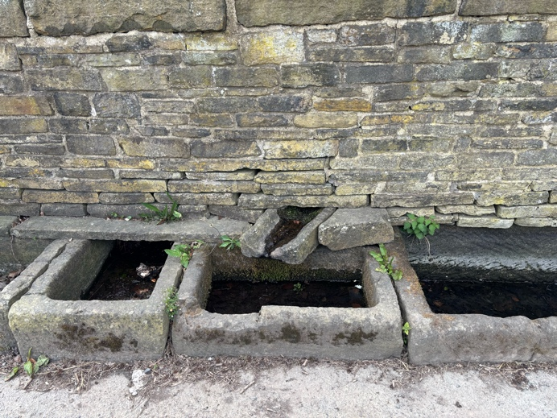The most imposing of the wells is Helliwell Syke Well (which means “holy well by boggy land”) where a spring feeds a series of four troughs. It is set amidst a profusion of ash-trees, which are often associated with sacred waters. There has been evidence of a well at Helliwell Syke since Saxon times.

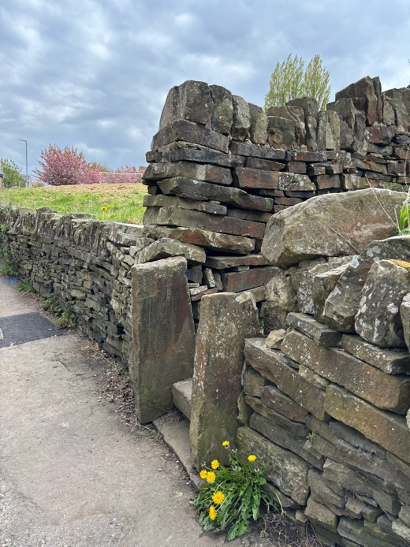JOURNEY ON along Skye Lane and as the road begins to climb, just before the 20 sign, take the stone steps to your right.

At the end of the path (wall to left) go through the stone gap and turn left by the wall side, then through the gate and turn right (not straight on) to walk with the fence on your left.

Pass through the metal kissing gate.

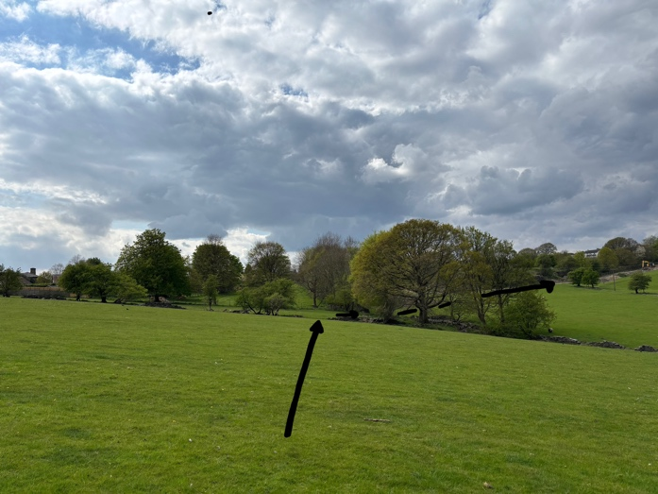Walk straight ahead through a gap in the broken boundary wall (as indicated below). Follow the path down between two trees. Keep in the same line heading for a farm gate to the right of a large mound.

Pass through the gate to the left of the farm gate and follow the enclosed track up the hill, over a style.

On reaching the stone entrance, take the left-hand fork but do not go left into the paved alley.

On reaching North Edge lane, turn left to continue along North Edge Park.

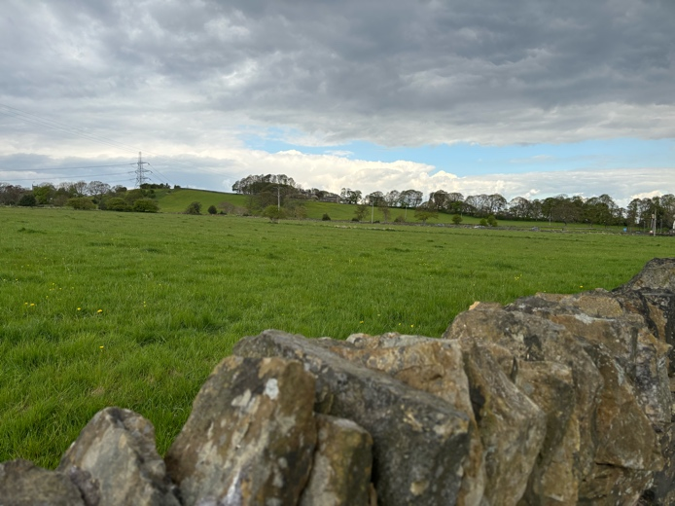Reflection 4 – look back on where we have been

* Pause and look back over the fields to where you have been earlier on the journey.
* How does looking back make you feel? Does it bring enjoyment looking back on memories? Do you miss that part of the walk?
* Look forward down the road along North Edge Park.
* How does looking forward to the future make you feel? Excited about the next chapter or anxious about what tomorrow brings?
* There is a Chinese proverb often accredited to the Tao Te Ching that says – ‘If you are depressed you are living in the past. If you are anxious you are living in the future. If you are at peace you are living in the present’. Reflect for a moment on that quote. Does it help explain how you are feeling?
* The Bible is brimming with quotes about peace. To not be afraid. To not be anxious about anything. And it talks about a peace that surpasses all understanding - peace beyond our limited understanding. **May we today all discover such peace.**

JOURNEY ON along North Edge Park towards the main road. On reaching the main road, turn left down Denholme Gate Road for a long decent back to the church.