Warley Circular

Getting there and parking

Meet in the car park next to the playground and chapel, Warley Town Lane, HX2 7RZ. No parking charges. Street parking if carpark full.

Other Information

Walk length 2.8 miles.

Moderate Ability – Gentle uphill climbs. No stiles.

No toilet facilities.

Refreshments available at The Maypole Inn.

Walking Boots essential as walking through fields. Walking Poles advised if muddy/wet.

Long trousers recommended as there can be nettles.

Sheep in the fields – dogs on lead.

Route Details and Reflections

From the car park, exit by the steps and noticeboard. Turn right along path with the playground to your right and the chapel in front of you to your left.

Pass the school and head down right to the road junction.

At the road junction turn right, after 50 yards bear left, leaving the road down a track.

Follow the track as it continues beside the field. Eventually the track bears left and you follow this for a further 50 yards, then at the finger post take a right turn through a gate alongside a field.

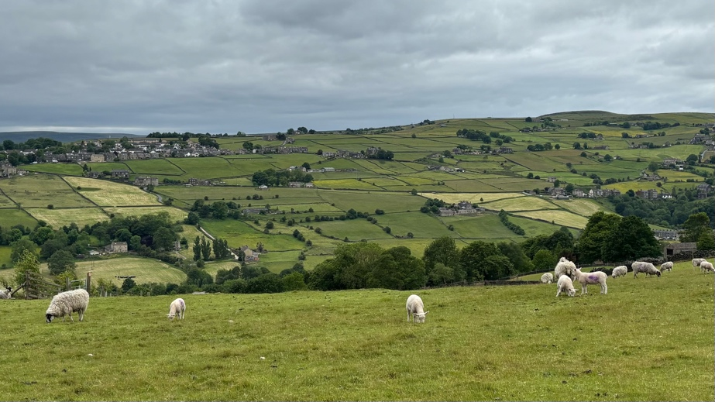Reflection 1 – Panoramic View

* Take a look around – what do you see?
* I selected this walk as the views took my breath away. I hope they have the same effect on you.
* There are panoramic views, there are lambs in the field, and just breath in that fresh air. How does this make you feel?
* I read a book last week called – ‘How to be a bad Christian and a better human being’. The second chapter is entitled. ‘Bumping into God – How to find God without going near a church’. We left the church at the carpark. Do you think we can ‘bump into God’ up here?
* Take another look around.
* Do you feel closer to God up here than in a church?
* If so, you are not alone. Many people feel closer to God in nature, seeing beauty in his creation, with moments that take our breath away.

JOURNEY ON. The path continues along the wall of the field to your right. Sheep are often in the field.

As you reach the gate of the field, you will see a wooden gate to your left. Pass through the gate and continue straight ahead alongside a wire fence on your left.

Before you reach a cluster of trees and a bench ahead of you, bear right up alongside a wire fence which will be on your left hand side. You are heading towards the phone mast.

Continue ahead with the wire fence on your left hand side to reach a wooden gate, pass through the gate and continue ahead along the path.

As you reach the big Sycamore tree on your left-hand side, the path bears left (signposted left), along a narrow walled and fenced track.

Pass through the gate at the end of the track, then pass between the houses to join a lane. Bear right and head uphill along the lane.

As you reach the first junction on your left, turn left downhill. You will pass a driveway on your left-hand side, then 15 yards later bear right along a yellow posted footpath, slightly elevated from the main lane (take care to spot this, not immediately obvious).

Pass through the gate and continue straight ahead with the wooden fence to your right.

Pass through another wooden gate and continue straight ahead.

Pass through the gap beside the gate of the field and then bear slightly right, following the direction of the sign. After 30 yards of diagonal walking (to the right) you will find a path on the brow of the hill. Descend down the hill.

The path descends through a gate to a lane characterised by old lampposts. Turn right along the lane.

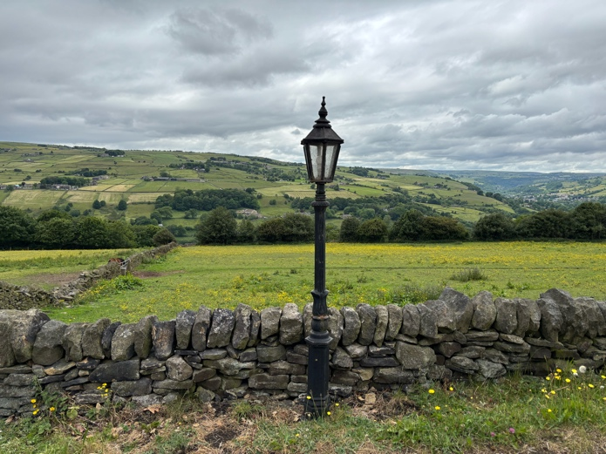Reflection 2 - Lamppost

* Take a look around – what do you see?
* Aren’t these lampposts wonderful!
* They make me want to come back and drive up here in the evening to see how these old lamps are able to light up the way. Has anyone ever driven up here at night? I imagine that they have a wonderful glow rather than a stark bright LED light.
* They maybe old but they are able to light up the way. Jesus said that he was ‘The Way’ and was often described as the ‘true light’.
* This lamppost guides the way in the dark. Pause to think about what guides you on.

JOURNEY ON

Continue along the lane until it reaches a road, then bear right and uphill along this road.

Continue along Butts Green Road until you reach Great Edge on your right hand side. Turn right into Great Edge.

As you reach a track on your right hand side with a wood directly ahead, stop for a reflection.

Reflection 3 – out of bounds wood

* Take a look around – what do you see?
* That wood looks so inviting…but we can’t go in! There’s no public access. The forbidden forest. But it looks so inviting.
* As we walk around the perimeter, take a look in and seee if there is a good reason why we aren’t allowed in.

Head down the lane to your right.

* I really wanted to go in that wood but it isn’t safe for the public.
* Sometimes the answer to a request for a prayer is ‘No’ when we want the answer to be ‘Yes’.
* Could it be because that is what’s best for us?
* Both myself and Sue often say the words – God is good, all the time! Not some of the time, all of the time. Is there something happening in your lives at the moment where the answer seems to be ‘No’ rather than ‘Yes’. It may not be the answer we are wanting but could it be the right answer…at least for now?

JOURNEY ON

Follow the lane down to your right as it bears left passing between two houses.

Ahead, you reach the gate you passed through on the outbound journey. Pass through the gate, follow the path and bear right at the end of the path.

Pass through the gate and continue down the side of the field with the wire fence to your right.

As you reach the bench and the pine trees on your right hand side, bear left along the track.

At the end of the field pass through the gate and bear left. After a short while the track bears to the right.

As the track reaches the road, look back at the panorama.

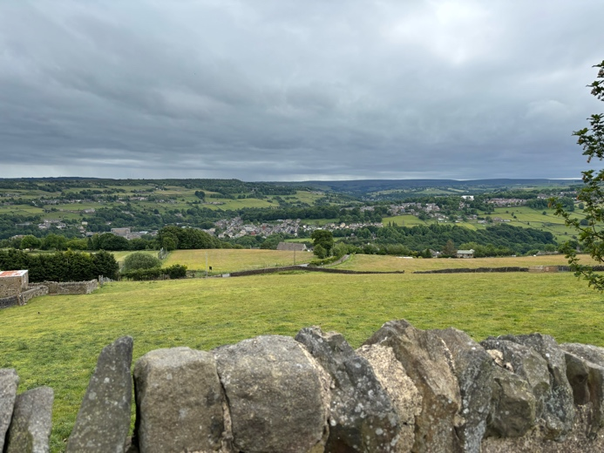Reflection 4 – one last glimpse

* Take a look around, for one last glimpse before we leave these wonderful panoramic views. ‘One last glimpse’.
* Last week we celebrated ascension – the risen Christ, who was seen by over 500people, ascended to heaven. One last glimpse before he was gone. But today we celebrate Pentecost, Jesus promised to never leave us so he sent his Spirit. So it wasn’t one last glimpse!
* Our walk is coming to an end but let’s just pause to think about the week ahead. I’m sure there will be challenges but are there some nice things that you are looking forward to – big or small?
* We’ve been grateful for these beautiful panoramic views but let’s try and find beauty in the everyday, in the week ahead. Let even the small things take our breath away.

JOURNEY ON

Join the road bearing right, to then bear left after about 50 yards up the cobbled lane.

On reaching the school, leave the cobbled lane, bearing left along a tarmac path to return to the carpark.