Shelf Circular from Bethel Chapel

Getting there and parking

Meet at Bethel Chapel, Halifax Road, Shelf, Halifax HX3 7RS.

Parking at the chapel is with prior permission from the Chapel only. Otherwise, street parking.

Other Information

Walk length 2.5 miles.

Moderate Ability – Short steep uphill and downhill sections, one long moderate uphill climb.

Toilet facilities only in the chapel when open.

Long trousers advised due to nettles in Summer.

Walking Boots and Walking Poles strongly advised due to sloping and potentially muddy terrain.

Route Details and Reflections

Exit the chapel car park towards the main road and turn right, passing the chapel on your right.

As you reach the corner of the graveyard by the Shelf Deli Express, turn right down a ginnel.

At the end of the ginnel, pass through the entry stones to proceed straight ahead along the side of a field.

At the end of the field, pass through the stones, over a wooden style to enter a second field and proceed straight ahead. Note – Cows may be in the field.

Exit the field over a wooden style and continue straight ahead down by the wire fence.

Exit the next field through a style and pass through the wall to turn left down Green Lane.

Stay on Green Lane as it bends to the right. Stop for a reflection at High Bentley Farm on your left.

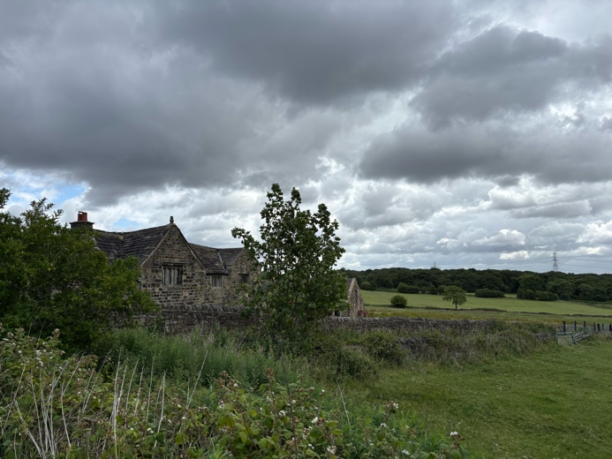Reflection 1 - View and High Bentley Farm

Bit of history:

High Bentley Farm is Grade II\* listed and was built in the Mid 17th Century.

Shelf contains 28 listed buildings that are recorded in the National Heritage List for England. Of these, one is listed at Grade I, the highest of the three grades, two (including this farm) are at Grade II\*, the middle grade, and the others are at Grade II.

Most of the listed buildings are houses, cottages and associated structures, farmhouses, and farm buildings. The other listed buildings include a guide post, a public house, a church, two boundary stones, a milestone, a set of stocks, and the archway to a former brewery. Who knew! 28 listed building in Shelf alone and its surrounding area.

* This farmhouse was built in the mid 17th century, so it has been standing for well over 250 years. Think about all that this farm house has seen over the years.
* How has it managed to stay standing for over 250 years, perhaps strong foundations?
* What strong foundations have you built your life upon? What are your core values and your beliefs? What strong foundations have provided you with stability, resilience and strength. Where have they come from? Who or what has guided you.
* Spiritual bit: Jesus is frequently described in the bible as the cornerstone. It’s a powerful metaphor as the cornerstone is the first stone laid in a building's foundation. It is the cornerstone that determines the structure's alignment and stability.
* Let’s pause, reflecting on strong foundations and give thanks for all the strong foundations in our lives that have provide us with stability, resilience, and strength, especially during challenging times.

JOURNEY ON

Continue along the lane and pass through the gate signposted Heathwood House.

As you reach Berry Bottoms, take the public footpath on the left-hand side as indicated.

Pass through a double narrow wooden gate.

Follow the path as it descends down to the right, ignore the fork to the left. Note – poles recommended..

Ignore the path to the right that goes over a bridge. Continue ahead following the waterfall sign and bear right after 40 yards, passing through a stone gate pilar on your left.

After 50 yards you reach the waterfall.

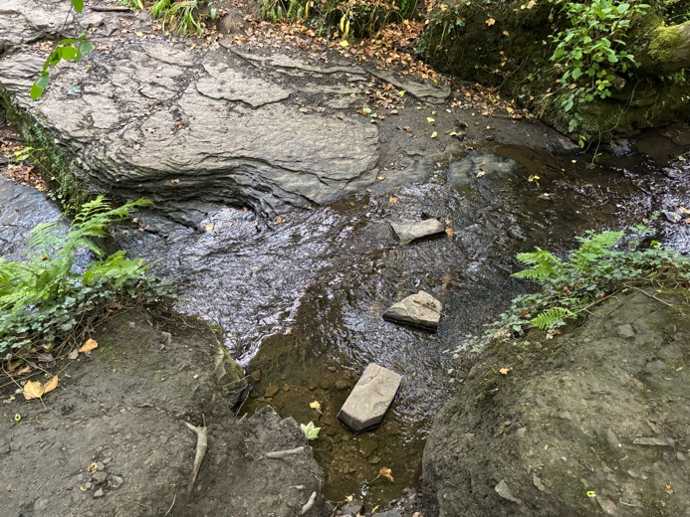Reflection 2 - Stepping stones and waterfall

* Take a look at the stepping stones at the top of the waterfall. As we explored various routes for this walk, we attempted to go over the stepping stones. The second stone is unstable and a bit wobbly!
* There will be times when life feels a bit unstable and a bit wobbly. Perhaps from how we view things, or, like this stone, it actually IS unstable and a bit wobbly.
* We pause to reflect on whether there is something in our lives that isn’t as stable as those firm farm foundation stones that we saw earlier. What’s making life a bit wobbly at the moment? Or, are we laying our trust on something that isn’t very stable?
* We always have a choice – we could completely avoid this unstable stone and go back; we could bypass it – step over onto the next stone; or we can go around it. Today we are going to go back to the sign and over the bridge. We are able to by-pass it to rejoin the walk and it actually makes the walk nicer as the hedges and brambles over the stones, on the other side of this beck, are virtually impassible.
* Spiritual bit: There is a proverb in the bible (the bible is actually made up of 66 small books and one book is called ‘Proverbs’). This proverb reads – ‘Trust in the Lord with all your heart. Never rely on what you think you know. Remember the Lord in everything you do, and he will show you the right way’. (Proverbs 3:5-6 Good News Translation)
* Let’s pause and think about the choices we need to make about the things that are unstable in our lives and to be shown the right way.
* Whatever the obstacle, we always have a choice.

JOURNEY ON

Head back to the waterfall sign. Then turn left, crossing the footbridge and over the style. Then take the stone steps in the field, progressing ahead towards the barn. Continue on the path.

Exit the field via the style and the gap in the wall, to turn right. Immediately on your right, pass through a metal gate and stepped style.

Turn left up the lane, signposted ‘Shelf’.

As you exit the bridle track, continue ahead up the road (named ‘Bridle Stile’ but not signposted)

75 yards up the hill, turn right opposite the new build houses, on what appears to be a drive, with Shelf Hall Cottage on your right.

As the path bears to the right, ignore the first path and continue along the lane passing the tennis courts on your right.

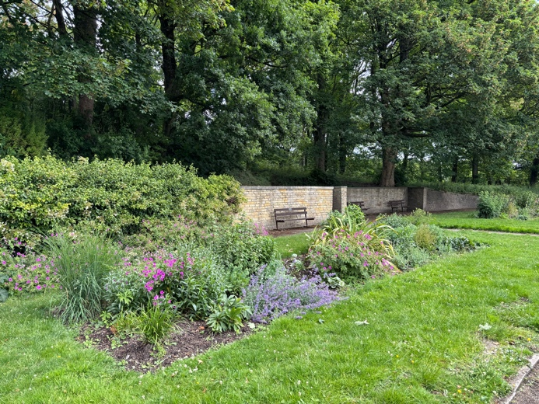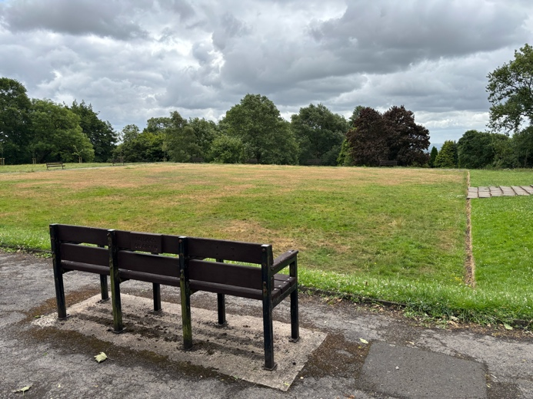Reflection 3 - Park and old bowling green

* Take a look around, what do you see?
* A lovely flowerbed and what appears to have been a bowling ground. It’s now grown over. Imagine what it used to look like?
* How much work do you think would be needed to put in to restore it? What resources would be needed? Time? Strength?
* We’ve reflected on on strong foundation stones; things that make life a bit unstable but we always have a choice on how we handle those obstacles; and now we reflect on the potential of this park, our potential. Imagine what this park could look like with a bit of TLC – tender loving care.
* Spiritual bit: TLC – love - is in the DNA of every religious tradition and every moral system. Every Christian/Jew/Buddhist/Muslim/Hindu/humanist knows that love is the golden rule: do unto others as you would have them do unto you. Jesus said, the greatest commandment is to love God and to love your neighbour as yourself.
* Sometime we forget to love ourselves. If we can imagine what this park could look like with a bit of TLC, lets pause to imagine how different we could feel, how we could be, if we just fully understood how much God loves us.

JOURNEY ON

Progress along the lane to take a right-hand path, bearing ahead to the right. Note – this is opposite two wooden steps and sycamore stump.

As you reach the yellow finger post, turn right down a wooden stairway.

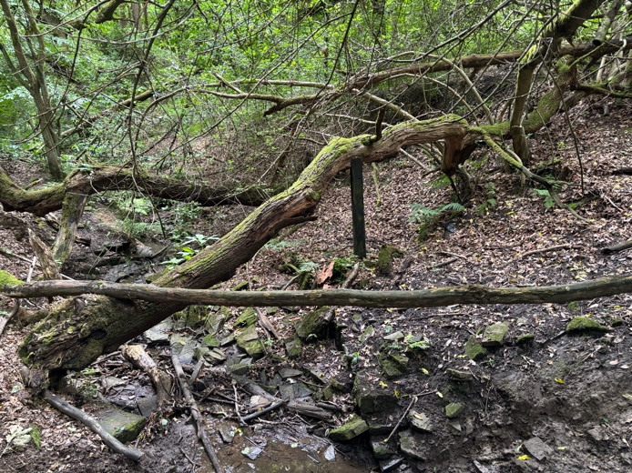Reflection 4 – Propping each up

* Take a look around, can you spot a tree being propped up?
* It takes a lot of strength to be that prop. Have you ever been the prop for someone else? Have you ever struggled to find the strength to be that prop? Are you currently feeling that strain?
* Or are you the one that is currently being propped up – by your family, your friends, your faith?
* Final spiritual bit: Jesus said, “Everyone then who hears these words of mine and does them will be like a wise man who built his house on the rock. And the rain fell, and the floods came, and the winds blew and beat on that house, but it did not fall, because it had been founded on the rock”. (Matthew 7: 24-27)
* We pause to reflect, with thankful hearts, for all our family, friends and faith, that has propped us up and ask for the strength to keep us going when we find ourselves as the prop.

JOURNEY ON

Bear right over the bridge with the green metal fence to your left.

Note - Don’t miss the stone strata and possible waterfall to your right.

At the end of the fencing, turn left, continuing to follow the line of the fencing.

Exit the path through a metal kissing gate. Cross the road to join Brow Wood Rise, uphill to your left.

After 50 yards, with the Brow Wood Road sign opposite, turn left onto Greenacres Drive.

Continue to the end of the cul-de-sac, to reach a white garage door on your left, take the path to the right of this garage.

Do not join the main road, follow the path as it bears right behind the dark grey wooden fence.

On reaching the clearing, turn left towards the main road, then turn right to return to Bethel Chapel.