

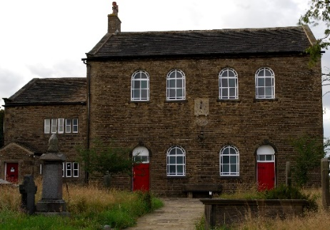

Intro: Mount Zion is full of History and many thousands of footsteps have trod around this site over the last 4 Centuries. There have been many famous people who have made the journey to this historic site including John and Charles Wesley the founders of the Methodist Church. There have also been many thousands of people not so famous and yet have also contributed to the history of this place. Today, you are also contributing to the history here by undertaking steps yourself around this sacred and historic place. As you go on this journey of reflection know that you are part of the legacy of this special place.
If the front gates are closed go up the lane and through the gate on the right. Then come down by the side of the cottage (white walled building) and then go round the front of the chapel down the path to the gates at the bottom.

Point 1: Front Gates.
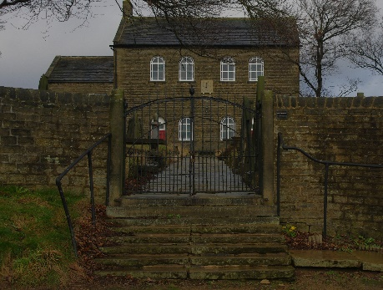
Before you take a step forward think about what a step is.
Think about the physical step you are taking with your feet, placing each one in front of the other. What does this movement help you to do?
Often, we take steps without even thinking about it, think about the other things we do that helps us to exist without thinking about it.
SPIRITUAL: Perhaps you might like to think about and be thankful for those things we can do instinctively like:
- Having a brain and heart that keeps everything alive
- The ability to breathe in and out unaided.
- Moving your body that helps you to function
- Having things to eat and drink that sustain you.
Perhaps you might like to thank God for those things you have thought about.
Journey onwards and stop part way up the path.

Point 2: Path
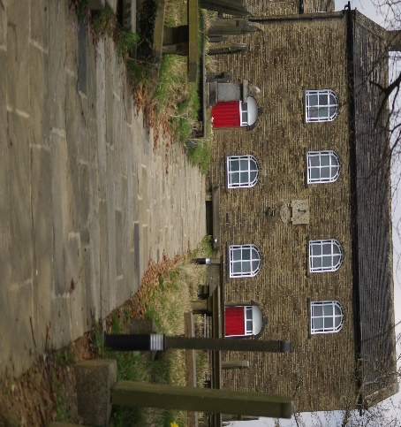
You have taken a few steps up the path. Stop for a while. What do you notice?
As you look around think about the few steps you have just taken. Your steps are part of a well-trod path that has been here a couple of hundred years.
Think about those people who have taken these steps. Think about why they may have taken these steps.
They might have been going to worship, for a wedding, baptism or funeral.
They may have been visiting this historic place, come for a cream tea, school visit or school carol service, visiting a grave or even to come and just find a peaceful place.
Take a look back at your steps so far up the path and think about your own life’s past journey.
Think about the journeys you have taken that spark happy memories for you.
SPIRITUAL
As you have taken these steps so far in your life, you have not travelled alone. Think of those who have travelled with you and give thanks for their companionship however long or short.
We never walk the journey through life alone its just sometimes we are unaware of God’s presence with us.
Perhaps you might like to look at your life and try and identify those times when you felt you were not alone.
Journey on to the chapel doors

Point 3 Chapel doors
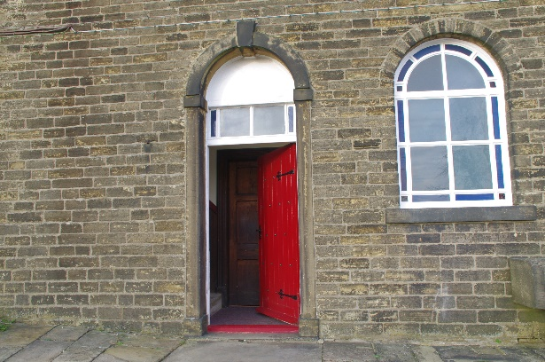

Stand back and look at the Chapel Doors.
Think about all the people who have entered those doors over the past 200+ years for celebrations, sad occasions, Carol services, Christmas services, Harvest, Easter and other Holy Days.
Other people may have entered the doors for a concert or exhibition, heritage days, visits by schools or groups.
Think of the places you go to that bring you a sense of joy, excitement, enjoyment and anticipation.
If the church is open why not go in, sit down and take in the atmosphere and sense of history of the place.
SPIRITUAL
In our lives we have doors we have to choose to go through for the first time. These are doors that perhaps we don’t know what is on the other side. It takes a small degree of faith and trust to go through and see what is beyond.
Perhaps you might like to think about the doorway of opportunity of knowing more about God’s love for you and about the small step of faith required by you.
Take a step back and go and sit on the stone seat (if dry)

Point 4 Stone Seat
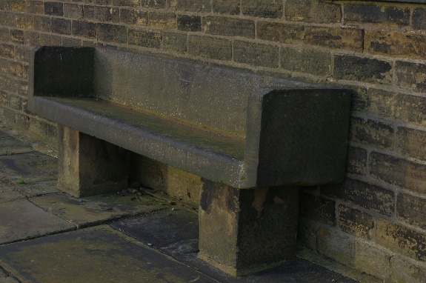

Have a look at the Stone seat between the front doors, if dry sit on it and close your eyes.
Listen to the sounds or even the stillness and the quietness.
As you listen look down the path, to the houses at the bottom and beyond.
Think about those houses and the people that live there.
Each person in those houses will have their own interests and things that they enjoy.
As you look down the path, think about your past and the things you enjoy or enjoyed doing that you no longer do.
SPIRITUAL: We all have things that we enjoy doing, these things are life giving to you.
What can you do to enable you to have things in your life that are life giving?
Perhaps you might like to thank God for those things which give you life.
Now look at the Sun Dial above your head.

5 Sundial
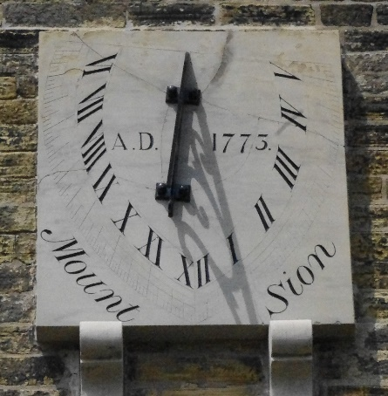
As you look at the sun dial think about how this was one of only a few ways of telling the time.
As we know there are only so many hours in one day and often there doesn’t seem enough.
Think about how your days are made up in terms of the necessities like eating, sleeping etc.
Think about what you fill your days doing.
Think about how important or not these things are to your well- being.
Which of these things can you let go of that enables you to rest or do something that is life giving?
SPIRITUAL:
Jesus once said, ‘I have come that you may have life in all its fullness’. What thing/s in your life stop you from having this life that Jesus offers?
Go to Cottage Door

Point 6 Cottage
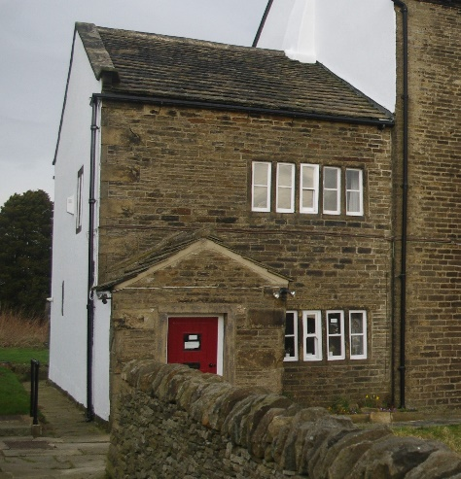
As you look at the cottage what do you notice?
The cottage used to house the Chapel caretaker and their family. This was someone’s home. Think about your home and what it gives you.
On many occasions visiting preachers who walked or were on horse back used to be offered accommodation in the cottage as they travelled around.
Think about a time when you have been offered hospitality by someone and the gratitude you felt.
Think for a moment about those who have no permanent home like the homeless, asylum seekers or sofa surfers.
SPIRITUALITY
Perhaps you might like to think about being grateful for the place you call home.
What could you do to help those who have no place to call home.
Journey on: Go into the walled garden area

Point 7 Irene’s Garden
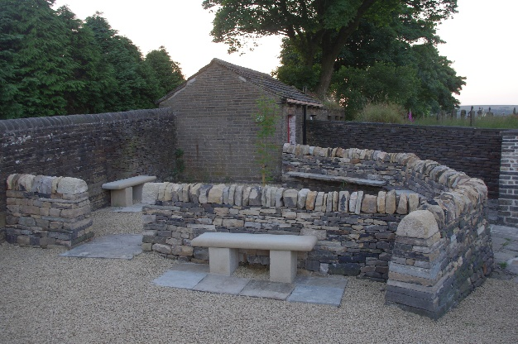
As you walk into the walled Garden area known as ‘Irene’s garden’ what do you notice?
This walled garden area was built in memory of a Lady called ‘Irene’ who spent a lot of time here at Mount Zion looking into the history as well as looking after the space. She was a former teacher and local preacher who cared passionately about this special place.
Think about the special places you have that you like to visit and are passionate about.
Think about how those places make you feel.
SPIRITUALITY:
There are special times and places where we appreciate creation, the awe and wonder of a place and its beauty and peace.
These are what are known as ‘thin places’ where the physical meets the spiritual.
Think about these places and how you are touching something of the very nature of God.
Sit for a short while and reflect upon this.

Journey on: You don’t need to move far as the next point is the ‘Centre Piece’ in Irene’s garden.

Point 8 Centre Piece
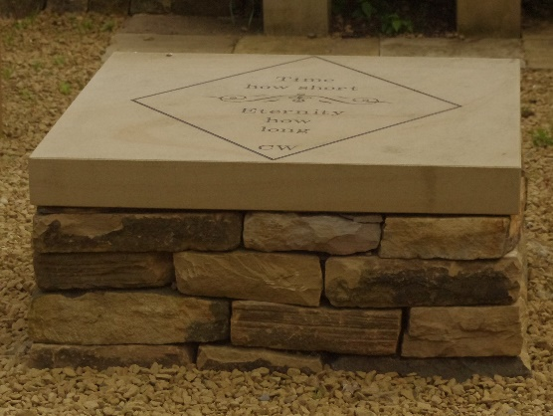
Notice the words etched into the Centre Piece. “Time how short, eternity how long”.
Urban legend has it that these words were scribed into a window in the ‘prophets chamber’ (a room used for visiting preachers) by Charles Wesley a preacher and great hymn writer when he visited Mount Zion. The window got blown out one night in a ferocious storm.
Think about these words again, “Time how short, eternity how long”. What do you think of as you read them?
We already looked at the Sun Dial that got us thinking about ‘Time’.
As you sit here think about those with whom you have spent quality time with and the investment you have made and that they have made in you.
This Centre Piece helps us think about our own life and what we have done with the time we have spent so far.
It also helps us think about the future and perhaps gets us thinking about what is beyond this life.
SPIRITUAL
‘Time how short, Eternity how long’ makes us think about different aspects of life, death and beyond. What do you think is beyond this limited time that we live our lives?
Go to the Sheds, go between the cottage and large wall and look left

Point 9. The Sheds
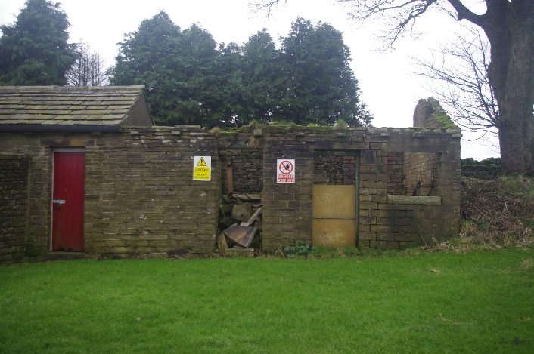
As you look at the sheds at the side of the cottage what do you notice?
Think about the state of the derelict ones and think about how things deteriorate when they are not cared for.
Think about your own life or someone you know who is struggling at the moment.
Think what could happen if you or they are not cared for.
Now let your imagination run riot and think about what could be done with these derelict sheds with time and the right resources invested on them.
Now think about yourself or that person and the possibilities that can be brought to birth when time and the right resources are invested in life.
SPIRITUAL
God is in the business of re-creating and bringing to birth new things. In one of the Psalms it says, ‘Forget the former things, don’t dwell on the past. See I am doing a new thing.” These buildings are a reminder of the past, but that is all they are a reminder and not essential. There are new possibilities that can be bought about as you have already imagined.
What things do you need to not dwell on so that new things can develop and be brought about in your life?
Move to 2nd gate on left (where you may have come in)

Point 10 Rear Gate
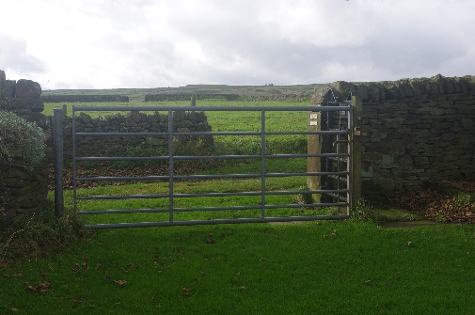
As you look at the gate and before you go through it take a good look around.
Think about all the people and families who are represented in the graveyard.
These are people who were wealthy, poor and everything in between, some would have had large families or no family at all. Think about your family and what they mean to you.
As you look at the gate again think about gates and what they do.
Gates are there to hold something in, to keep something out and to create a temporary barrier.
Gates are designed to be opened and allow travel through them, so that people on journeys are able to continue forwards without their way being permanently blocked.
Have a think about your own life and the gates (situations) you go through and how sometimes they are open and sometimes temporary closed.
Sometimes there are gate keepers who come along our life’s journey and open the gates through life for us, sometimes we have to open gates ourselves.
Think about those who have helped you on your journey and opened the way for you.
SPIRITUAL.
Jesus once said “I am the Gate; whoever enters through me will be saved.”
Think about this and what that means for you bearing all you have experienced on this reflective journey.

END:
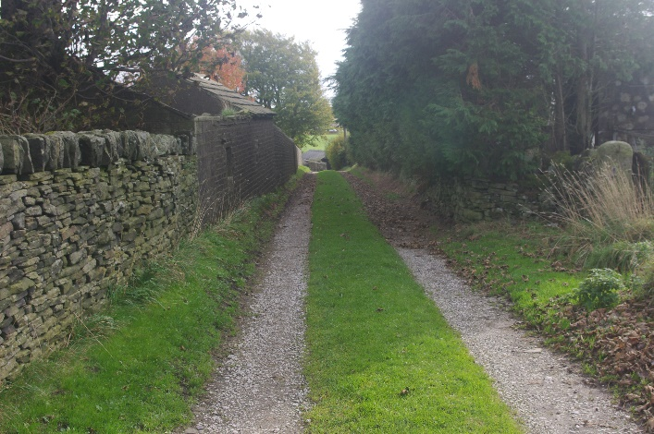
We have now come to the end of our reflective journey around Mount Zion. Perhaps you might like to spend a short time in and around the site before you journey home.

We at Mount Zion hope you have been provoked to think, reflect and consider changes you might wish to make in your life to enable you to have a fruitful and blessed life.
If you have enjoyed this reflective walk and found it helpful, then please share your experience with others.
If there is anything we can do to improve the experience for you then please do contact us and let us know.

May you be blessed with peace, hope and love as you journey through life.

For more information about Walking ‘The WAY’ then please visit https://www.calderdalemethodistcircuit.org.uk/about-us/walking-way.html
Or Email: walkingthewaycalderdale@gmail.com

