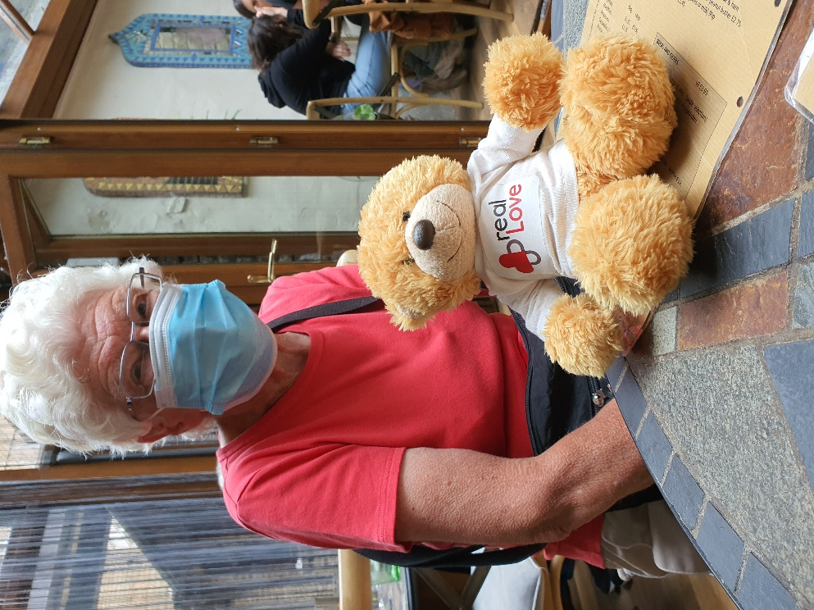
Wes the Bear – Showing Real Love in the Upper Valley
At our Synod in April this year, the Yorkshire West District issued every church with a challenge, to celebrate the ways in which we are or have been demonstrating Real Love in our communities, especially during the past eighteen months. The Calderdale Circuit allocated Wes to each church for a week and asked for photographs of Wes sharing in what we are doing on Social Media. Wes was in the Upper Valley between the middle of June and the middle of July. For those of you not familiar with Social Media, here are the photographs of Wes’ experiences of Real Love in the Upper Valley.
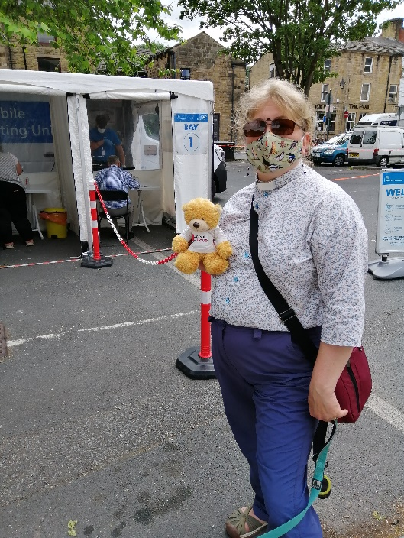
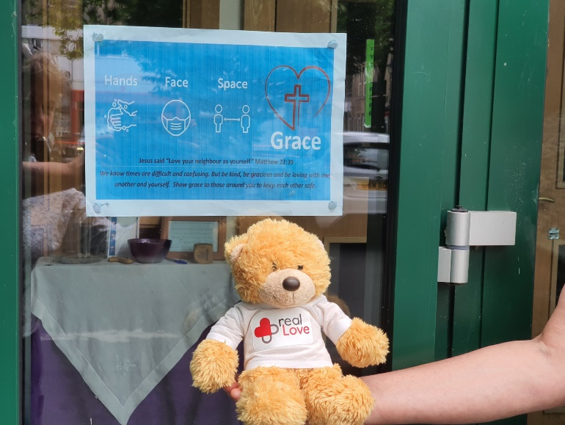
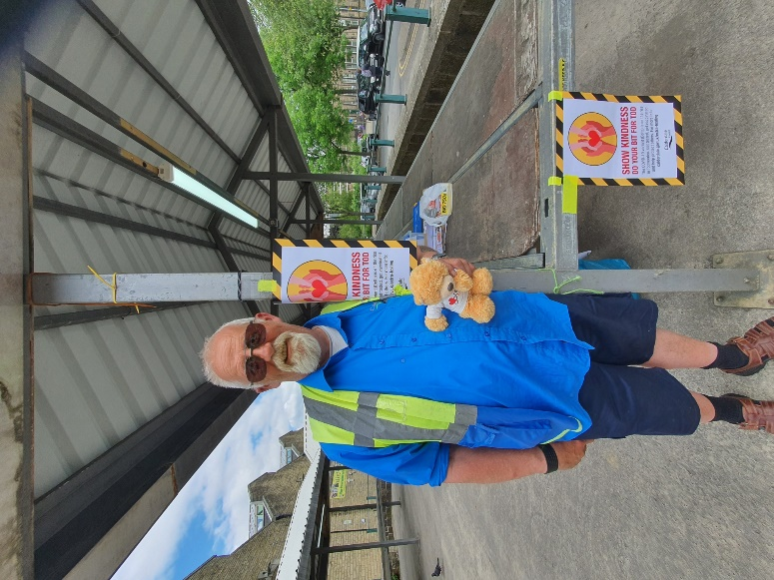
At Todmorden, Wes encouraged the local COVID volunteers and market traders; set a good example by going for a test at the Pop Up centre to help track the Delta variant; and looked at one of the inspirational posters through which the Church have been showing love to the community during lockdown.

