Haworth Heritage Trail

This walk has been created by the team at Brontë Parsonage Museum: Brontë.org.uk. Photos and reflections by Walking the Way.

Getting there and parking

Meet outside Brontë Parsonage Museum, Church Street, Haworth, BD22 8DR.

Three pay and display car parks nearby. The nearest is Museum Car Park (BD22 8DS) off West Lane and has public WCs (currently £1.50 per hour).

Other Information

Walk length 2.8 miles.

Moderate Ability – village streets, fields and moors. One short but steeper section on a stoned path and a few moderate inclines and declines.

Toilet facilities in the car park next to the parsonage. Charges apply (currently 30p).

Walking Boots and Walking Poles are advised due to sloping terrain, stones and cobbles.

*Note - History in Italics*

Route Details and Reflections

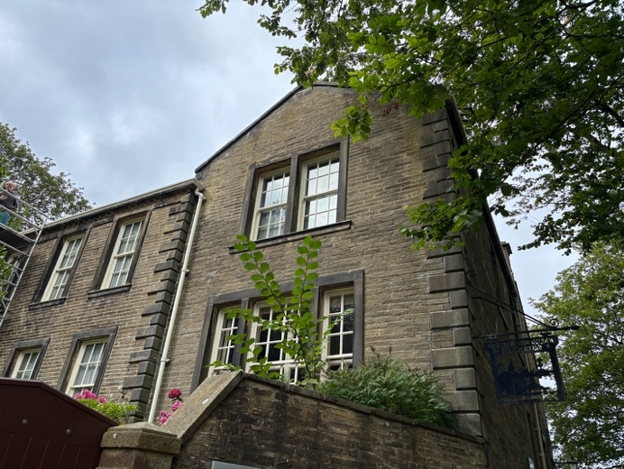Start at the Bronte Parsonage Museum

*A bit of history*

* *From 1820, Haworth Parsonage was the home of the world-famous Brontë sisters, Charlotte, Emily, and Anne, along with their father, Patrick, and brother, Branwell.*
* *It was in this very building that the three sisters wrote their groundbreaking novels.*
* *Charlotte is known for Jane Eyre, Shirley, Villette, and The Professor. Emily is famous for Wuthering Heights. Anne's most well-known works are Agnes Grey and The Tenant of Wildfell Hall.*

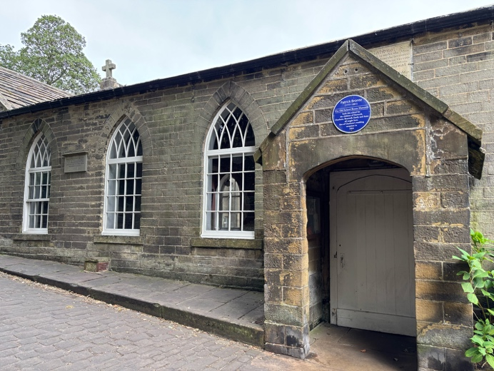Head down Church Street a few metres to the Old School Room on your left.

* *Old School Room: Patrick Brontë (their father) founded this National Sunday School for girls and boys. Every member of the Bronte family taught here; schools like this provided the only free education available.*

Turn right into the churchyard, pausing by the steps and the graveyard.

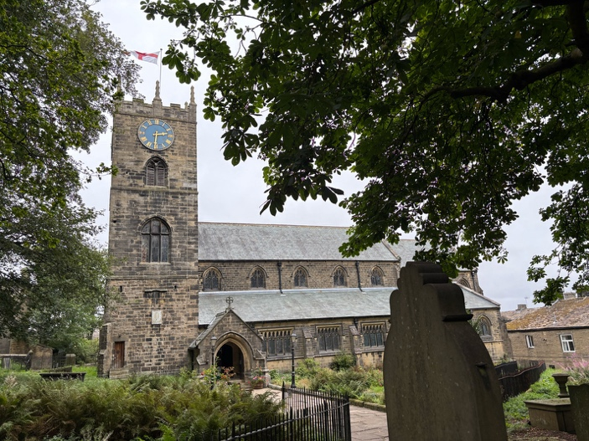

* *This small churchyard is crammed with hundreds of gravestones of local villagers - the weavers, the stonemasons, the clog makers. The average life expectancy was only around 25 years!*

Follow the path left around St Michael and All Angels Church, which is well worth a visit and is often open to welcome visitors (lots of Brontë history)..

Turn right, down the steps onto Main Street and a small cobbled area. Notice the stocks to the left of the steps.

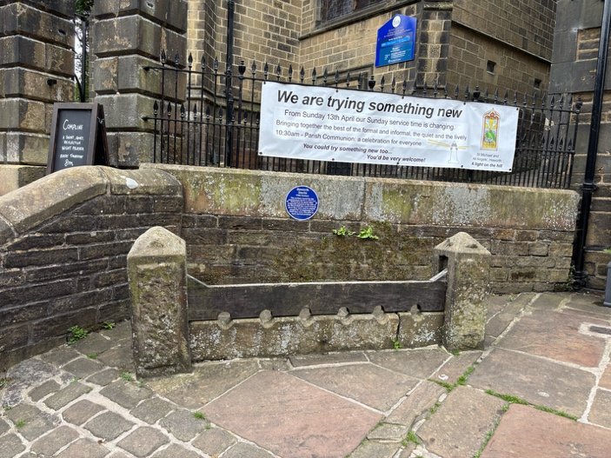

* *This square was once the heart of the community, where exhausted horses could rest after pulling carts up the steep road!*

Continue downhill on Main Street

* *Worker's cottages: Look out for the long line of upper floor windows on the buildings along Main Street. These were once the homes of handloom weavers & woolcombers. The upstairs rooms are where the cloth was woven and good daylight was essential.*

Continue down to the Old Hall before heading onto Bridgehouse Road as it curves down the hill towards the valley bottom. Stop on the bridge and peek over to see the Keighley and Worth Valley Railway.

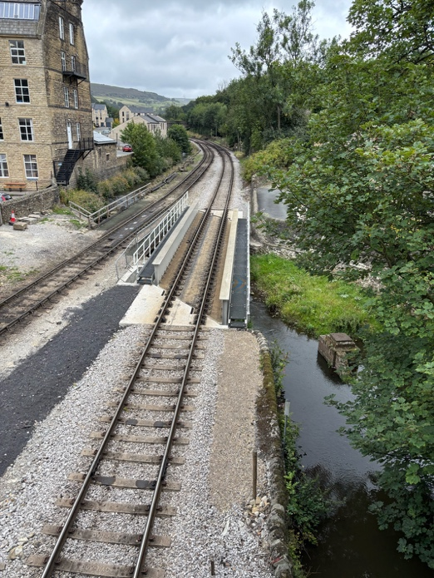

On the far side of the bridge take the first right into River View. Ahead is all that remains of Bridgehouse Mill

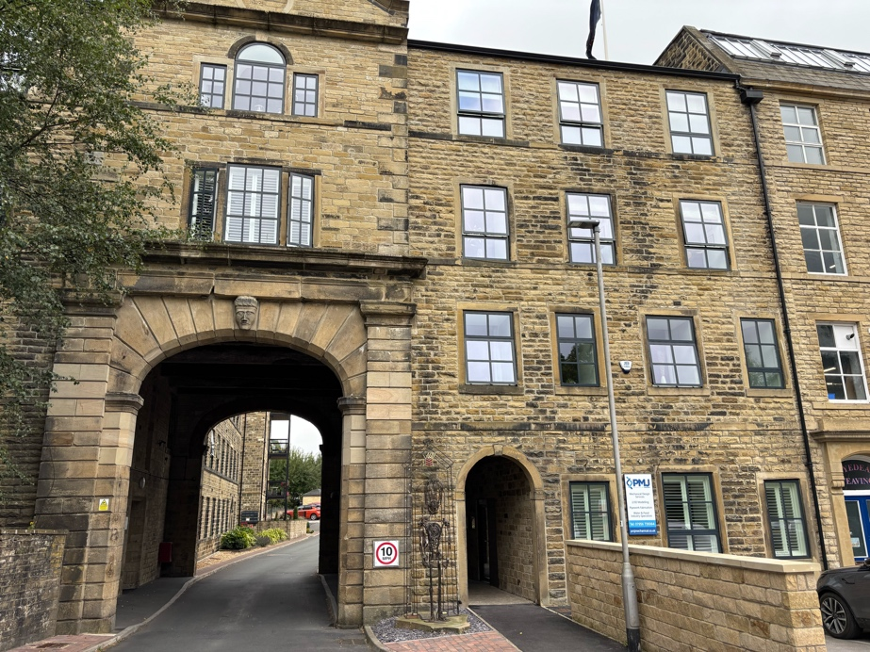

* *Bridgehouse Mill, the first in a ribbon of textile mills that threaded through the valley. It was one of the first textile mills to be powered by water. The beck was fed into a channel or 'goit' and into a dam to power the water wheel which drove the spinning machines.*

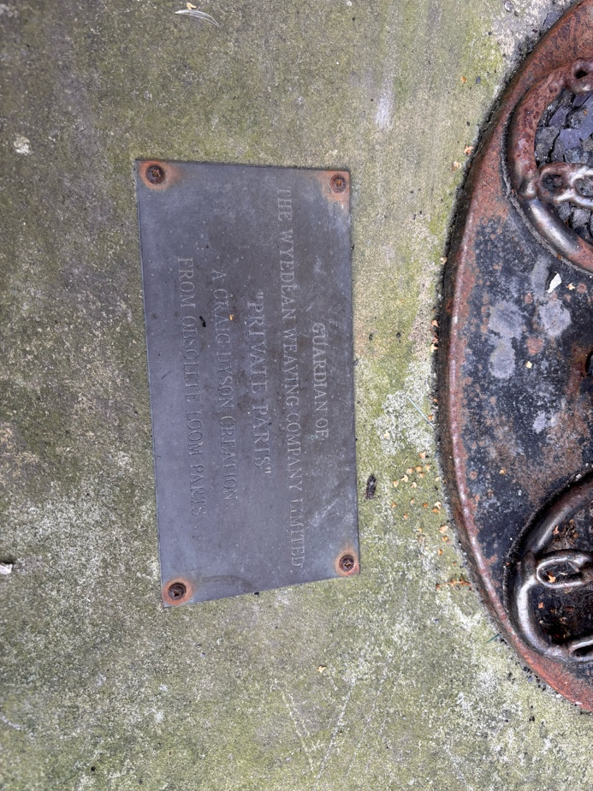

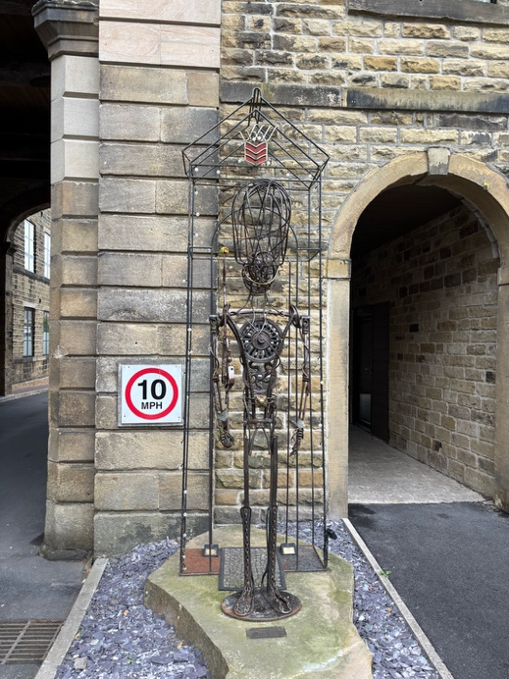**Reflection 1 – Made from obsolete loom parts**

* Take a look at this statue – what has it been made from?
* It has been made from obsolete loom parts. The loom parts have been transformed into something else, into a human statue.
* Let’s just pause and think about transformation, how we physically change as we get older, as we mature.
* Spiritually, reflect on how we are more than just this physical body that transforms and matures, we mature spiritually.
* Where are you on that spiritual journey? When it comes to faith in God, what looks real to you at this moment? We just quietly pause before moving on.

JOURNEY ON Head through the central archway and follow the road through the modern housing estate.

At the end, you'll come to a footpath by the beck. Follow the path through a metal kissing gate.

At a ruined farm building on the left take the right fork and head through the stone stile.

Follow the path across the courtyard of the cottages. Immediately after, take the gap in the fence to your right and follow the path downhill back towards the valley bottom. Continue along the riverside path until you reach an ancient stone bridge over the beck.

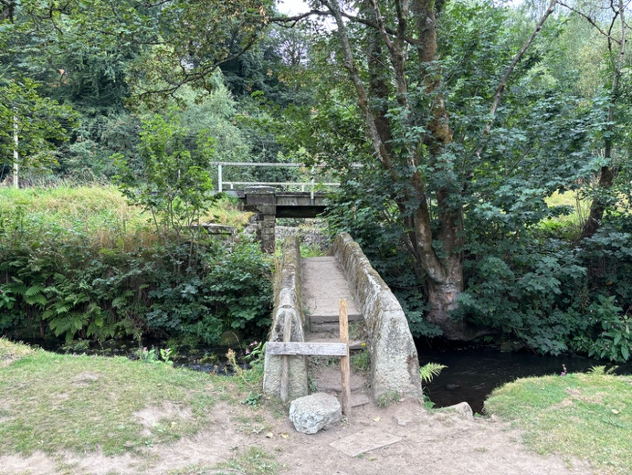**Reflection 2 – Donkey Bridge and railway track**

* *Donkey Bridge is part of a centuries old packhorse trail that was used to transport goods across the country.*
* *Keighley and Worth Valley Railway: Originally created in the 1860s to connect the mills and villages of the Worth Valley with the main railway station at nearby Keighley. Today it is run as a heritage railway by 700 volunteers and famously provided the backdrop for the film The Railway Children.*
* We are thinking about transformation today – the loom parts being made into the statue and the bridges here have had to move with the times. The donkey bridge would not be able to carry the railway, a new bridge needed to be created in the same place.
* The Bible talks about becoming a new creation – a complete inner transformation. It says, if anyone is in Christ, he is a new creation; the old has gone, the new has come!” (Corinthians 5:17). Before we journey on just pause and reflect on what that may mean. In Christ we become a new creation - the old has gone, the new has come!

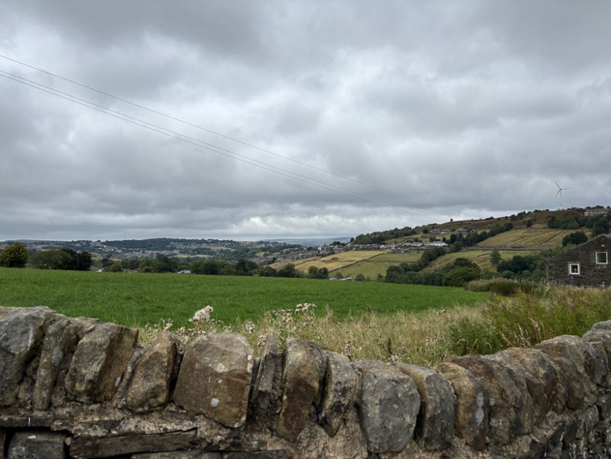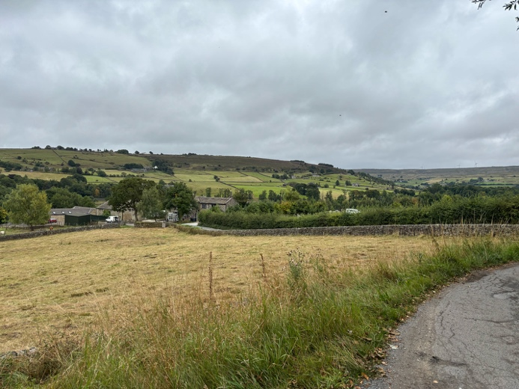JOURNEY ON Cross the bridge, head under the railway arch and follow the packhorse trail as it slopes up the valley. Continue past Marsh End Farm until the path meets Marsh Lane. Keep an eye out for some lovely views.

Turn left onto Marsh Lane, passing all the houses, then turn right onto Old Oxenhope Lane. As the road bends sharply left, enter the farmyard and go straight on, looking out for the footpath signs.

Leave the farmyard and continue on the track into the field.

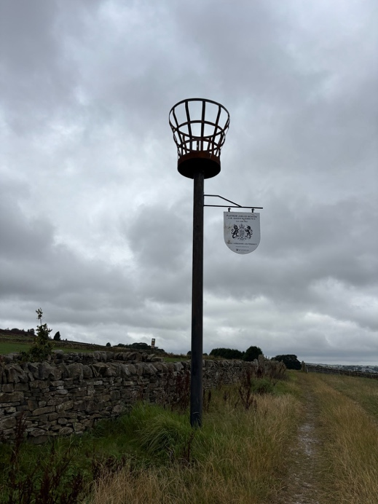Reflection 3 – Beacon

* Fire Beacon - Historically, beacons were large fires lit on high ground as a rudimentary but effective, long-distance communication system. Their primary use was to warn of an impending invasion by displaying smoke during the day and flames at night.
* More recently, they are lit for national celebrations, such as royal jubilees. Take a look at the sign.
* Fire is also used in the process of transformation. For example, in the Industrial Revolution, fire was essential for turning Coal into Coke to fuel the engines. Fire is used to refine steel to become a better version of itself.
* Before we journey on, pause to reflect on whether anything needs refining in our lives for us to become the person we always hoped we would be.

Keep left at the two windmills and pass through the small gap in the wall. This leads to a section of wall lined path. Continue straight ahead towards the line of conifer trees, keeping the wall to your right.

Pass through the small wooden gate, keeping the conifer trees on your right. At the end of the trees cross the track and continue through the small metal gate signed Haworth Main St. Pass through two fields and at the end turn right into the stone walled path.

Follow the walled path round as it zig-zags

Reflection 4 – View

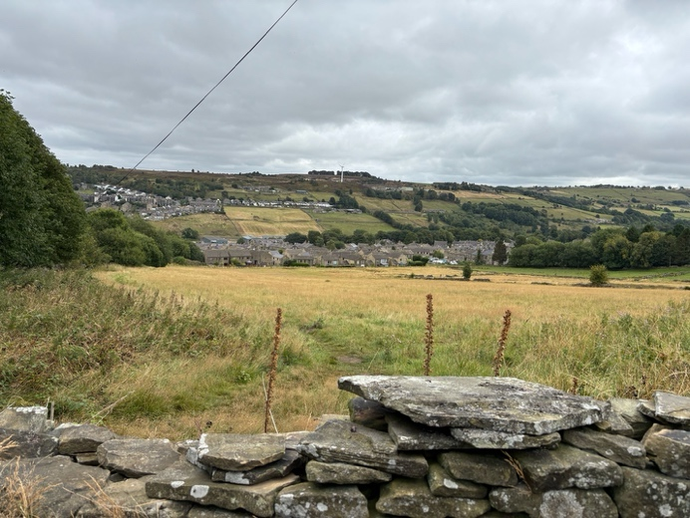

* Take a look around, what do you see?
* We are on the Brönte Way back into Haworth.
* A lot has changed over the past 200 years.
* We simply pause to reflect on the journey that has brought us to here and think about any changes we want to make in our lives for the journey ahead.
* And perhaps ask God to help us in this transforming process.

JOURNEY ON The path straightens out into a paved path leading to a kissing gate and back to the Parsonage graveyard.