
Shibden Park circular, inc Magna Via, ‘Sunny Bunces’ and Allen Brickworks

Getting there and parking

Meet outside ‘Café Culture in the Park’, near Mereside carpark, Shibden Park, Halifax. HX3 6XL.
Current carpark charges £1 per hour. Café open most days until 4 or 4:30pm depending on the day of the week and weather.

Other Information

Walk length 3.8 miles.
Moderate Ability – Slightly more challenging walk than normal as it involves a steep initial uphill climb and is slightly longer at almost 4 miles, however it is a lovely walk full of history including walking down the Magna Via, passing the site of the historic ‘Sunny Bunces’ and Allen brickworks.
Walking Boots and Walking Poles are strongly advised.

Route Details and Reflections

Exit the car park to follow the main path alongside the lake on your left-hand side.

Walk through the playground and exit with the public consciences on your left. Bear right and progress through the tunnel under the railway. Continue ahead following the narrow path between the fields to reach Shibden Hall Road.

Cross the road to enter Shibden Hall Croft opposite to the left. Take the first right turn and first path to the left up Pump Lane.

As you reach the top of Pump Lane, turn left at Valley View Barn also signposted ‘Hipperholme via Wakefield Gate’.

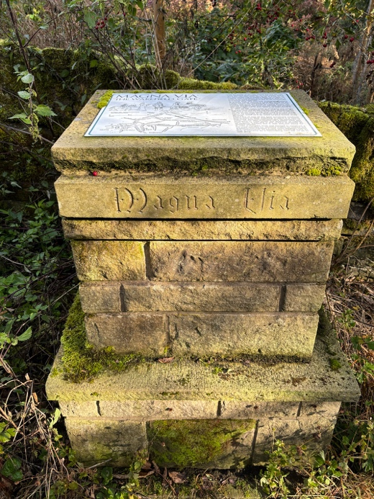
History

You are now walking on the ‘Magna Via’, until the mid 18th century this was the only route eastwood out of Halifax. This was the route that Ann Lister walked almost daily when she was at home in Shibden Hall.

Refection
First a reflection. Today we are thinking about perceived beauty. This will be particularly evident when we reach Allen Brickworks.

- Just pause and take a look around, what can you see?
- What, to you, is ‘obviously’ beautiful?
- Did you look out at the view for the ‘obviously’ beautiful? If so, try looking down, can you see any beauty close by?
- Can you see beauty in anything more ‘unusual’?
- As we journey today, feel present in the moment, not just looking out at the views in the distance but let's try looking for the beauty in everything and in the everyday.

JOURNEY ON
The track descends through a narrow walled path.
Take care as it can be slippy as you pass over the cobbles.

An amusing reference involving this route, is dated 12th August 1818, when Anne Lister reported:
"In the evening at 8.30 my Aunt and I went to the top of Bairstow to see the fireworks played off from the Piece Hall...
At 9.20, my Aunt, Marian, and I set off.
Finding we saw little or nothing from the top of Bairstow [we] dashed straight down the hill. My aunt, unable to keep her feet, slid down on her honourable part, Marian ditto, &we all laughed exceedingly."

Just after the Magna Via sign, take the left fork downhill.
At the end of the row of terrace cottages on Norcliffe Lane, turn right.
Pass the graffitied skip and bear left as the path forks.

History – Sunny Bunces

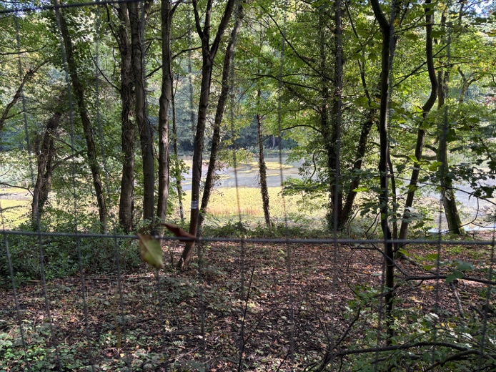
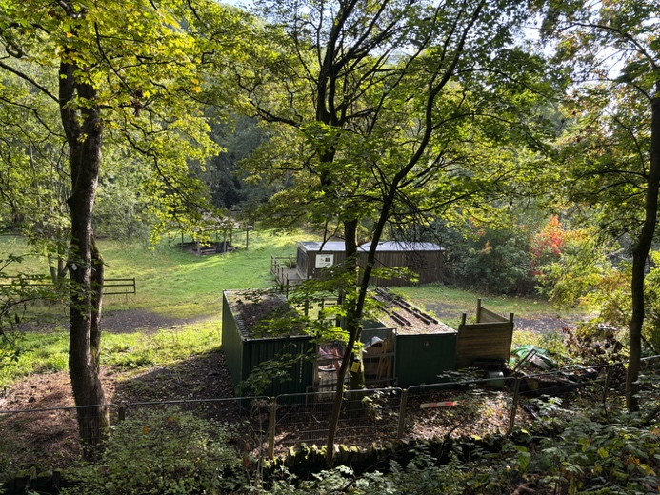
Look to your left. This is what remains of ‘Sunny Bunces’

Welcome to once famous ‘Sunny Vale’. Popularly known as ‘Sunny Bunces’ after its owner Mr Jospeh Bunce. Opened on 1st May 1880.

It was a 40 acre park with 2 man-made boating lakes (one has now dried up).

There were many facilities, including a dining room, a maze, music, shows, carnivals, swings, helter-skelter, miniature railway engine, skating, boating and dancing, and the Palace of Illusion which Bunce had bought from the Bradford Exhibition. For the more adventurous there were white knuckle rides such as the aerial glide and the glacier slide – a terrifying descent sitting on a coconut mat!

The dining room seated 1,000 people and would regularly serve meals to over 4,000 customers per day and catered up to 50,000 on a bank holiday. Thousands of day-trippers came to the site by train to Hipperholme railway station – followed by a long walk. A fireworks display marked the end of each season.
Closed in 1949.

Enter the clearing of Allen Brickworks and bear right.

Stay on the path do not go into any buildings. View from a distance ONLY.

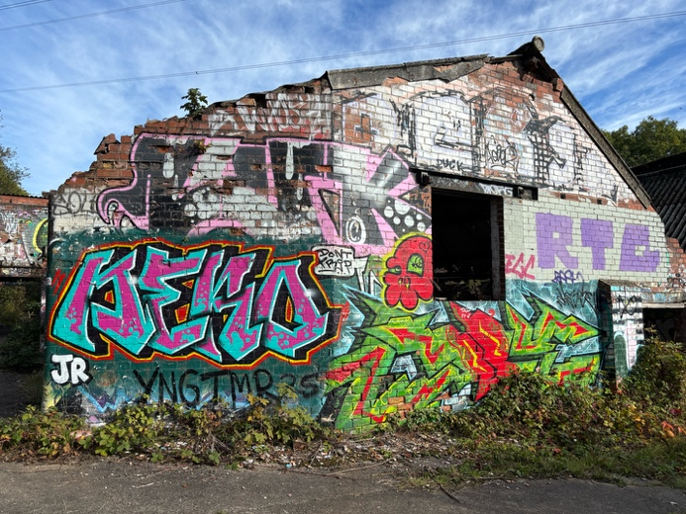
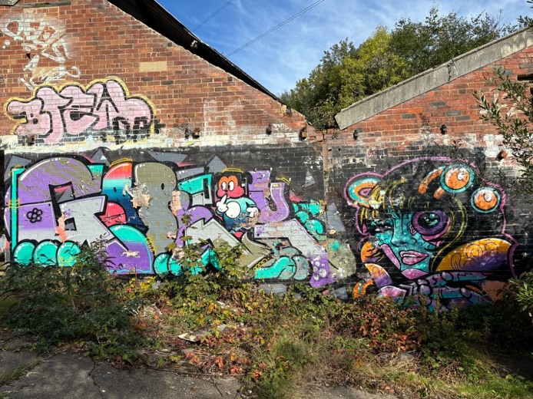
History – Allen Brickworks

Established in 1905, the Allen Brickworks hold a significant place in the industrial narrative of Halifax. It was Henry Victor Allen (1887-1960), who took over the existing Halifax Glazed Brickworks and revolutionised its production. Under his leadership, the works transitioned to specialising in refractory bricks. These exceptional bricks, famed for their Selfrac brand name, boasted exceptional heat resistance, making them ideal for lining kilns, furnaces, and fireplaces around the world.

The success story of the Allen Brickworks continued under the ownership of G R Stein, who consolidated their dominance by acquiring other brickworks in the region. However, the tides of industry shifted, and the brickworks eventually ceased operations in the 1960s.

Reflection 2 – Graffiti - Wall art or vandalism

- These brickworks have been closed since 1960.
- What do you think of the graffiti? Do you see wall art or vandalism?
- There is no right or wrong answer as beauty is something that is perceived. As we say, ‘Beauty is in the eye of the beholder’.

Would it surprise you if this is an attraction, described as the ‘ultimate mini graffiti city’ and an ‘open-air gallery’. Listen to this description - “While the brickworks stand as a testament to a bygone era, their surfaces have taken on a new life. Vibrant and artistic graffiti adorn every corner, transforming the walls into an open-air gallery. From novice sketches to captivating tags, the artwork adds a layer of contemporary intrigue to the historical site.”

- Can you remember how you felt when you saw the first graffiti on the walk, the graffitied skip? Has your view changed since being immerse here for a few minutes.

JOURNEY ON
Return to the clearing and exit the brickworks from where you originally entered. Take the first right down the steps to a walled path. Path becomes quite rough with bricks, so proceed with care.

Cross the wooden foot bridge. Continue to follow the path by the brook.
Exit the wood through offset wooden gate and turn left up the dirt track.
As you reach the T-junction, turn left passing Sunny Vale.
At the end of Surcliffe Wood Lane take the left down Badger Lane.
Stop at the entrance to ‘Underwood’.

Reflection - Wooden carvings
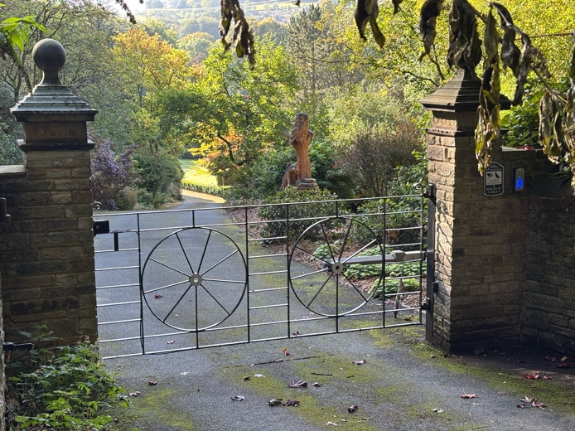
-

- Take a look though the entrance. What can you see?
- Can you see the wood carving? Can you see the trees?
- Both are made from wood. Which do you perceive to be as the most beautiful?
- The bible talks about inner beauty - true beauty is not derived from external adornments (such as jewellery or clothes) or physical appearances but from the qualities of the inner self. (1 Peter 3:3-4)
- Both the carving and the trees are made from the same thing – wood. Wood is the inner beauty. Can both be beautiful in their own way?

JOURNEY ON
Before you reach Northcliffe Lane, turn right at the ‘Unsuitable for motor vehicles’ sign. Signposted Shibden Hall Road.

Go over the wooden stile and later over the stone stile.
Exit via via the steps into Halifax Old Road. Cross the road and turn left.
Just recessed form the road, turn right at the sign on your right for ‘Leading to Breakneck House Breakneck Fold!’

Reflection 4 – Flowers
- Just stop at some flowers.
- How have you got on today at trying to look for the beauty in everything?
- Pause to look at the flowers and reflect on this thought ‘A flower does not think of competing with the flower next to it. It just blooms.’
- Each of us our precious in the eyes of God. Do you realise how precious you are? Life does not need to be a competition and definitely not one of perceived beauty. We just need to bloom!

JOURNEY ON
As the track forks, bear right up the private no through road.
Pass under the railway bridge and turn right.
At the end of Breakneck Lane turn left to join Halifax Road

Pass stump cross garage and Nether Brea, then take the public footpath through a kissing gate.

Take care on the steps as they can be mossy.

Enter Shibden Park keeping the railings to your left. Up the steps to the left and turn right, walking anticlockwise around the lake to return to the carpark.

