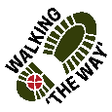
Mountain Circular, inc Queensbury Tunnel

Getting there and parking
Meet outside Foxhill Primary school, Queensbury, BD13 1LN.
Park on Fleet Lane opposite the school.

Other Information
Walk length 3.25 miles.
Moderate Ability – Mainly path on a disused railway, however downhill at the start on a leafy dirt track and a 1-mile ascent uphill on road and path at the end.
Walking Boots and Walking Poles are advised for the initial decent.

Route Details and Reflections

Descend down the right-hand side of the school. Ignore the public footpath sign to the left and bear right down a tarmac lane (Harp Lane).

As you reach the road, turn right heading up the hill towards Queensbury.

As you reach the main road (signposted Small Page), turn left down the main road heading towards Queensbury crossroads.

At the traffic lights by the Queensbury Tavern, turn left.

As you reach Station Road on your left, turn left to follow the Great Northern Railway Trail.

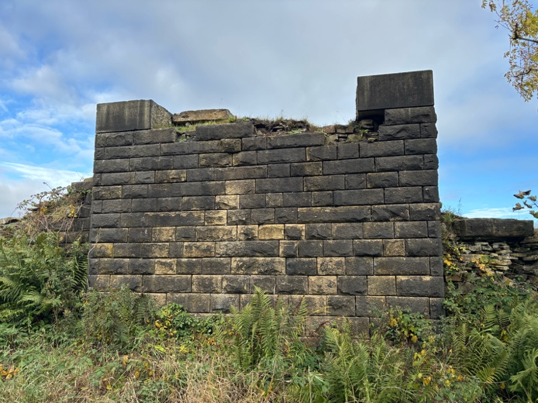
Reflection 1 - Disused Great Northern Railway train-line
- Today is Remembrance Sunday, later we will pause to remember the fallen, for now we remember the history of this area, what went on in this area before us.
- Today we will be walking part of the Great Northern Railway Trail and soon we will reach where the original Queensbury Station once stood. The station owed its existence to the efforts of local business leaders – notably John Foster, owner of the Black Dyke Mills (we will hear more about him later).
- The railway line between Bradford and Thornton was completed in 1878. Passenger services were withdrawn in May 1955 but goods trains were not withdrawn until 1965. The track was lifted and the last remains of the station were also demolished in May 1966

JOURNEY ON
At the bottom of the hill, proceed ahead through the metal gateway.

Before the metal gate, bear left on a gravelly track. You are now on the old disused railway line.

Reflection 2 – Ten men

- Before we reach the Queensbury Tunnel, we pause to remember the ten men who lost their lives building the tunnel.
- Around 600 men - 200 of whom were miners - were involved in building it and they were supported by 14 horses. Working conditions were unimaginable, with poor air, incessant water ingress, darkness – with light provided only by candles. It involved great danger, with very few health and safety measures. As a result, accidents occurred in significant numbers. Some were life-changing: burns, loss of limbs, crush injuries etc. and ten fatalities.
- Today, on Remembrance Sunday, we are going to respectfully pause and remember those men who lost their lives here (the eldest was only 44) and remember those we lost in the great wars. I will read the ten men’s names and then we will pause for a minute’s silence or you can move around this memorial and read more about these men, respectfully in silence.

Let us remember before God,
and commend to his sure keeping:
those who have died for their country in conflict;
those whom we know and whose memory we treasure;
and all who have lived and died in the service of humanity, including these ten men.
- Richard Sutcliffe (30), John Swire (44), Henry Ingham (36), Sutcliffe Hodgson (29), Henry Jones (39), John Gough (40), Richard Jones (33), Llewellyn Jones (31), Frederick Goulding (25) and Captain Pickles (30).

Older person
They shall grow not old as we that are left grow old:
age shall not weary them, nor the years condemn.

Young person
At the going down of the sun and in the morning
we will remember them.
We will remember them.

Queensbury Tunnel – History
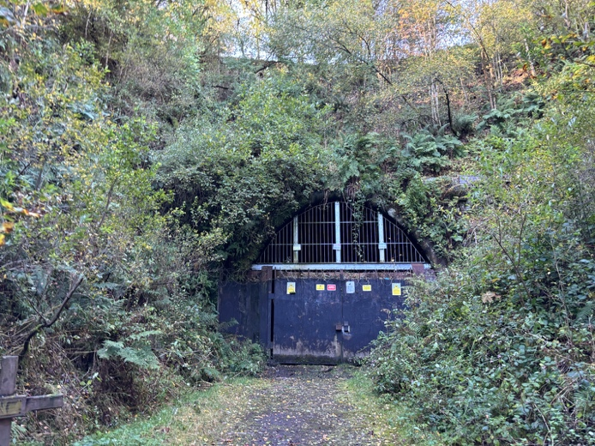
To deliver a line between Halifax and Keighley it would take 3 viaducts and several tunnels, the greatest of which is just in front of you - Queensbury Tunnel. At 2,501 yards (2,287metres) in length, it was one of the most significant engineering feats ever undertaken by the Great Northern Railway and the longest on their network when it opened in 1878.

Construction was due to take 2 years but it took 4 years. 7 shafts were sunk but two were abandoned, causing great delays, as the pumps could not cope with the amount of ingressing water.

Shortly before work finished, a reporter from the Halifax Guardian walked through the tunnel, describing the scene inside he remarked that “The pyramids of Egypt sink into insignificance compared with such a work” - reflecting the extent to which great engineering endeavours were held in awe by the Victorians.

Since 2014 there has been controversy over its future, would a greenway be built through it costing millions? As you can see, a decision has been recently made to abandon the scheme and fill the tunnel in.

JOURNEY ON
Retrace your steps back to the wide junction and then bear left, continuing in the disused railway line.

Continue on passing through the metal gate. As you reach the second gate with boulders, pass through the boulders to enter the lane turning left.

As the road bears round to the right, cross the road to join the footpath, and bear right up hill on Cockin Lane.

Stop for a reflection at ‘Yews Green Farm’

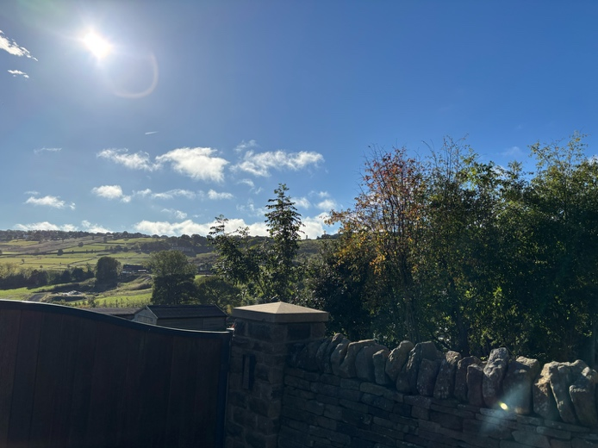
Reflection 3 – Black Dyke Mill chimney at Yews Green Farm.

- The chimney on the horizon is part of Black Dyke Mills. Famous for one of the oldest, most respected brass bands in the world – The Black Dyke Band - but originally for the production of some of the world’s finest Worsted and Mohair cloths.
- John Foster started the business in 1819 (Do you remember that we have him to mainly thank for the railway line?). He would buy yarns and distribute them from a warehouse to the hand-loom weavers, who then returned with their woven pieces. John would then take these pieces to the Bradford Piece Hall to sell to the merchants who would arrange for the dyeing and finishing.
- He started to build the mill in 1834. By 1851 Black Dyke Mills was dominating the landscape and at the Great Exhibition, John Foster took first prize for alpaca and for mohair fabrics, and the gold medal for yarns.
- Today the mill in Queensbury is no longer in operation, as the company went into administration in 1989. It is now filled with a range of businesses – from a boxing gym to a music school.

- Spiritual bit - Everything has its time. There is a quote from the bible - ‘The grass withers, the flower fades, But the word of our God stands forever.’ (Isaiah 40:8)
- Just pause to reflect on those words. ‘The grass withers, the flower fades, But the word of our God stands forever.’
- The mill has had its time for the production of yarn, that time has past, but it still stands and now has a new use. It’s not obsolete.
- No doubt our purpose and use, our identify, has changed over the years. Sometimes we need to re-assess our purpose...but we still stand…we are not obsolete. What does the next chapter of our life look like?
- We pause to reflect – What’s next for us?

JOURNEY ON
Cross the road by The Junction Inn and then take the right-hand lane up Laneside.

As the road bears right in front of the old water house (a white building), bear left to take a bridal path up the hill to your left.

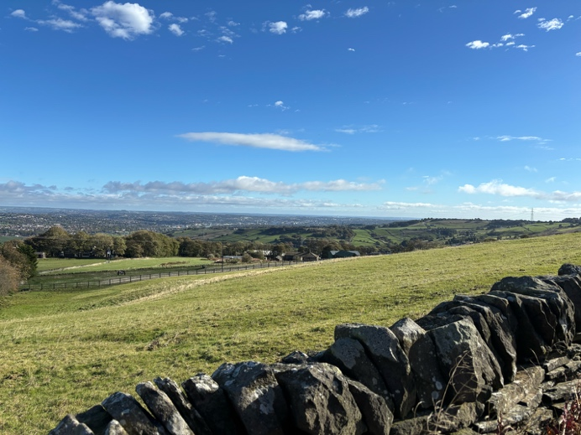
Reflection 4 – View

- Take a look around, what towns and cities can you see? - To your right is Bradford and Leeds, with Thornton and Howarth to your left. On a fine day you can see for miles!
- Spiritual bit – when you can see for miles, it can make us feel so small. But it is the complete opposite. We are simply part of something much bigger than ourselves. ‘You were made by God and for God’ – and until we understand that, life will never really make sense.
- Let’s pause, enjoy the view, reflect on those words ‘You were made by God and for God’ and feel the sense of belonging that comes from knowing that we are part of something much bigger than ourselves.

JOURNEY ON
Continue up the path. As you reached the main road, cross the road and turn left along the footpath (take care as a busy road) to return to the start of the walk.

